snippThis is year 3 curriculum overview for the Autumn 2 term. This overview gives you a brief explanation of what the pupils will be doing in school.
Topic  Our topic this half term is ‘Over the Rainbow’ which is a colour and science focus, each week there is a different theme.  Week 1- Colour mixing  Week 2- Red  Week 3- Blue  Week 4- Yellow  Week 5- Green  Week 6-Purple  Week 7- Christmas  Week 8 (3 days) - Christmas  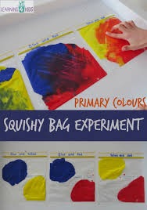 | Maths  We follow a weekly cycle covering all aspects of maths.  Week 1- Geometry  Week 2- Number  Week 3- Measure-  Week 4- Geometry- Position & Direction.  Week 5-Number  Week 6- Measure  Week 7- Christmas Maths  Week 8 (3 days) - Christmas  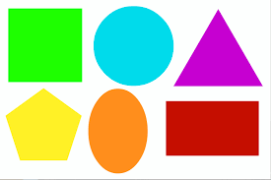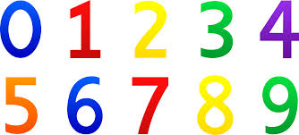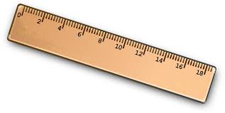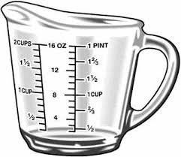 | English  This half term our school focus is Traditional Tales. Year 3’s chosen tale is ‘’Cinderella’  Each class will be exploring different versions, suitable to the children's needs.  Some classes will be comparing old and new versions and alternative versions.  Our Christmas performance will be a variation of Cinderella!  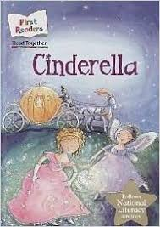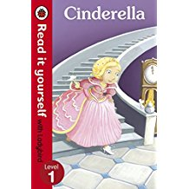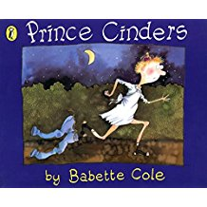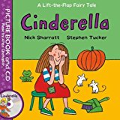 | Phonics/ Reading  We will continue to teach phonics in our differentiated groups within the year group.  Some children are at the pre phonics stage learning to identify and discriminate between different sounds.  Some children are learning the sounds of letters and how to blend sounds to read words.  In reading the pupils will be reading 1:1 with an adult at least once a week | Cookery  Year 3’s cookery focus this half term is bread.  Week 1 - Foccacia  Week 2- Naan  Week 3- Soda  Week 4- No yeast bread  Week 5- Sweet loaf  Week 6-Gingerbread Rudolph  Week 7- Mince pies  Week 8 (3 days) - No cooking  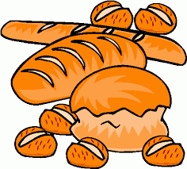
Dressing in a colour  As part of our topic every Monday we are asking children to dress in the colour of that week to wear to our assembly  MONDAY 6th Nov week 2- Red  MONDAY 13th Week 3- Blue  MONDAY 20th Week 4- Yellow  MONDAY 27th Week 5- Green  MONDAY 4th Dec week 6-Purple | Expressive Arts  For the first two weeks we will be working with two classes from East site on a whole school project.  ‘Side by Side Sculptures’  Following this,  Week 3- Country music  Week 4- Line Dancing  Week 5- Drama- Improvisation  Week 6 & 7- Role play- Cafe.  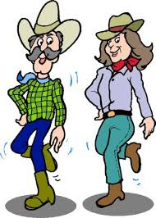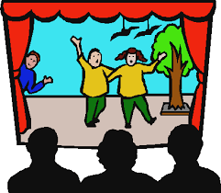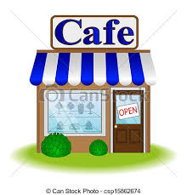 | Year 3  Over the rainbow  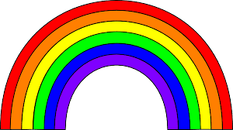  Autumn 2 Overview |  | PE  This half term in PE the pupils will be focussing on dance & gym.  We will continue to take part in some morning exercise- focusing on walking, dancing and keep fit exercises.
Computing  This half term our ICT unit is Story Making. Children will use a range of storytelling packages to produce a sequence of events from a story, adding simple narration in the form of; words, pictures, sounds, symbols to tell their story. |  | Trips  This half term we will be visiting between East / West to build our art project. We will also go on individual Christmas class trips planned by the teacher.  Some classes go to ASDA every week. | Important dates  Friday 17th Nov-Training day  Thurs 7th Dec - Year 3 ‘colour’ party - children to wear bright colourful clothing  Monday 18th - Cinderella performance to parents - 2pm

