This is the curriculum overview for Yellow Class for the Autumn 2 term. This overview gives you a brief explanation of what the pupils will be doing in school. It also gives you suggestions of activities to support pupil’s learning at home. These are only suggestions, not compulsory activities.
Topic  Our topic this half term is ‘Mission to Mars’ which has a science focus. Each week we will be learning about different aspects connected to this.  Week 1- Halloween  Week 2- The Night Sky (including Bonfire Night)  Week 3- Space Travel  Week 4- What can you see in space?  Week 5- Objects that use electricity  Week 6- Electrical Circuits  Week 7- Christmas  Week 8 - Christmas | Maths  Throughout this half term we will be working on concepts linked with Measurement, Number and Geometry  Week 1- Measure- Time  Week 2- Number - Division / Sharing  Week 3- Geometry - Position & Direction  Week 4- Measurement - Mass / Weight  Week 5- Number - Place Value  Week 6- Geometry - 3D Shape  Week 7- Measurement - Money  Week 8 - Christmas | English  This half term our school focus is Traditional Tales. Year 5/6’s chosen tale is ‘Jack & the Beanstalk.’  Week 1- Intro to Jack & the Beanstalk  Week 2- Characters & adjectives  Week 3- Sequencing and re-writing the story  Week 4- Intro to an alternative version  Week 5- Characters & adjectives used in the story  Week 6- Sequencing and re-writing the story  Week 7 - The Jolly Christmas Postman - linking to Christmas  Week 8 - The Nativity | Phonics/ Reading  We will be teaching phonics in our differentiated groups within the year band. Pupils will be learning the sounds of letters and how to blend sounds to read words. | Cookery  Year 5/6’s cookery focus this half term is curries. We will be making vegetable biriyani, egg curry, potato curry and curry side dishes.  Alongside this we will be making some gingerbread and Christmas cookies / treats.  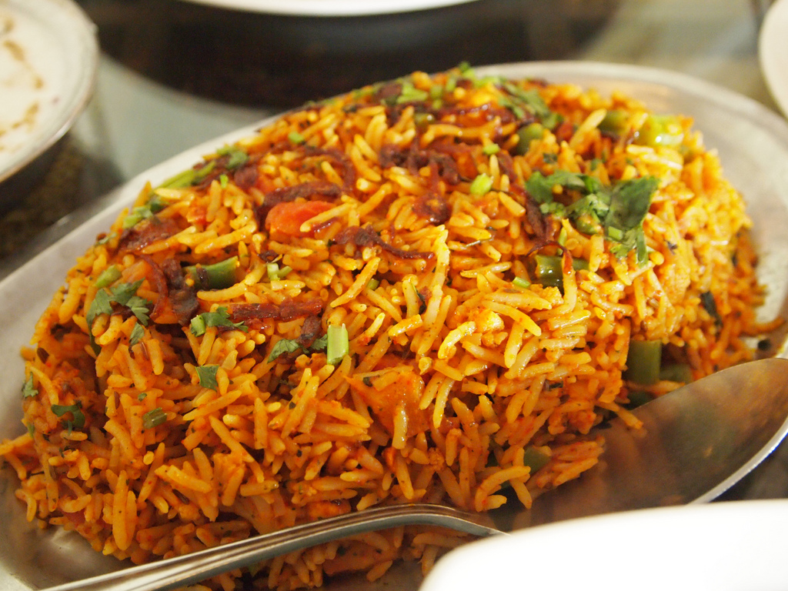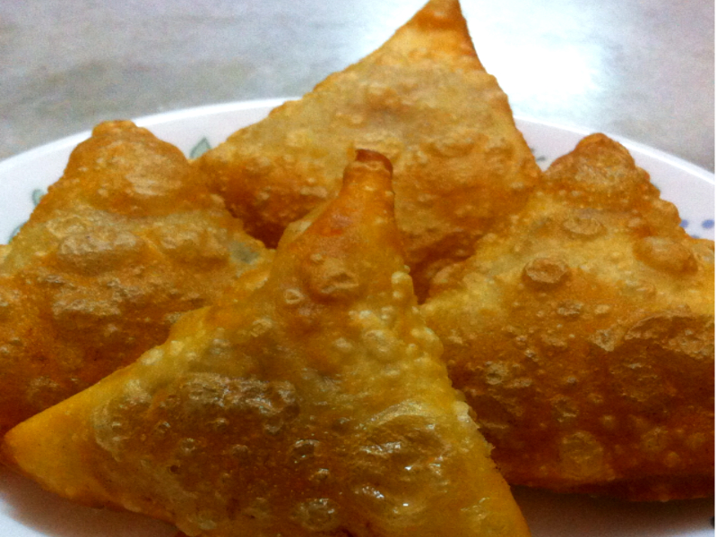
Computing  This half term our ICT unit is Story Making. The pupils will use Powerpoint to produce a sequence of slides showing key images from Jack & the Beanstalk. They will add in simple narration in the form of; words, sounds or symbols to tell the story. | Expressive Arts  For the first two weeks we will be working with another class from East site on a whole school project.  Following this we will then focus on:  Week 3- Country music  Week 4- Line Dancing  Week 5- Drama- Improvisation  Week 6 & 7- Choice of favourite activity from weeks 3-5. | Yellow Class  Mission to Mars    Autumn 2 Overview | Communication  This half term the children will continue to participate in a range of speaking and listening activities through discreet activities and throughout the curriculum. The weekly speaking and listening sessions encourage the development of spoken language, turn taking and listening skills. The children will also join in with Write Dance and Attention Skills sessions. | PE  This half term in PE the pupils will be focusing on dance & gym.
Home activity ideas...  - Explore plants growing, encouraging care for them by watering them  - Listen to a range of country / line dancing music and copy each other's movements  - Share a range of books, including traditional tales, encouraging participation in repetitive verses  - Find things that use batteries and mains electricity at home / outside  - Maybe even enjoy a curry!  -Have fun & enjoy your time together. | Science  Our science work will link in with our topic learning about physical properties with a focus on light.  Week 1 & 2- Sources of light  Week 3 & 4 - Awareness of the sun, moon & shadows  Week 5- Objects that use electricity  Week 6- Making simple electrical circuits | Trips  This half term we will go to visit East site to build our art project with our buddy classes at East. | Important dates  Friday 17th Nov-Training day  Wednesday 13th Dec- Panto  Wednesday 20th Dec- End of term. | PSHE  Pupils will continue to work on their personalised learning program targets each week.

