This is Sapphire’s curriculum overview for the Autumn 2 term. This overview gives you a brief explanation of what the pupils will be doing in school. It also gives you suggestions of activities to support pupil’s learning at home. These are only suggestions, not compulsory activities.
Topic  Our topic this half term is ‘Mission to Mars’ which has a science focus. Each week we will be learning about different aspects connected to this.  Week 1- Halloween  Week 2- The Night Sky (including Bonfire Night)  Week 3- Space Travel  Week 4- What can you see in space?  Week 5- Objects that use electricity  Week 6- Electrical Circuits  Week 7- Christmas | Maths  We will be linking our maths activities in with our story- Jack and the Beanstalk. We will have a 2 week focus on each strand.  Week 1 & 2 – Number  Week 3 & 4 – Geometry  Week 5 & 6 – Measure  Week 7 – Christmas Maths | English  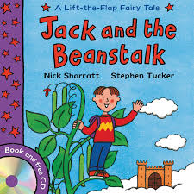  This half term our school focus is Traditional Tales. Year 5/6’s chosen tale is ‘Jack & the Beanstalk.’ Through the book we will be covering a range of different speaking & listening activities and styles of writing. | Phonics/ Reading  We will be teaching phonics in our differentiated groups within the year band. Pupils will be learning the sounds of letters and how to blend sounds to read words.  In class the children will continue with individual reading 1:1 with an adult.   | Cookery  Year 5/6’s cookery focus this half term is curries. We will be making vegetable biriyani, egg curry, potato curry and curry side dishes.  Alongside this we will be making some gingerbread and Christmas cookies.  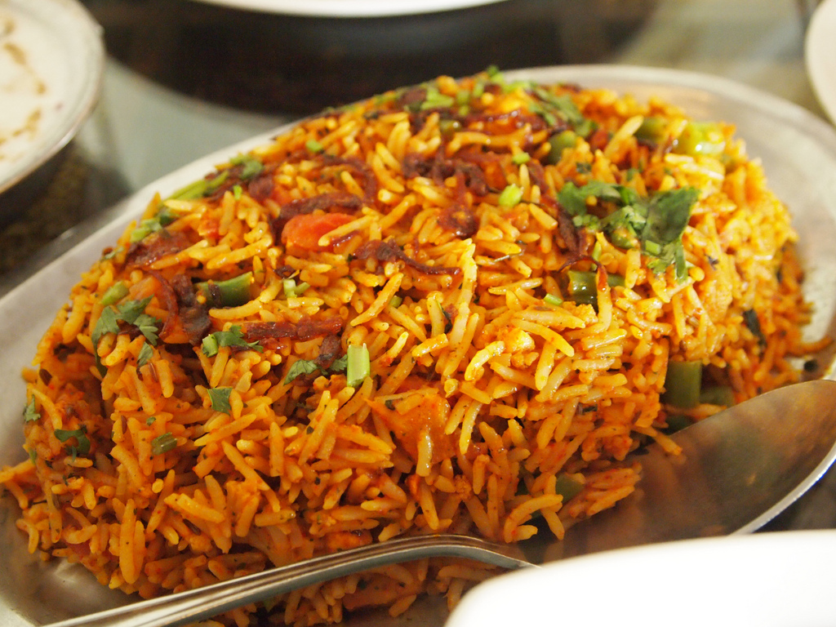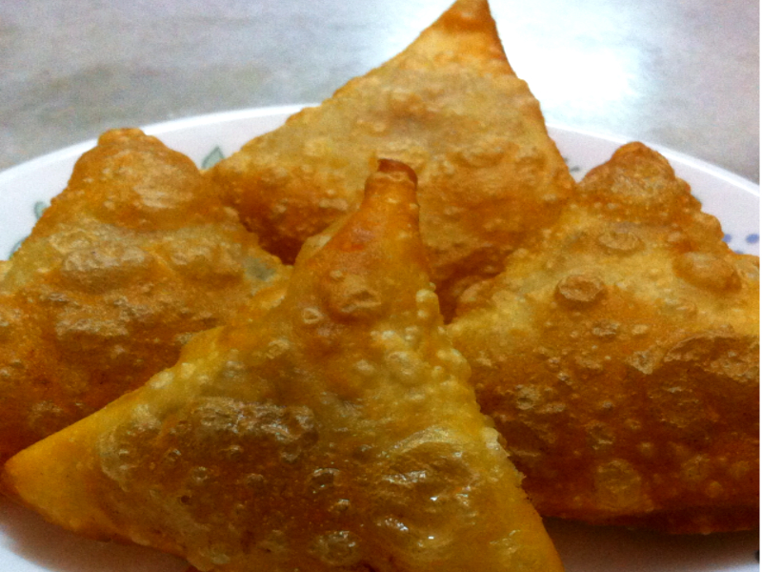
Computing  This half term our ICT unit is Story Making. The pupils will use PowerPoint to produce a sequence of slides showing key images from Jack & the Beanstalk. They will add in simple narration in the form of; words, sounds or symbols to tell the story. | Expressive Arts  For the first two weeks we will be working with two classes from East site on a whole school project.  Following this,  Week 3- Country music  Week 4- Line Dancing  Week 5- Drama- Improvisation  Week 6 & 7- Choice of favourite activity from weeks 3-5. | Sapphire Class  Mission to Mars    Autumn 2 Overview | Communication  The pupils in Sapphire Class are working on a range of different communication targets. Some pupils are working on communicating through PECS and signing, whilst others are building vocabulary and attempting to speak in fuller sentences. | PE  This half term in PE the pupils will be focusing on dance & gym.  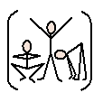
Home activity ideas...  Reading: Share a book with your child and look at the pictures. Talk about the characters and what you can see happening in the pictures.  Maths: Point out the different shapes to be found around your home. Take your child shopping and talk about the quantities of anything you buy. Look together for numbers on street signs and car registration plates. | Science  Our science work will link in with our topic learning about physical properties with a focus on light.  Week 1 & 2- Sources of light  Week 3 & 4 - Awareness of the sun, moon & shadows  Week 5- Objects that use electricity  Week 6- Making simple electrical circuits    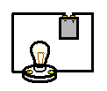 | Trips  This half term we will go to visit East site to build our art project with our buddy classes at East. | Important dates  Friday 17th Nov-Training day  Wednesday 13th Dec- Panto    Wednesday 20th Dec- End of term. | PSHE  Pupils will continue to work on their personalised learning program targets each week.  In addition we will be thinking about firework and safety around the home e.g. electrical objects.

