This is the curriculum overview for Gold Class for the Autumn 2 term. This overview gives you a brief explanation of what the pupils will be doing in school. It also gives you suggestions of activities to support pupil’s learning at home. These are only suggestions, not compulsory activities.
Topic  Our topic this half term is ‘Mission to Mars’ which has a science focus. Each week we will be learning about different aspects connected to this.  Week 1- Halloween  Week 2- The Night Sky (including Bonfire Night)  Week 3- Space Travel  Week 4- What can you see in space?  Week 5- Objects that use electricity  Week 6- Electrical Circuits  Week 7- Christmas | Maths  This half term will start off looking at 2D and 3D shapes and understanding properties.  We will then look at positional language and measure and specifically link this into our topic.  Finally we will complete the term by looking at number with some of our children counting out quantities and some of our children developing their addition and subtraction skills as well as investigating the ideas around division and multiplication. | English  This half term our school focus is Traditional Tales. Year 5/6’s chosen tale is ‘Jack & the Beanstalk.’  Alongside this we will also be reading a range of books both fiction and non-fiction linked to our topic starting with Aliens wear Underpants. | Phonics/ Reading  We will be teaching phonics in our differentiated groups within the year band. Pupils will be learning the sounds of letters and how to blend sounds to read words. | Cookery  Year 5/6’s cookery focus this half term is curries. We will be making vegetable biriyani, egg curry, potato curry and curry side dishes.  Alongside this we will be making some gingerbread and Christmas cookies.  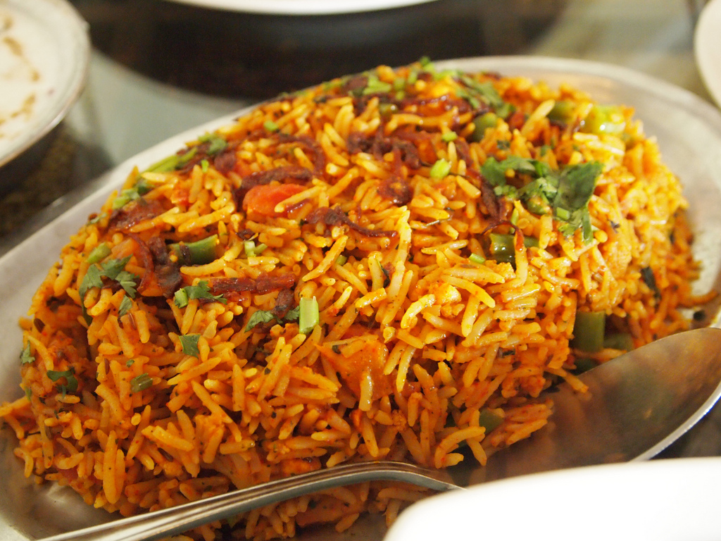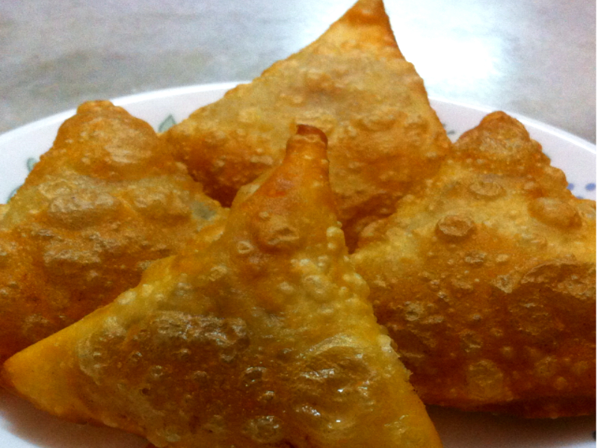
Computing  This half term our ICT unit is Story Making. The pupils will use Powerpoint to produce a sequence of slides showing key images from Jack & the Beanstalk. They will add in simple narration in the form of; words, sounds or symbols to tell the story. | Expressive Arts  For the first two weeks we will be working with two classes from East site on a whole school project entitled  Side by Side 2.  We will then be exploring Country Music and Line Dancing for 4 weeks.  Finally the Expressive Arts room will be transformed into a supermarket ready for some fun real life roleplay. | Gold Class  Mission to Mars    Autumn 2 Overview | Communication  We will continue with  Golden Gift of the Gab FM  where the children have the opportunity to listen to our class radio and answer questions about a the show which as always will relate to our story or topic.  We will also continue with a weekly Karaoke session where the children get to choose their favourite songs and follow the words on the screen.  Finally during breakfast time, snack time and PM circle time we will use our chatter mats and question cards to practice asking and answering questions using full sentences. | PE  This half term in PE the pupils will be focussing on dance & gym.  Gold Class will also be swimming up until Christmas and running around the Track twice a week to build up our general fitness.
Home activity ideas...  Pumpkin sculptures.  Christmas Cards/Season’s Greetings Cards.  Getting the children to help around the house with laying the table through to hanging clothes is a great way to develop independence skills.  Test out our roleplay work and see how the children get on at the shops. We’d love to hear about your experiences.  Take a look at our weekly newspaper online and see what your children can tell you about our featured stories. | Science  Our science work will link in with our topic learning about physical properties with a focus on light.  Week 1 & 2- Sources of light  Week 3 & 4 - Awareness of the sun, moon & shadows  Week 5- Objects that use electricity  Week 6- Making simple electrical circuits | Trips  This half term we will go to visit East site to build our art project with our buddy classes at East. | Important dates  Friday 17th Nov-Training day  Wednesday 13th Dec- Panto  Wednesday 20th Dec- End of term. | PSHE  Pupils will continue to work on their personalised learning program targets each week.  In addition to this we will also be looking at road safety and stranger danger.

