This is DIAMOND Classes curriculum overview for the Autumn 2 term. This overview gives you a brief explanation of what the pupils will be doing in school. It also gives you suggestions of activities to support pupil’s learning at home. These are only suggestions, not compulsory activities.
Topic  Our topic this half term is ‘Mission to Mars’ which has a science focus. Each week we will be learning about different aspects connected to this.  Week 1- Halloween  Week 2- The Night Sky (including Bonfire Night)  Week 3- Space Travel  Week 4- What can you see in space?  Week 5- Objects that use electricity  Week 6- Electrical Circuits  Week 7- Christmas | Maths  Wk 1 Number  Wk 2 Shape  Wk 3 Number  Wk 4 Position/direction  Wk 5 Measure  Wk 6 Number- Christmas counting  Wk 7 Shape- Christmas decorations  Wk 8 Measure-big and small presents! | English  This half term our school focus is Traditional Tales. Year 5/6’s chosen tale is ‘Jack & the Beanstalk.’  We will be listening to the story and joining in with actions & songs related to the story.  We will also be matching pictures of Jack, the giant, the beanstalk and joining in with role play eg pretending to climb the beanstalk, pretending to be a giant by stamping our feet etc | Phonics/ Reading  We will be teaching phonics in our differentiated groups within the year band. Pupils will be learning the sounds of letters and how to blend sounds to read words. | Cookery  Year 5/6’s cookery focus this half term is curries. We will be making vegetable biriyani, egg curry, potato curry and curry side dishes.  Alongside this we will be making some gingerbread and Christmas cookies.  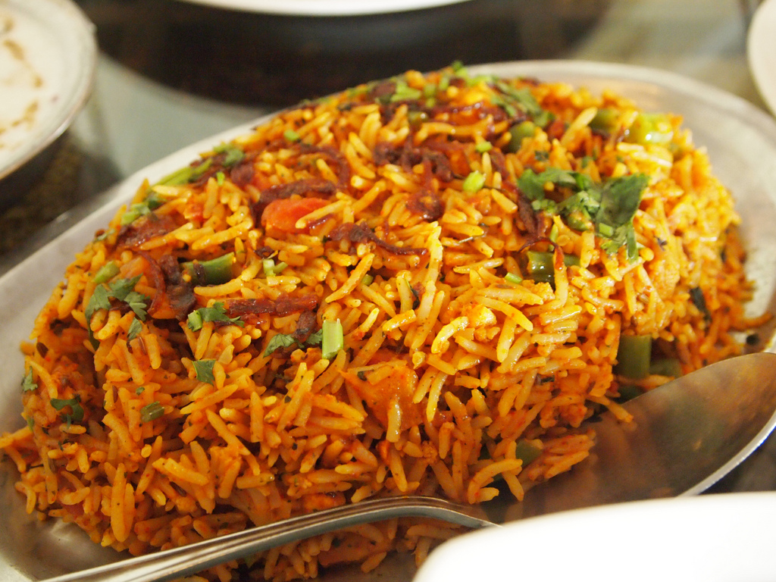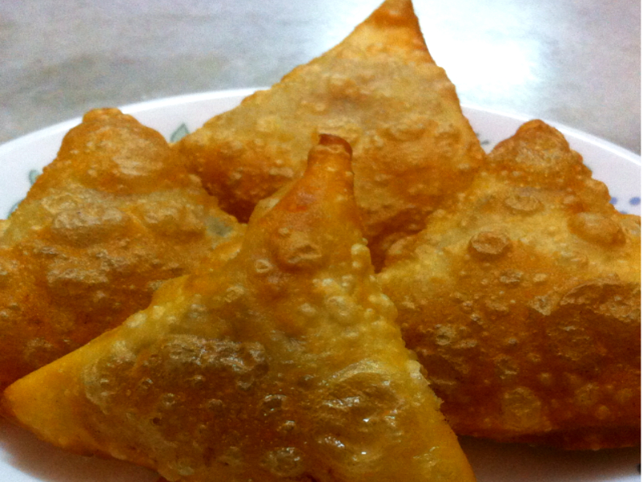
Computing  This half term our ICT unit is Story Making. With help some pupils will use Powerpoint to produce a sequence of slides showing key images from Jack & the Beanstalk.  Some pupils will also have photos of themselves joining in with role play in English and learning about sequencing eg  1st plant the seed/2nd the beanstalk grows  1st climb beanstalk/2nd see giant! | Expressive Arts  For the first two weeks we will be working with two classes from East site on a whole school project.  Following this,  Week 3- Country music  Week 4- Line Dancing  Week 5- Drama- Improvisation  Week 6 & 7- Choice of favourite activity from weeks 3-5. | DIAMOND Class  Mission to Mars    Autumn 2 Overview | Communication  Pupils are encouraged to communicate in many different ways so that they learn to tell us what they want. They may copy actions and learn how to use signs to show what they want.  Some pupils are encouraged to look at photos and symbols to exchange the picture of what they want.  All pupils have an opportunity to make sounds from their mouth and to practise trying to say some words eg “hello!” | PE  This half term in PE the pupils will be focussing on dance & gym.
Home activity ideas...  Use photos to show pupils what is happening at home eg car- when you go out in car, bed- when it is time for bed etc.  Encourage “hello” and “goodbye” verbally as well as waving.  Look at the Richmond hill website for videos and activities to use at home. | Science  Our science work will link in with our topic learning about physical properties with a focus on light.  Week 1 & 2- Sources of light  Week 3 & 4 - Awareness of the sun, moon & shadows  Week 5- Objects that use electricity  Week 6- Making simple electrical circuits | Trips  This half term we will go to visit East site to build our art project with our buddy classes at East.  We also hope to go to see Father Christmas and enjoy seeing pretty christmas lights and decorations. | Important dates  Friday 17th Nov-Training day  Wednesday 13th Dec- Panto  Wednesday 20th Dec- End of term. | PSHE  Pupils will continue to work on their personalised learning program targets each week.

