This is Purple Classes curriculum overview for the Autumn 2 term. This overview gives you a brief explanation of what the pupils will be doing in school. It also gives you suggestions of activities to support pupil’s learning at home. These are only suggestions, not compulsory activities.
Topic  Our topic this half term is ‘Let There Be Light’ which has a RE focus. Each week we will be learning about a festival of lights.  Week 1- Halloween  Week 2- Bonfire Night  Week 3- Diwali  Week 4- Chinese New Year  Week 5- Hanukkah  Week 6- Christingle  Week 7- Christmas  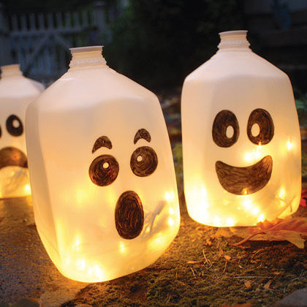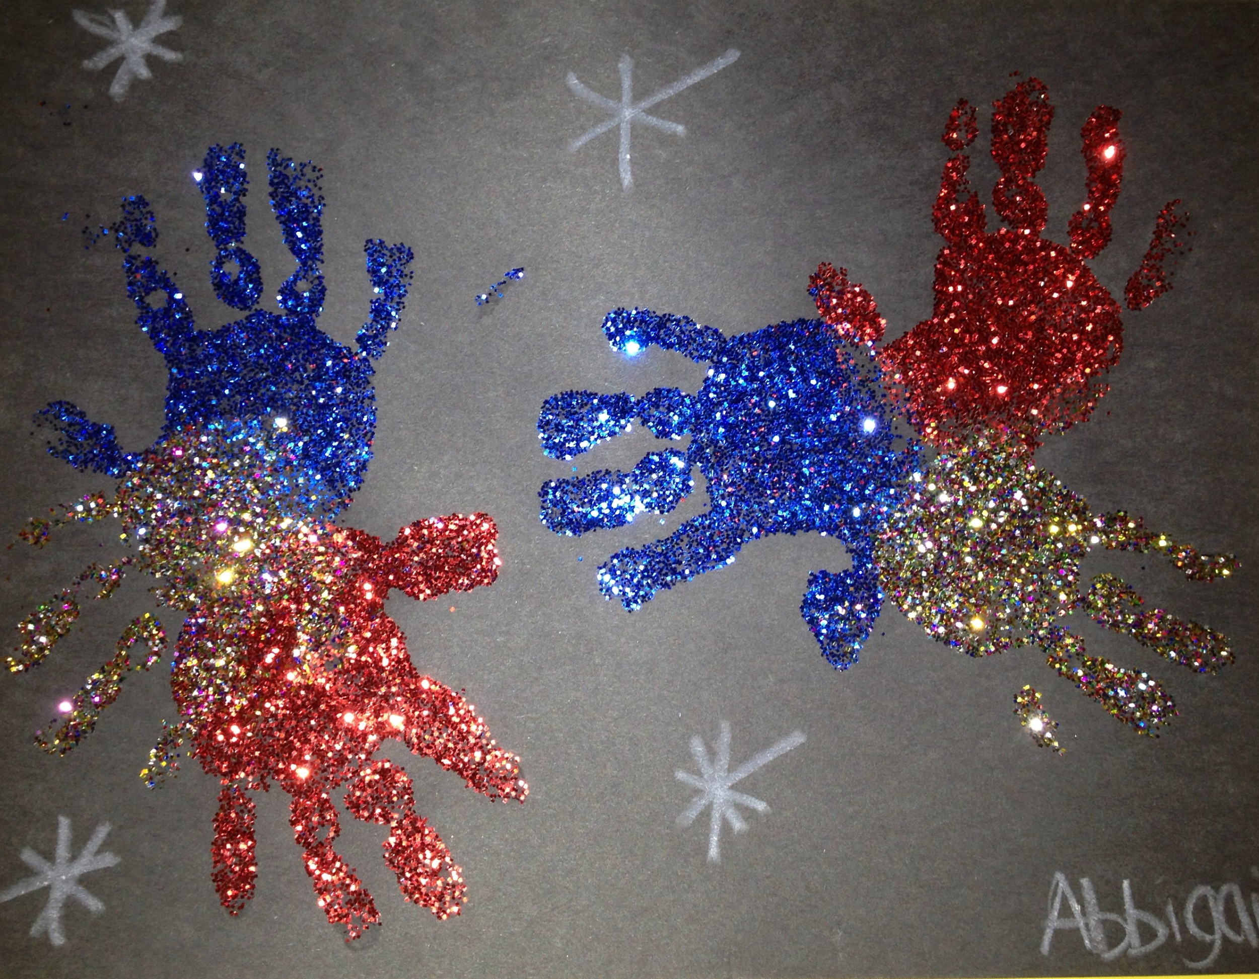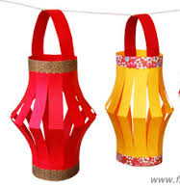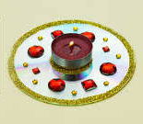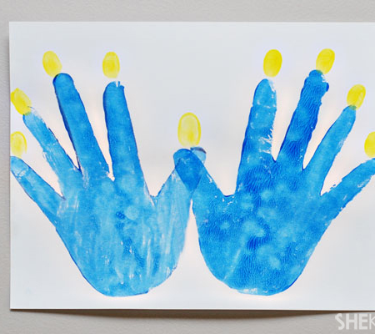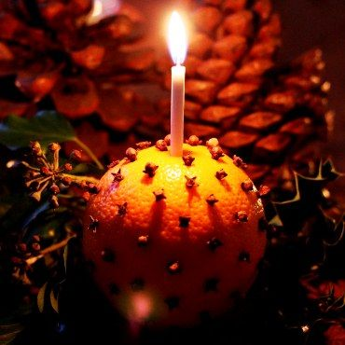 | Maths  Week 1- Number  Week 2- Geometry  Week 3- Measure  Week 4- Number  Week 5- Geometry  Week 6- Measure  Week 7- Number | English  This half term our school focus is Traditional Tales. Year 4’s chosen tale is ‘Goldilocks and the Three Bears’.  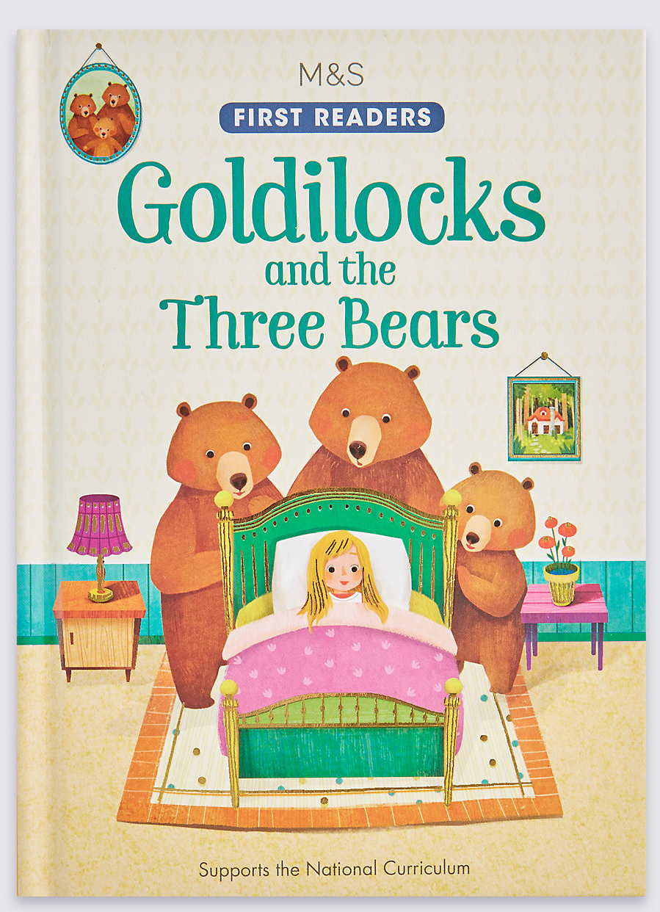 | Phonics/ Reading  We will continue to teach phonics in our differentiated groups within the year group. Pupils will be learning the sounds of letters and how to blend sounds to read words.  In reading the pupils will be reading 1:1 with an adult and sharing a book from a library. We will visit the library to change our books once a week. We will also be looking at non-fiction texts linked to our topic and about some books about bears! | Cookery  Year 4’s cookery focus this half term is eggs. We will be making poached eggs, scrambled eggs, fried eggs, boiled eggs, omelettes and egg sandwiches.  Alongside this we will be making some chocolate firework treats, decorating biscuits into spiders webs, traditional Barfi sweets and some Christmas treats too.  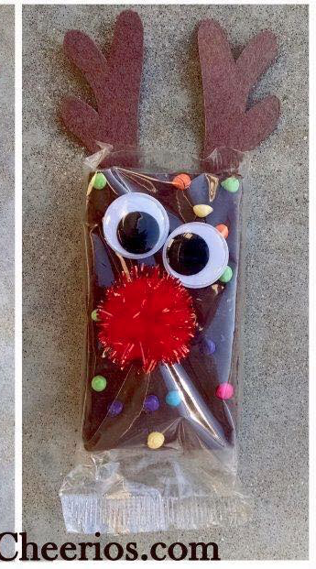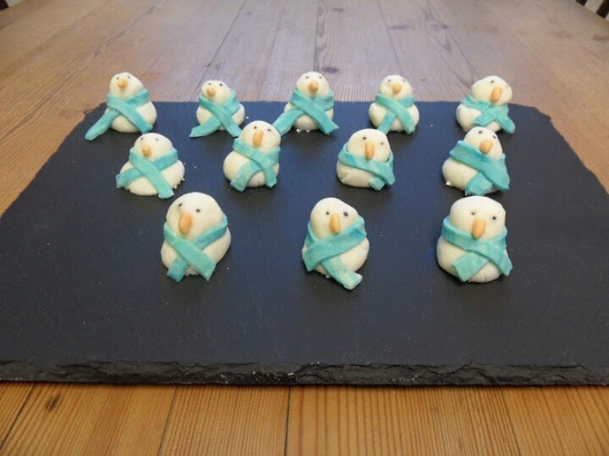
Computing  This half term our ICT unit is Story Making. The pupils will use a range of storytelling packages to produce a sequence of events from a story or journey, adding simple narration in the form of; words, sounds or symbols to tell a simple story of events. | Expressive Arts  For the first two weeks we will be working with two classes from East site on a whole school project.  Following this,  Week 3- Country music  Week 4- Line Dancing  Week 5- Drama- Improvisation  Week 6 & 7- Role play- Shops. | Purple Class  Let There Be Light  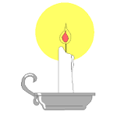  Autumn 2 Overview | Speech & Language  We will continue with our weekly focus on speaking and listening with fun tongue and mouth warm ups. We will be focussing on role play and taking on different characters from our story Goldilocks. Also learning to say new rhymes in front of our peers. | PE  This half term in PE the pupils will be focussing on dance & gym.  We will continue to take part in some morning exercise- focusing on trampet work, yoga and keep fit exercises.  Have a look at some of our yoga and dance videos here. https://richmond-hill-school.primarysite.media/
Things to do at home...  - Take your child to a local shop during weeks 6&7 linking to this half terms expressive arts role play area.  - Writing and sounding out the letters of the alphabet.  - Use the 3 Bears programs on purplemash  - Sort bowls, plates and cups by size.  - Do some yoga at home with your child using the videos on our video resource page on the school website. | Science  Our science work will link in with our topic learning about physical properties with a focus on light. | Trips  This half term we will go to visit East site to build our art project with our buddy classes at East.  We will also go on a trip to town to buy a Christmas present for our year band secret Santa and then to end the term we will go on a lovely trip to visit Santa. | Important dates  Friday 3rd Nov.-Pumpkin Party  Friday 17th Nov-Training day  Tuesday 12th Dec- Christmas performance PM.  Wednesday 13th Dec- Panto  Monday 18th Dec- Christmas trip  Wednesday 20th Dec- End of term. | PSHE  Wk 1 - Kind Hands  Wk 2 - Kind Feet  Wk 3 - Friends  Wk 4 - Playing together  Wk 5 - Playing together  Wk 6 - Playing together  Wk 7 - Playing together  The last few weeks focus on learning play skills as next term we are joining up to ‘play’ with an older class in the school

