This is Silver Classes curriculum overview for the Autumn 2 term. This overview gives you a brief explanation of what the pupils will be doing in school. It also gives you suggestions of activities to support pupil’s learning at home. These are only suggestions, not compulsory activities.
Topic  Our topic this half term is ‘Mission to Mars’ which has a science focus. Each week we will be learning about different aspects connected to this.  Week 1- Halloween  Week 2- The Night Sky (including Bonfire Night)  Week 3- Space Travel  Week 4- What can you see in space?  Week 5- Objects that use electricity  Week 6- Electrical Circuits  Week 7- Christmas | Maths  We will be spending:  · 2 weeks on measure (time)  · 2 weeks on geometry (exploring 2D and 3D shapes and pattern)  · 2 weeks on number  Every day Amelia leads the ‘snack shop’ whereby, the children have to choose what they want from the menu and find the correct money in their pots to pay for it. | English  This half term our school focus is Traditional Tales. Year 5/6’s chosen tale is ‘Jack & the Beanstalk.’  We will be focusing on, retelling the story (verbally and in writing) for understanding, character description to encourage the use of objectives, letter writing (saying sorry) and inventing our own class version of Jack and the Beanstalk. | Phonics/ Reading  We will be teaching phonics in our differentiated groups within the year band. Pupils will be learning the sounds of letters and how to blend sounds to read words. | Cookery  Year 5/6’s cookery focus this half term is curries. We will be making vegetable biriyani, egg curry, potato curry and curry side dishes.  Alongside this we will be making some gingerbread and Christmas cookies.  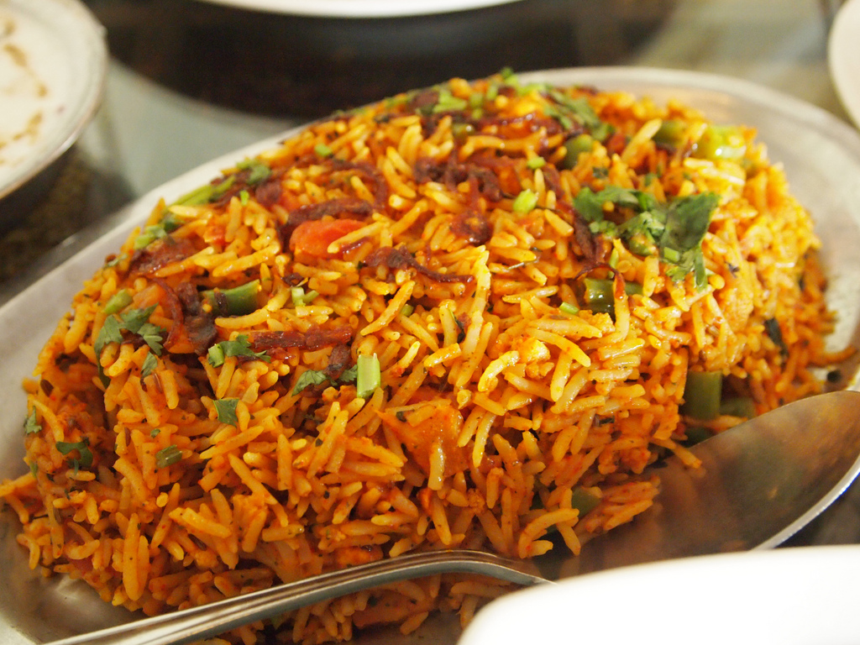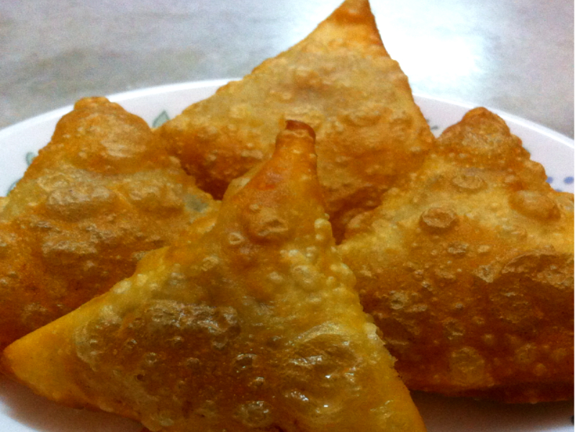
Computing  This half term our ICT unit is Story Making. The pupils will use Powerpoint to produce a sequence of slides showing key images from Jack & the Beanstalk. They will add in simple narration in the form of; words, sounds or symbols to tell the story. | Expressive Arts  For the first two weeks we will be working with two classes from East site on a whole school project.  Following this,  Week 3- Country music  Week 4- Line Dancing  Week 5- Drama- Improvisation  Week 6 & 7- Choice of favourite activity from weeks 3-5. | Silver Class  Mission to Mars    Autumn 2 Overview | Communication  We will be doing some drama activities acting out Jack and the Beanstalk.  In Circle Time the children are encouraged to speak about how they are feeling, what they like etc and to ask and answer questions.  Snack time is also a very sociable time when children interact with each other and the adult leading the activity. | PE  This half term in PE the pupils will be focussing on dance & gym.
Home activity ideas...  · talk about the things you do at different times of the day.  · Discuss o’clock times  · Read Jack and the Beanstalk  · Talk about different objects that use electricity.  · Cook curry.  · Discuss the meaning of Christmas. | Science  Our science work will link in with our topic learning about physical properties with a focus on light.  Week 1 & 2- Sources of light  Week 3 & 4 - Awareness of the sun, moon & shadows  Week 5- Objects that use electricity  Week 6- Making simple electrical circuits | Trips  This half term we will go to visit East site to build our art project with our buddy classes at East. | Important dates  Friday 17th Nov-Training day  Wednesday 13th Dec- Panto  Wednesday 20th Dec- End of term. | PSHE  Pupils will continue to work on their personalised learning program targets each week.  We will have a focus on ‘stranger danger’, accepting people who are different to us, stealing and being safe using electricity.

