Please find below the Key stage one curriculum overview for Autumn 2 term. The overview gives you a brief explanation of what the pupils will be doing in school. It also gives you suggestions for activities to support pupil’s learning at home. These are only suggestions, not compulsory activities.
English  This half term the theme for English is traditional tales. The chosen traditional tale for this half term is The Gingerbread Man.   At home:  Make gingerbread man cookies.  Visit a bakery to purchase a gingerbread man,  Watch a version of the story:  https://www.youtube.com/watch?v=slidHnMR1yE |  | Art  Pupils will be developing their fine motor skills through a range of light and dark activities.  At home:  Make pictures using black and white paper.  Make fireworks pictures  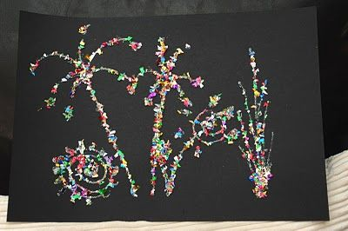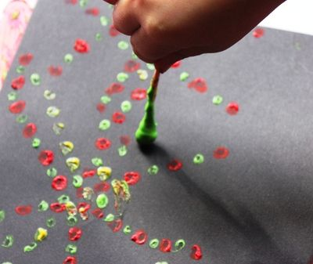  Draw night and day pictures  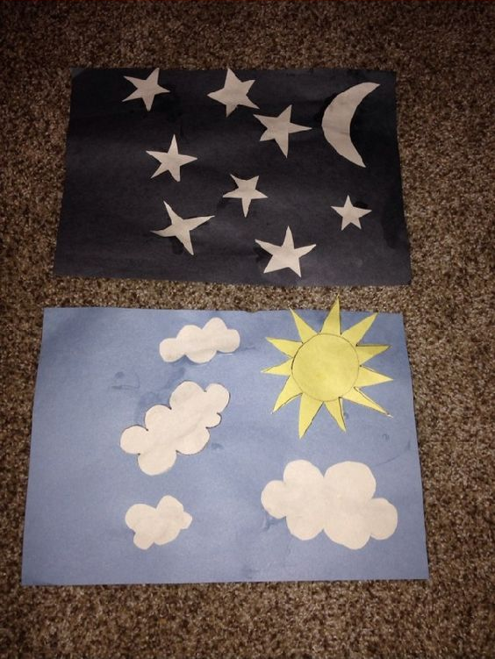 | Science  The topic this half term is science based. Pupils will be learning about light and dark, day and night and simple circuits.  At home:  Experience light and dark rooms.  Use torches in a dark room  Make a den and light it up with torches or glow sticks.  Go outside when it is dark, try and look for the moon.  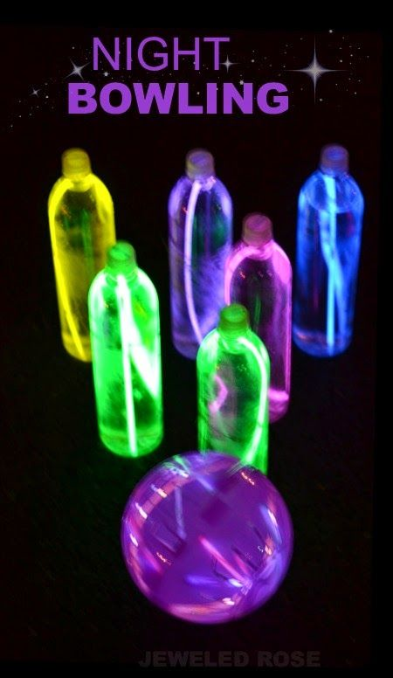 Glow stick skittles. | Maths  Maths is split into 3 strands: Number, Geometry and Measurement. Each week learning will focus on a different strand.  At home:  Baking: make Christmas cookies.  Make firework playdough, match and sort colours  Write numbers with the beam of a torch in a dark room.  Die rice to make a fireworks sensory tray for filling and emptying.  https://littlebinsforlittlehands.com/dye-rice-sensory-play-colored-rice/  Make shadows with geometrical shapes, talk about their properties, match the objects with the shape.
PE
In Pe this half term pupils will be developing their coordination and balance through basic gymnastic skills.
ICT  This half term pupils will learn how ICT can be used for a variety of purposes and in the end publish their own story.  At home:  Look at online Gingerbread man games  https://www.topmarks.co.uk/learning-to-count/gingerbread-man-game  http://www.abcya.com/kids_make_a_gingerbread_house.htm  Design your own Gingerbread man on drawing programmes. |  | Topic  Whizz bang is a physical science based topic. The topic curriculum is split into weekly themes:  Week 1: Diwali  Week 2: Fireworks  Week 3:Night and day  Week 4: Shadows and light  Week 5: Light and circuits  Week 6:Light and circuits  Week 7: Christmas  At home:  Visit a fireworks display  Make fireworks biscuits  Make shadow puppets with a torch.  Talk about electricity safety | Cooking  During cooking this half term we will be making a range of pastry based sweet and savory dishes.  Towards the end of the half term we will be making Christmas based snacks.  At home:  Practice the skills of mixing, spreading, grating and chopping.  Make simple pastry based sweet or savory dishes.  Expressive arts.  This half term pupils will take part in activities related to Country music. Pupils will also be working with a class on our West site to produce a join art piece for our side by side projects.
PSHE
PSHE is a curriculum area of learning that is embedded in all that we do.

Activities that you can support at home include:
Getting dressed and undressed independently.

Washing hands and body independently.

Making a simple snack/drink independently.

Cleaning teeth.

