This is Pearl Class’s curriculum overview for the Autumn 2 term. This overview gives you a brief explanation of what the pupils will be doing in school. It also gives you suggestions of activities to support pupil’s learning at home. These are only suggestions, not compulsory activities.
Topic  Our topic this half term is ‘Mission to Mars’ which has a science focus. Each week we will be learning about different aspects connected to this.  Week 1- Halloween  Week 2- The Night Sky (including Bonfire Night)  Week 3- Space Travel  Week 4- What can you see in space?  Week 5- Objects that use electricity  Week 6- Electrical Circuits  Week 7- Christmas | Maths  In maths we will continue with the weekly rotation of the following areas: number, geometry (shape), geometry (position and direction) and measure.  ‘Sam’s Snack Shop’ will be open every snack time and this half term the children will take turns to be the shopkeeper – really challenging and developing their money counting skills! | English  This half term our school focus is Traditional Tales. Year 5/6’s chosen tale is ‘Jack & the Beanstalk. We will continue with the weekly rotation of: writing, reading, speaking & listening.  We will be doing lots of descriptive writing about the characters and settings. For this we will develop our vocabulary and try to use and spell different (and new) adjectives. We will also read and write letters, diary entries and instructions to and from the characters. | Phonics/ Reading  We will be teaching phonics in our differentiated groups within the year band. Pupils will be learning the sounds of letters and how to blend sounds to read words.  The children will apply their knowledge of phonics throughout the day for all reading and writing.  The children in Pearl class will continue the ‘phonics sound splat’ game on a weekly basis which they all love. | Cookery  Year 5/6’s cookery focus this half term is curries. We will be making vegetable biriyani, egg curry, potato curry and curry side dishes.  Alongside this we will be making some gingerbread and Christmas cookies.  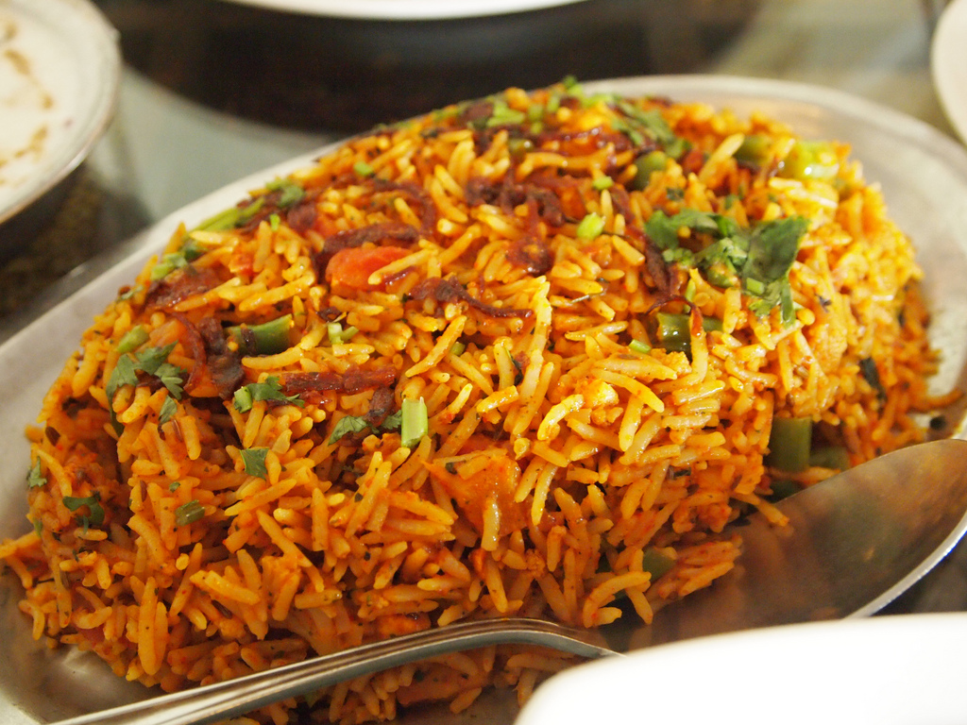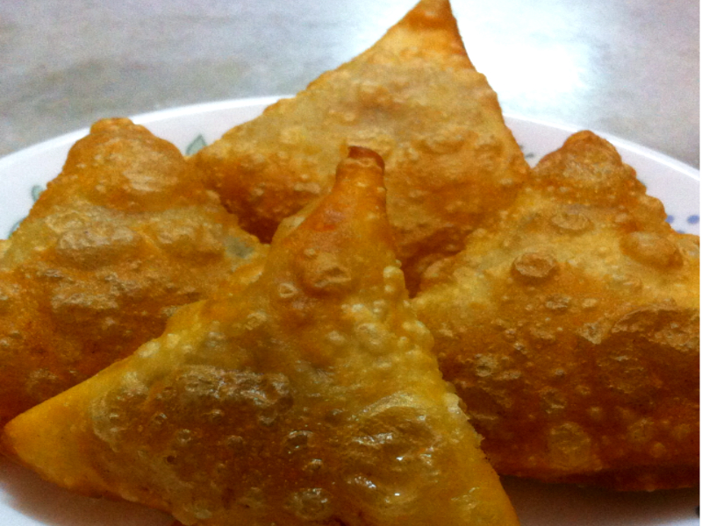
Computing  This half term our ICT unit is Story Making. The pupils will use Powerpoint to produce a sequence of slides showing key images from Jack & the Beanstalk. They will add in simple narration in the form of; words, sounds or symbols to tell the story.  The children will become more independent in being able to open, save and retrieve their work each week. | Expressive Arts  For the first two weeks we will be working with our buddy class from East site (Owl class) on a whole school project. We are making a giant ‘Pearl / clam shell’ which Owl class will fill with the pearls that they will make.  Following this,  Week 3- Country music  Week 4- Line Dancing  Week 5- Drama- Improvisation  Week 6 & 7- Choice of favourite activity from weeks 3-5. | Pearl Class  Mission to Mars    Autumn 2 Overview | Communication  We will continue with our speaking and listening lessons every Wednesday when the children make ‘real life’ phone calls using real telephones to different people / places e.g. making a doctor’s appointment, ordering a meal!  The children will practice saying their personal details e.g. full name and address. We also choose a ‘question’ master each day who wears a special hat and has the role of asking questions throughout the day to initiate conversation. | PE  This half term in PE Pearl class will be focussing on dance & gym.  Pearl class will continue with their swimming lessons every Tuesday and will also be continuing to run laps around the track in the mornings for some extra fitness.
Home activity ideas...  Chocolate or toffee apple making.  Practice identifying which TV programs / DVD’s / games are age appropriate when in the supermarket / shops / at home.  Christmas gifts / cards.  Practice role playing the characters from Jack and the Beanstalk. | Science  Our science work will link in with our topic learning about physical properties with a focus on light.  Week 1 & 2- Sources of light  Week 3 & 4 - Awareness of the sun, moon & shadows  Week 5- Objects that use electricity  Week 6- Making simple electrical circuits | Trips  This half term we will go to visit East site to build our art project with our buddy classes at East.  On Thursday 14th December, Pearl class (and other year 6 pupils) have been invited to Woodland’s School to watch their Christmas performance. | Important dates  Friday 17th Nov-Training day  Wednesday 13th Dec- Panto  Thursday 14th Dec - Woodland’s performance (for yr6 children)  Wednesday 20th Dec- End of term. | PSHE  Pupils will continue to work on their personalised learning program targets each week.  There will be a strong focus on learning about age appropriate toys / games / DVD’s / TV programs and learning which ‘age certificates’ are safe for year 6 children.

