This is Red Classes curriculum overview for the Autumn 2 term. This overview gives you a brief explanation of what the pupils will be doing in school. It also gives you suggestions of activities to support pupil’s learning at home. These are only suggestions, not compulsory activities.
Topic  Our topic this half term is ‘Let There Be Light’ which has a RE focus. Each week we will be learning about a festival of lights.  Week 1- Halloween  Week 2- Bonfire Night  Week 3- Diwali  Week 4- Chinese New Year  Week 5- Hanukkah  Week 6- Christingle  Week 7- Christmas  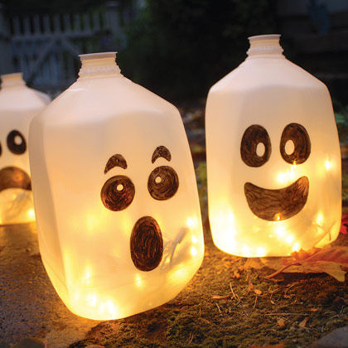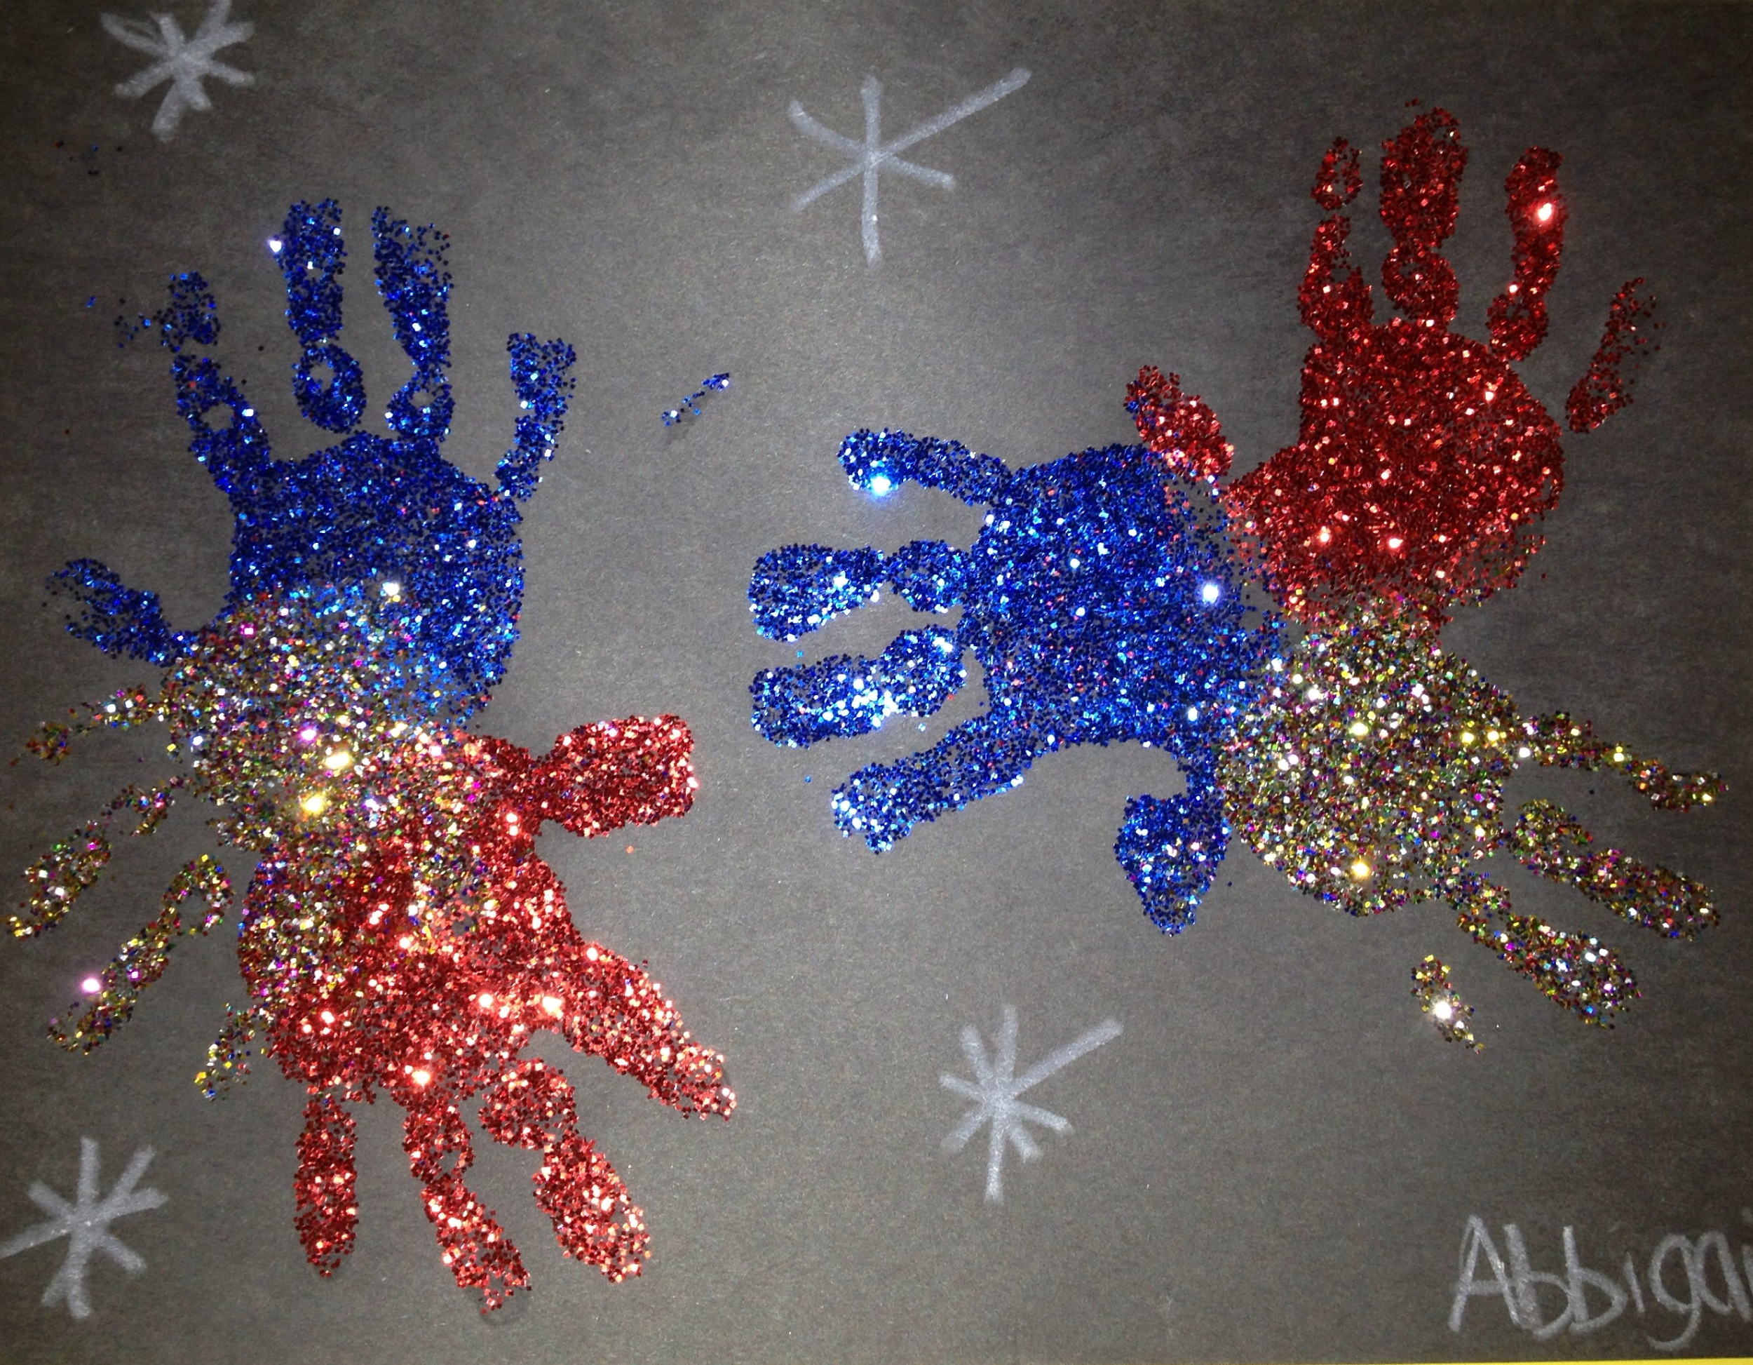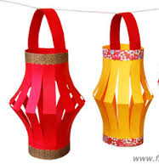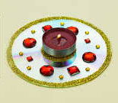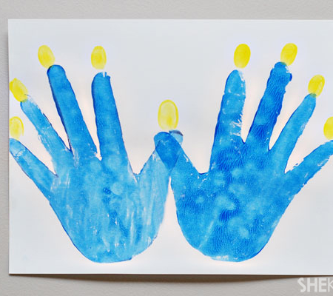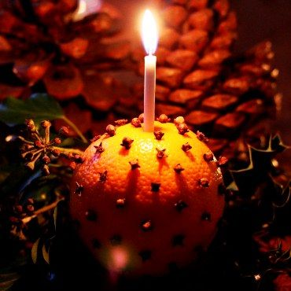 | Maths  Week 1- Weight  Week 2- Weight  Week 3- Length  Week 4- Length  Week 5- Capacity  Week 6- Time    Week 7- Temperature | English  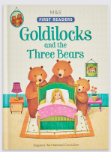  This half term our school focus is Traditional Tales. Year 4’s chosen tale is ‘Goldilocks and the Three Bears’. We will be focusing on this for four weeks before moving on to Christmas stories and poems for the last three weeks.  Week 1- Reading  Week 2- Reading  Week 3- Writing  Week 4- Writing  Week 5- Writing  Week 6- Speaking  Week 7- Listening | Phonics/ Reading  We will continue to teach phonics in our differentiated groups within the year group. Pupils will be learning the sounds of letters and how to blend sounds to read words.  In reading the pupils will be reading 1:1 with an adult and changing their book on Thursdays. We will visit the library once a week to look at different books and then share a book together. We will also be looking at non-fiction texts linked to our topic and about some books about bears! | Cookery  Year 4’s cookery focus this half term is eggs. We will be making poached eggs, scrambled eggs, fried eggs, boiled eggs, omelettes and egg sandwiches.  Alongside this we will be making some chocolate firework treats, decorating biscuits into spiders webs, traditional Barfi sweets and some Christmas treats too.  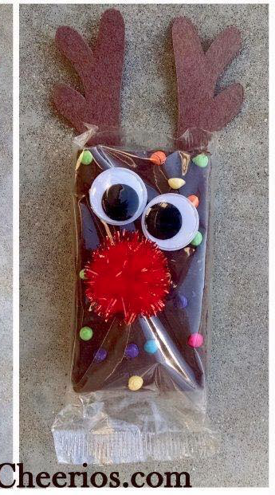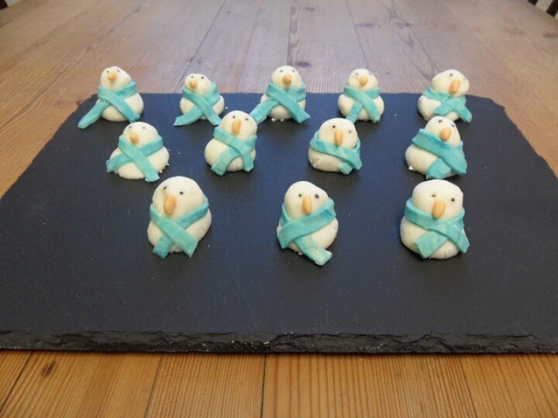
Computing  This half term our ICT unit is Story Making. The pupils will use a range of storytelling packages to produce a sequence of events from a story or journey, adding simple narration in the form of; words, sounds or symbols to tell a simple story of events. | Expressive Arts  For the first two weeks we will be working with Penguin class from East site on a whole school project.  Following this:  Week 3- Country music  Week 4- Line Dancing  Week 5- Drama- Improvisation  Week 6 & 7- Role play- Shops. | Red Class  Let There Be Light  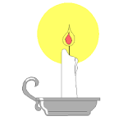  Autumn 2 Overview | Swimming  We are still swimming on Tuesday mornings this half term. | PE  This half term in PE the pupils will be focusing on dance and gymnastics.  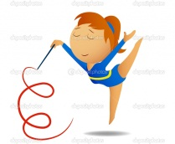  The children will continue to do sensory circuits every morning also.
Things to do at home...  - Take your child to a local shop during weeks 6&7 linking to this half terms expressive arts role play area.  - Writing and sounding out the letters of the alphabet.  - Use the 3 Bears programs on Purplemash  - Sort bowls, plates and cups by size.  - Discussing big, small, short, long and comparing lengths of toys ay home  - festival related arts and crafts | Science  Our science work will link in with our topic learning about physical properties with a focus on light.  Week 1 & 2- Shadows  Week 3- Torches  Week 4- Light/ Dark  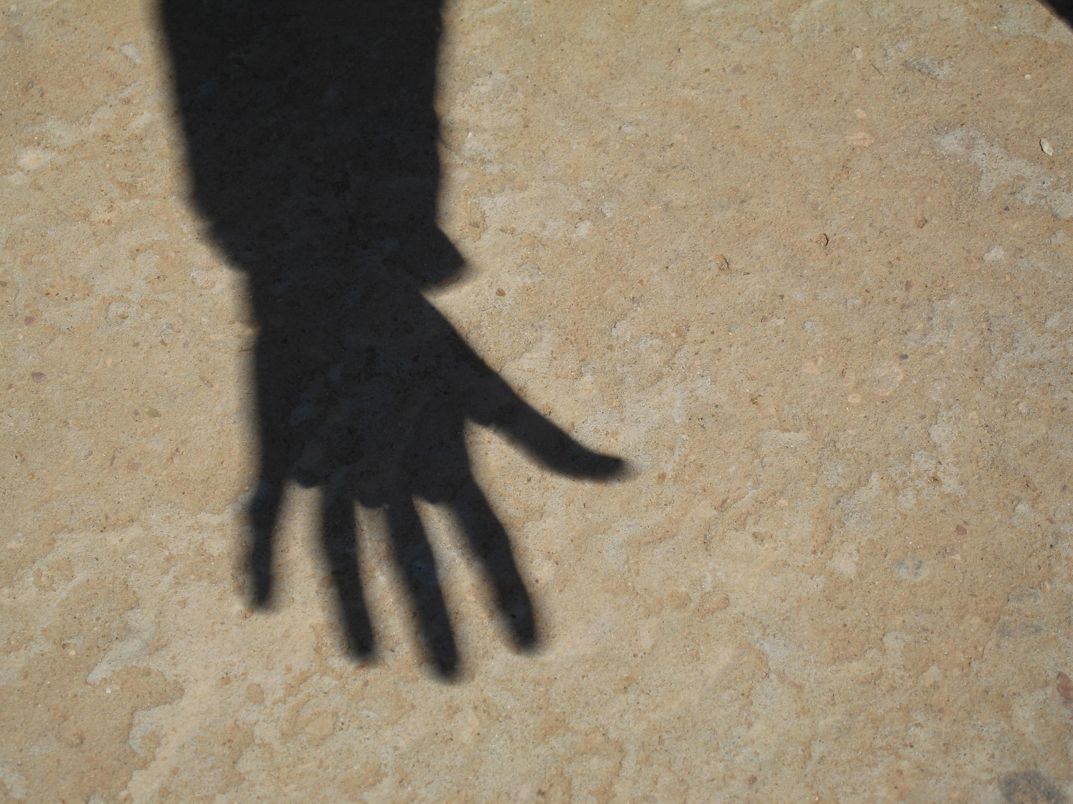  Week 5- Light sources  Week 6- Batteries  Week 7-Electricity | Trips  As always letters will go home when trips are planned.  We have the bus booked for Monday 11th December.  Other possible trips include:  Wardown park museum  Town- to see Father Christmas  Town (Poundland)- to get Christmas presents and decorations. | Important dates  Friday 3rd Nov.-Pumpkin Party  Friday 17th Nov-Training day  Monday 11th Dec- Trip  Tuesday 12th Dec- Christmas performance PM.  Wednesday 13th Dec- Panto  Tuesday 19th Dec- Christmas lunch  Wednesday 20th Dec- End of term. | Attention skills, WriteDance & Dough disco  Attention skills- teaches children to focus on an object, adult and their peers and to follow instructions.  WriteDance and dough disco are quick 5 minute activites which improve the children’s fine motor skills.

