This is Emerald Classes curriculum overview for the Autumn 2 term. This overview gives you a brief explanation of what the pupils will be doing in school. It also gives you suggestions of activities to support pupil’s learning at home. These are only suggestions, not compulsory activities.
Topic  Our topic this half term is ‘Mission to Mars’ which has a science focus. Each week we will be learning about different aspects connected to this.  Week 1- Halloween  Week 2- The Night Sky (including Bonfire Night)  Week 3- Space Travel  Week 4- What can you see in space?  Week 5- Light and electricity  Week 6- Electrical Circuits  Week 7- Christmas | Maths  We will be spending:  · 2 weeks on Measure (wide and narrow and ordering widths)  · 2 weeks on Geometry (working with 3d shapes)  · 2 weeks on number (more/less/counting on)  Each week we will be taking part in dough disco, playdough to music, where we will be working on fine motor control and learning properties of 2d shapes. | English  This half term our school focus is Traditional Tales. Year 5/6’s chosen tale is ‘Jack & the Beanstalk.’  We will be focusing on, sequencing and retelling the story (verbally and in writing) for understanding and character description.  Closer to Christmas we will be reading and exploring, ‘Stickman’ by Julia Donaldson.  We will also be doing a weekly write dance where we work on fine and gross motor control. And the reading and spelling of high frequency words. | Phonics/ Reading  We will be teaching phonics in our differentiated groups within the year band. Pupils will be learning the sounds of letters and how to blend sounds to read words.  All children read or experience a book in their 1:1 workbox sessions. | Cookery  Year 5/6’s cookery focus this half term is curries. We will be making vegetable biriyani, egg curry, potato curry and curry side dishes.  Alongside this we will be making some gingerbread and Christmas cookies.  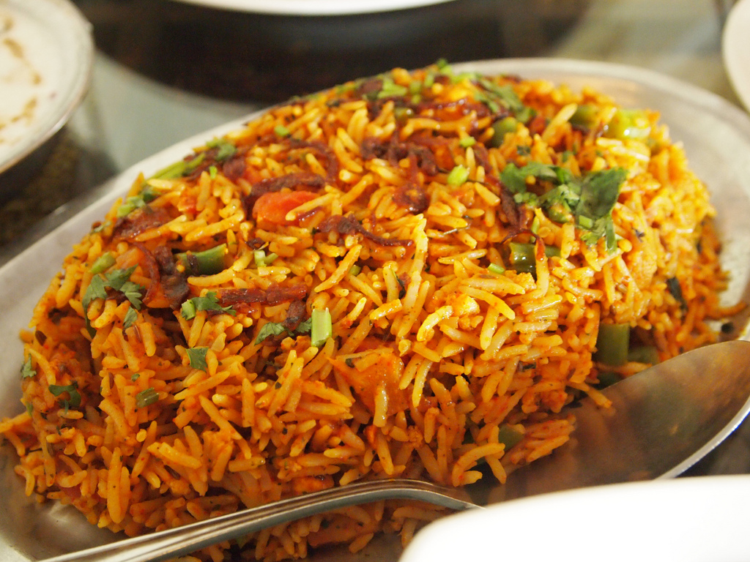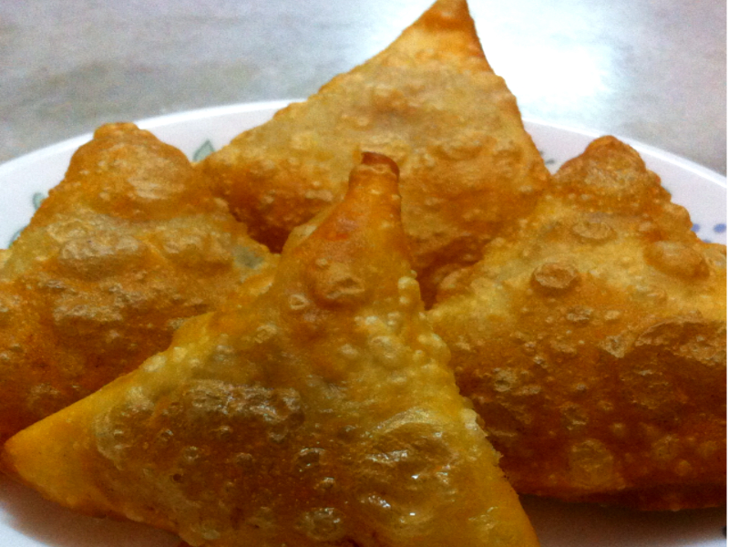
Expressive Arts  For the first two weeks we will be working with two classes from East site on a whole school project.  Following this,  Week 3- Country music  Week 4- Line Dancing  Week 5- Drama- Improvisation  Week 6 & 7- Choice of favourite activity from weeks 3-5. | Science  Our science work will link in with our topic learning about physical properties with a focus on light and electricity.  Week 1- Batteries as power  Week 2- Light sources  Week 3 - Shadows and silhouettes  Week 4 - Mains or battery  Week 5 and 6- Circuits  Week 7- DT science project | Emerald Class  Mission to Mars    Autumn 2 Overview | Communication  Emerald Class have a big focus on listening. We are encouraging listening to both adults and friends and retelling what they have said. You will find us practising this throughout the day.  We will be doing some drama activities acting out Jack and the Beanstalk and preparing for our Christmas production.  As always, We will be continuing with speaking and listening and singing groups linked into our topic. | PSHE  Pupils will continue to work on their personalised learning program targets each week.  We will have a focus on road safety during PSHE lessons and learn the Green Cross Code. We will be out walking locally and learning how to be safe around roads.  We will also cover some electrical safety linked into science.
Home activity ideas...  · Find 3d shapes, name them and count edges and faces.  · Read Jack and the Beanstalk/Stickman or watch videos of it.  · Talk about different objects that use electricity.  · Cook a curry.  · Remind about road safety when out and about. | Computing  This half term our ICT unit is Story Making. The pupils will use Powerpoint to produce a sequence of slides showing key images from Jack & the Beanstalk. They will add in simple narration in the form of; words, sounds or symbols to tell the story. | Trips  This half term we will be doing a Christmas themed trip in December. Watch this space... | Important dates  17th November -Training day  7th December- Provisional trip date.  13th December- Panto  20th December- End of term. | PE  This half term in PE the pupils will be focussing on dance & gym. We also regularly take part in guided dance in class as a form of brain gym where we wake up our mind and bodies!

