Topic  This Half Term our Topic is `What Lights up the Sky in Winter?`. During this topic the pupils will be learning about sources of light and different types of light associated with cultural or religious celebrations  such as Diwali,  Bonfire night,    Christmas.   | English  Our story English story this half term is a Traditional Tale; ‘Cinderella’. The pupils will compare and describe characters at different parts of the tale. They will also become authors and will re-write their own parts of the tale.  Amber class will continue to have their focussed writing lesson every  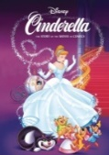  Monday to  write their  weekend news.  Youtube link  to the music story video is:  https://www.youtube.com/watch?v=8z0k8ZO19K4 | Phonics/ Reading  The pupils will be developing their phonics skills in our 3 phonics lessons per week.  Amber class will be developing their knowledge from digraphs to split digraphs (a-e, e-e, i-e, o-e, u-e). They will also have specific spelling lessons to teach them ‘spelling tricks’ for common exception words  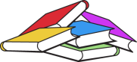  like; should,  could, because.  Remember…keep reading at home…it doesn’t need to be a book your child reads! It can be a food menu, the signs in the supermarket, the instructions of food tins, road signs…anything! | Maths    This half term the pupils will be continuing to developing their knowledge of number, shape and measure. They will be exploring activities that build their confidence and self-belief.  They will be applying their real life mathematics skills when using real money in our daily snack shop. This will start to include the use of money notes.   | Cookery  This half term the pupils will be exploring and learning how to use electrical appliances in the kitchen such as kettles, microwaves and ovens.  The aim of this is to build their confidence and ability to use cooking equipment independently and safely.  Week 1- Hot drinks  Week 2- Instant pastas  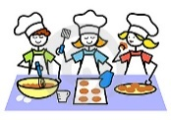  Week 3- Popcorn  Week 4- Biscuits  Week 5- Cookies  Week 6- Vegetation Pizzas  Week 7 & 8 - Christmas Cooking
Computing  In Computing, the pupils will be consolidating and developing their knowledge of how to use technology to rewrite their own version of the Traditional Tale ‘Cinderella’.  They will develop their skills to add illustrations and correctly use punctuation when typing on a QWERTY keyboard. | Expressive Arts  This Half Term in Expressive Arts the pupils will be exploring Cultures.  The pupils will be learning about our RHS family, celebrating and experiencing the many creative/artistic and cultural rituals, events and customs from across our Diverse Community.  Interventions  The pupils will be taking part in specific and tailored interventions for their personal development.  These will include cognition and learning interventions, communication and interaction interventions and social and emotional interventions.  Home Learning Activities | Amber Class  Leaves Pathway.  What Lights up the Sky in Winter?  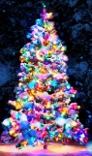  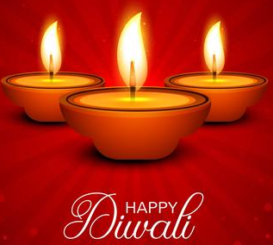  Autumn 2 Overview | Home Learning Activities  Pupils to use money at home to buy `snacks` in your house.  Practice using the kettle and microwave at home to make delicious drinks and food.  Go for a walk during the evening and explore what lights you can see. Are they man made or natural?  Watch our English story Cinderella and act it out at home. | PE  Each week the children  will have a specific PE slot  taught by John. They will also take part in  power walks to build up  their stamina. This half  term the pupils will be focusing on target practise and exploring sports such as archery.  Amber class will also take part in  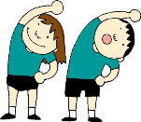  Regular power walks and up to 10 ‘exercise bursts’  in class each day  (e.g. one minute of  intense star jumps).

