Topic  Our topic this half term is: ‘Whizz Bang’. The topic curriculum is split into weekly themes:  Week 1 – Bonfire night  Week 2 – Diwali  Week 3 – Light  Week 4 - Dark  Week 5 - Hanukah  Week 6 – Christmas  Week 7 – Christmas   | Maths  Maths sessions will be focused on the three main areas of the maths curriculum: Number, Measure, using and applying statistics. Sessions will include activities from these areas.  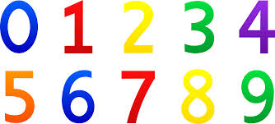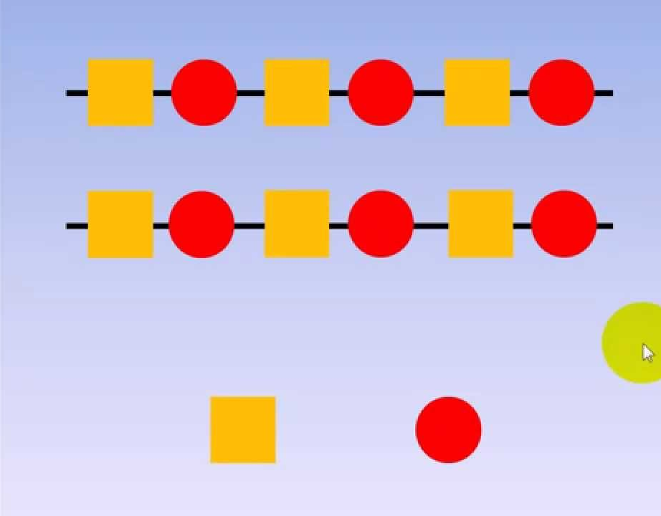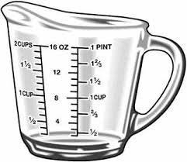 | English  This term we are focusing on The Three Little Pigs. The pupils will be encouraged to participate in reading the story and joining in with actions and sounds. We will complete art-based activities, mark making and writing, reading and communication as well as following the sensory story.  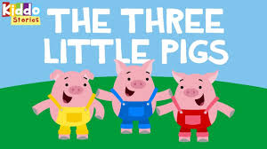  There are YouTube versions of the stories for you to watch at home. | Phonics / Reading  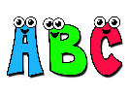  The pupils will have 2x weekly phonic sessions where we will focus on environmental and letter sounds. As well as focusing on mark making and writing with a variety of writing tools. | Cookery  The cookery focus this half term is types of bread. The skills taught are mixing, stirring and kneading.  Each week we will make a different flavour of bread:  Week 1: Plain bread  Week 2: Garlic bread  Week 3: Raisin bread  Week 4: Chocolate bread  Week 5: Banana bread  Week 6: Cinnamon and apple bread  Week 7: Cheese bread
Speaking and listening groups
The pupils will have 3x weekly sessions where we focus on developing the children language and communication skills. We focus the sessions on recognising and understanding symbols/words, attending to sessions and developing an understanding of nouns.
Computing  Our skills focus in computing this half term is story making. We will be using a variety of different PowerPoints to explore how we can make scenes from The Three Little Pigs on the computer screen using both the touch screen and/or the mouse.   | Expressive Arts  Every week, the pupils participate in an expressive arts lesson with Coral. This term the focus of the sessions is ‘reconnecting through culture’. During this session the pupils will be moving their bodies to music and following instructions. | Whizz Bang   | Interventions  The pupils will take part in daily interventions including identiplay, PECs, intensive interaction, story massage. MacPac. and shoe box tasks. These interventions are to help develop the pupils play skills, communication and attention in small group, focused sessions. | PE  All classes have 1x weekly PE slots, led by Owen. In PE this half term pupils will be developing their coordination through a warmup, dance and a cool down. There will also be strong focus on independence skills while getting changed into and out of our P.E kits.
 |  | At home  If you want to continue your pupils learning at home you could focus activities on our topic ‘Whizz Bang’ Activities could include looking at shadows, experiencing dark and light, experiencing day and night and making dens to play inside of. |  | Trips  Unfortunately, due to the current situation we are unable to go on trips at the moment. However, we will be going for power walks in the local environment to learn about road safety, keeping safe when out in public and to explore the world around us.

