Topic  Our topic this half term is: ‘Creepy Crawlies’ The topic curriculum is split into weekly themes:  Week 1 – Bug safari  Week 2 – 6 legged creatures  Week 3 – 8 legged creatures  Week 4 – Caterpillars to butterflies  Week 5 - Tadpoles to frogs  Week 6 – Slugs, snails and slimy things  Week 7- Creatures that fly  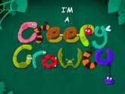 | Maths  Maths sessions will be focused on the three main areas of the maths curriculum; Number, Measure, using and applying statistics. Sessions will include activities from these areas.  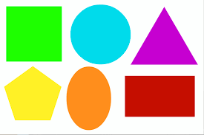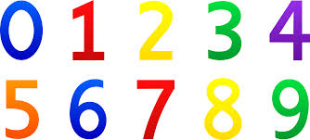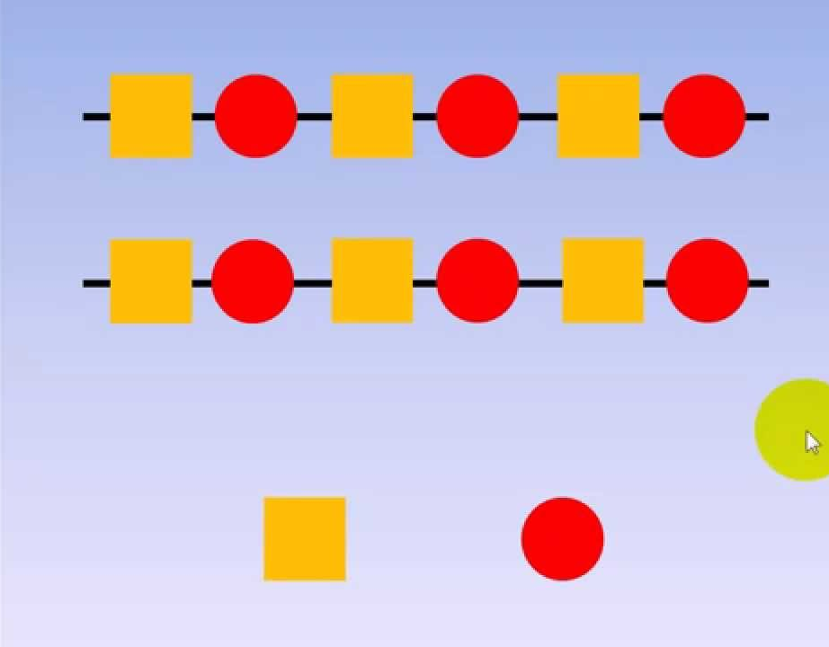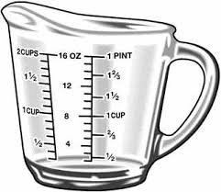 | English  This term we are focusing on well-known authors.  Week 1 – Don’t Put Your Finger in the Jelly, Nelly!  Week 2 – Don’t Put Your Finger in the Jelly, Nelly  Week 3 – The Very Busy Spider  Week 4 – The Very Busy Spider  Week 5 - AAAARRRRRGGGG Spider  Week 6 – AAAARRRRRGGGG Spider  Week 7 - AAAARRRRRGGGG Spider  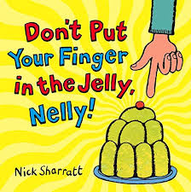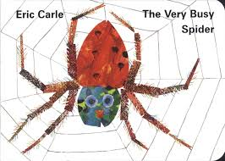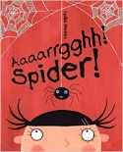 | Phonics / Reading  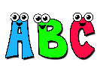  The pupils will have 2x weekly phonic sessions where we will focus on environmental and letter sounds. As well as focusing on mark making and writing with a variety of writing tools. | Cookery  The cookery focus this half term is types of pastry tarts. The skills taught are mixing, stirring, and spreading.  Each week we will make a different flavour filling.  Week 1: Jam  Week 2: Cornflakes  Week 3: Chocolate toothpaste  Week 4: Apple  Week 5: Lemon  Week 6: Custard  Week 7: Remaking the one we enjoyed the most!  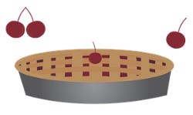
Speaking and listening groups
The pupils will have 3x weekly sessions where we focus on developing the children language and communication skills. We focus the sessions on recognising and understanding symbols/words, attending to sessions and developing an understanding of nouns.
Computing  Our skills focus in computing this half term is animation and design. We will be using a variety of different programmes to explore making our own animations using both the touch screen and/or the mouse.   | Expressive Arts  Every week, the pupils participate in an expressive arts lesson with Coral. This term the focus of the sessions is Ramadan. During these sessions the pupils will be exploring the culture through different medias.   | Creep Crawlies  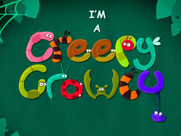 | Interventions  The pupils will take part in daily interventions including identiplay, PECs, intensive interaction, story massage. MacPac and shoe box tasks. These interventions are to help develop the pupils play skills, communication and attention in small group, focused sessions. | PE  All classes have 1x weekly PE slots, led by Owen. In PE this half term pupils will be developing their coordination through a warm up, tennis and a cool down. There will also be strong focus on independence skills while getting changed into and out of our P.E kits.
 |  | At home  If you want to continue your pupils learning at home you could focus activities on our topic ‘Creepy crawlies” activities could include making bug hotels, planting, and growing for the wildlife in your area or going on a bug hunt. |  | Trips  Unfortunately due to the current situation we are unable to go on trips at the moment. However we will be going for power walks in the local environment to learn about road safety, keeping safe when out in public and to explore the world around us.

