Year 5/6
Topic  Our Thematic unit this half term is ‘The Natural World which has a Science focus. We will be looking at lifecycles of different animals. In addition we will have 2 weeks focusing on Ramadam. Ramadan is the ninth month of the Islamic calendar, observed by Muslims worldwide as a month of fasting, prayer, reflection and community.  Week 1- Ramadan  Week 2- Plants  Week 3- Animals  Week 4- Humans  Week 5- Ramadan  Week 6- Plants  Week 7- Animals | Maths  We follow a pattern with Maths, spending a week on different areas. It follows the following pattern:  Week 1- Number  Week 2- Measure  Week 3- Using and Applying  Week 4- Number  Week 5- Measure  Week 6- Using and Applying  Week 7- Number  We also bring Maths into different areas of the curriculum to make it more creative.  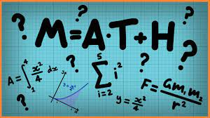’. | English  This half term our school focus is Well known authors. We are reading “Superworm” by Julia Donaldson  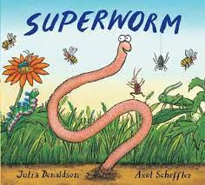  To help us with this story we’ve got a mini wormery in class we will be looking at. We will be learning about rhyming words as well as designing our own Superheroes. | Phonics/ Reading  We will continue to teach phonics. Some children are at the pre phonics stage learning to identify and discriminate between different sounds.  The majority of children are now learning the sounds of letters and how to blend sounds to read words. They are assessed every half term to see what the next steps are.  In reading the pupils will be reading 1:1 with an adult at least once a week. | Cookery  Shoots cookery focus this half term is mug cakes.  Wk1. Classic mug cake  Wk2 Vanilla sprinkles mug cake  Wk3 Carrot mug cake  Wk4 Chocolate mug cake  Wk5 Cookies and cream mug cake  Wk6 Banana mug cake  Wk7 Favourite mug cake  .
Computing  In computing we will continue to extend our computer skills and we will use the computer to support our learning in Topic, English and Maths.  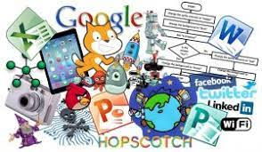 | Expressive Arts  Every week we have Expressive Arts sessions with Coral. The children learn to move and dance in different ways there is always time for some “freestyle” at the end of the lesson.   | The Natural World  Summer 1 Overview  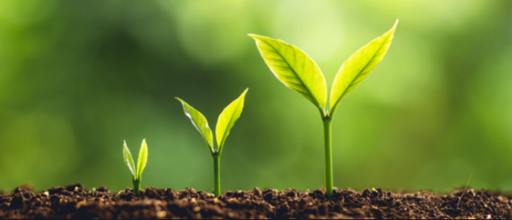  Sapphire Class | Speech & Language  We will be using a visual resource called ‘Colourful Semantics’ as a strategy to help the children verbalise simple sentences. They will look at a picture and use symbols to say 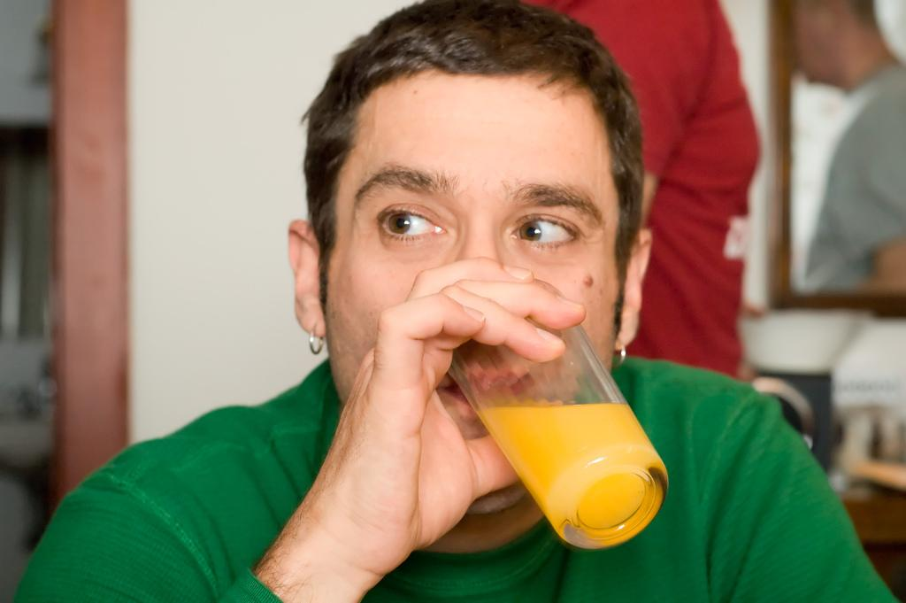The man is drinking juice. | PE  This half term in PE the pupils will be focussing on Racket tennis  In addition each class the children will continue to do power walks , wake up, shake up songs and yoga.
Home work  - Share the story of Superworm.  - Go out looking for Worms and minibeasts.  - Try making a muffin at home. | Science  Our science work will link in with our topic learning about the Natural World. Looking at life cycles from butterflies to humans.  . | Trips  Individual class teachers will inform of any updates on trips via the class email address. | Important dates  Any other dates will be emailed to you either by myself via Hummingbird class, on the RHS website, parent mail or the school admin email. | PSHE  Each class teaches bespoke PSHE in a fun and practical way. Following themes over the week or half term that include emotions, hygiene, personal safety, road safety, independence life skills

