This is Rainbow class’ curriculum overview for the Autumn 1 term. This overview gives you a brief explanation of what the pupils will be doing in school. It also gives you suggestions of activities to support pupils learning at home. These are only suggestions, not compulsory activities.
Topic  Our topic this half term is called All about me  We will be learning about  Week 1- back to school  Week 2- body parts  Week 3- likes and dislikes  Week 4- family  Week 5- senses  Week 6 – senses  Week 7 – body parts  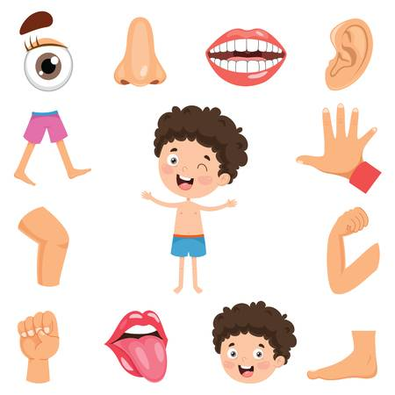 | PE  Our PE is taught by John and this half term he is focusing the children on getting back into the routine of listening to his instructions and moving and stopping when he bangs the drum.  We have PE on a Monday- please either send your child into school dressed in sports wear or ensure we have a PE kit in school for them to change into  The main activity theme will be dance this half term. | English  This half term our English focus is lovely books- We are reading a book The train ride  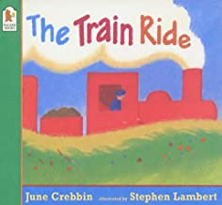  Climb aboard for a rhythmic train ride through the country. There's lots to see and someone very special waiting at the end!  A little girl and her mother board the train in town and set off on a journey through the countryside. As they travel, the girl looks out of the window, asking "What shall I see? What shall I see?" And what does she see? Sheep, cows, horses and much more. | Phonics/ Reading  We will continue to teach phonics. We will be learning a sound a week and identifying some words that begin with that sound. We will also use the sounds we know to read CVC words.  In reading the pupils will be reading 1:1 with an adult daily and every week they will visit the library to exchange 5 books that they want to share in class.  Please spend some time at home sharing books, reading to your child and listening to them reading or talking about the pictures. | Cookery  Our cookery focus this half term is sandwiches  The children will be making some delicious sandwiches with lots of different fillings  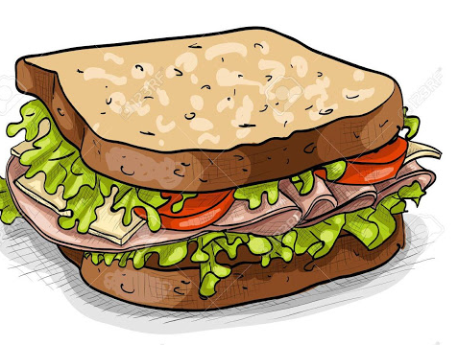  Week 2 - Jam  Week 3 - Soft cheese and cucumber  Week 4 - Chocolate spread  Week 5 - Egg & Cress  Week 6 - Tuna and sweetcorn  Week 7 - Marmite
PSHE  The children will be exploring the topic of emotions. Each week we will be looking at an emotion in detail.  Week 1 and 2 – emotions  Week 3 –green zone  Week 4 – blue zone  Week 5 – yellow zone  Week 6 – red zone  Week 7 – What makes us happy  Week 8- what makes us sad/ angry | Science  This half term in science we are going to be out explore the garden. Will we be clearing the weeds and getting our flower bed prepared to plant some winter flowers and vegetables! | 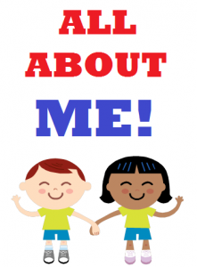  Autumn 1 Overview   | Speech & Language  We will be having speaking and listening groups which will focus on the children extending their listening skills and being able to take turns and ask each other simple questions and listen to their answers. The children will be split into two different groups. | Maths  We will be focusing on:  Week 1- back to school  Week 2 – measure  Week 3 – measure  Week 4 – number  Week 5 – number  Week 6 – geometry  Week 7 – geometry  Week 8 – number
Things to do at home...  - Look at The Train ride story online  - Talk about different body parts and what their names are  - Explore making different sandwiches  - Talk about how they are feeling and why.  - Use their preferred communication mode to develop their language skills. | Computing  In computers we will continue to extend our computer skills and we will use the computer to support our learning in Topic, English and Maths. | Trips  At the moment this half term we have not planned any trips due to Covid 19.  We will be doing a power walk around the local area several times a week. Please ensure your child has a pair of wellington boots in school. | PLPs  The children will work towards achieving their EHCP targets each day. | Expressive arts  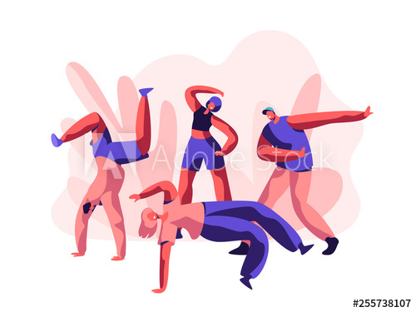  Coral teaches expressive arts and this half term the focus is on street dance.

