Topic  Our topic this half term is: ‘Leave your mark’ The topic curriculum is split into weekly themes:  Week 1 – Home and food  Week 2 – Weather  Week 3 – Textures  Week 4 – Dreams  Week 5 - Nature   | Maths  Maths sessions will be focused on the three main areas of the maths curriculum; Number, Measure, using and applying statistics. Sessions will include activities from these areas.  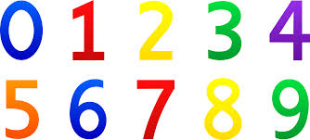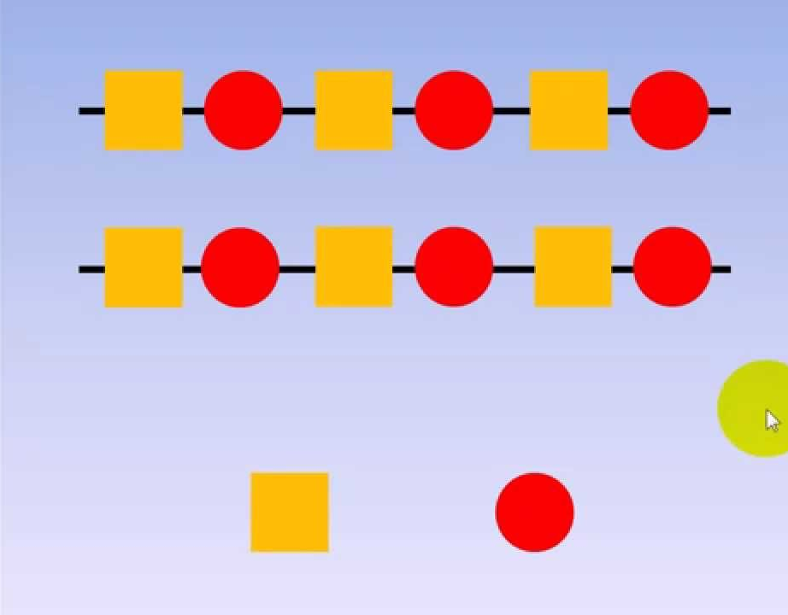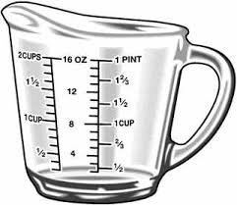 | English  This term we are focusing on a different nursery rhyme each week:  Week 1 – Teddy bear, Teddy bear  Week 2 – Zoom, zoom, zoom to the moon  Week 3 – I’m a little teapot  Week 4 – Twinkle twinkle  Week 5 - Miss Polly had a dolly  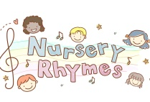  If there are any other nursery rhymes that you enjoying sharing at home please share these with the staff via the class email address. | Phonics / Reading    The pupils will have 2x weekly phonic sessions where we will focus on environmental and letter sounds. As well as focusing on mark making and writing with a variety of writing tools. | Cookery  The cookery focus this half term is types of savoury muffins. The skills taught are mixing, stirring and spreading.  Each week we will make a different flavour of savoury muffin:  Week 1: Cheese  Week 2: Sweet potato  Week 3: Apple and courgette  Week 4: Pizza  Week 5: Easter sweet muffins
Speaking and listening groups
The pupils will have 3x weekly sessions where we focus on developing the children language and communication skills. We focus the sessions on recognising and understanding symbols/words, attending to sessions and developing an understanding of nouns.
Computing  Our skills focus in computing this half term is animation and design. We will be using a variety of different programmes s to explore making our own animations using both the touch screen and/or the mouse.   | Expressive Arts  Every week, the pupils participate in an expressive arts lesson with Coral. This term the focus of the sessions is noodle drumming. During this session the pupils will be taking part in noodle drumming and following instructions. | Leave your mark | Interventions  The pupils will take part in daily interventions including identiplay, PECs, intensive interaction, story massage. MacPac and shoe box tasks. These interventions are to help develop the pupils play skills, communication and attention in small group, focused sessions. | PE  All classes have 1x weekly PE slots, led by Owen. In PE this half term pupils will be developing their coordination through a warm up, dance and a cool down. There will also be strong focus on independence skills while getting changed into and out of our P.E kits.
 |  | At home  If you want to continue your pupils learning at home you could focus activities on our topic ‘Leave your mark’ activities could include looking at making marks in sand, painting, manipulating play dough and practising your scissor skills. |  | Trips  Unfortunately due to the current situation we are unable to go on trips at the moment. However we will be going for power walks in the local environment to learn about road safety, keeping safe when out in public and to explore the world around us.

