Topic  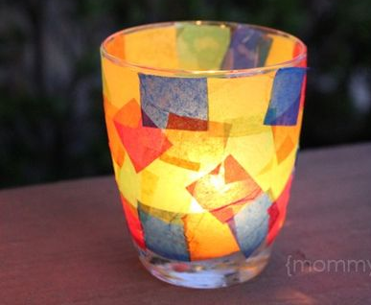  Our Thematic unit this half term is ‘Shine a light and celebrate which has a RE, Science & History focus. Each week we will be learning about a festival of lights.  Week 1- Guy Fawkes  Week 2- Shadows  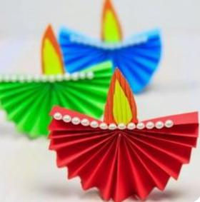  Week 3- Diwali  Week 4- Torches  Week 5- Electricity  Week 6- Hanukkah  Week 7- Christmas | Maths/computing  We will be covering number,  measure and using and applying  each week. The children will have  two classroom based lessons and one computer based lesson.    ’. | English  This half term our school focus is Traditional Tales. Our story book will be Little Red Riding Hood.  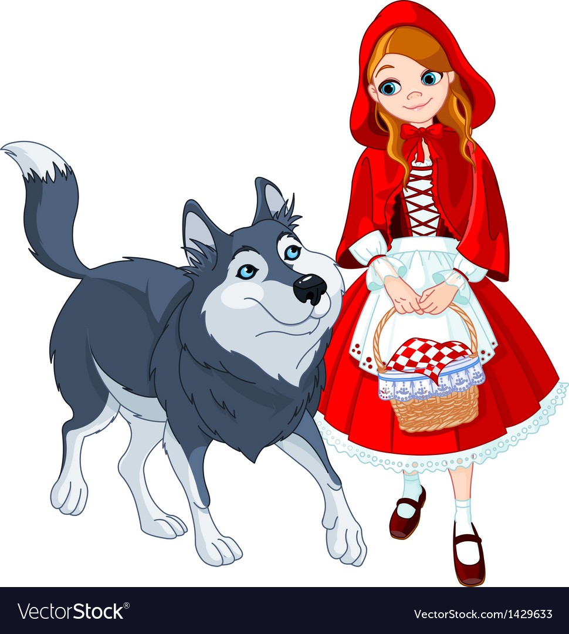 | Phonics/ Reading  In phonics this half term, we will continue to spilt the children into ability groups focusing on, learning the sounds of set 1, 2 and 3 sounds and blending them to make words. They are assessed every half term to see what the next steps are.  In reading the pupils will be reading 1:1 with an adult at least once a week. | Cookery  Shoots cookery focus this half term is pizza with various toppings.  Wk1. Cheese and tomato pizza.  Wk2 Vegetable crumpet pizza  Wk3 Vegetable pitta pizza  Wk4 Vegetarian sausage pizza  Wk5 Tuna and sweetcorn pizza  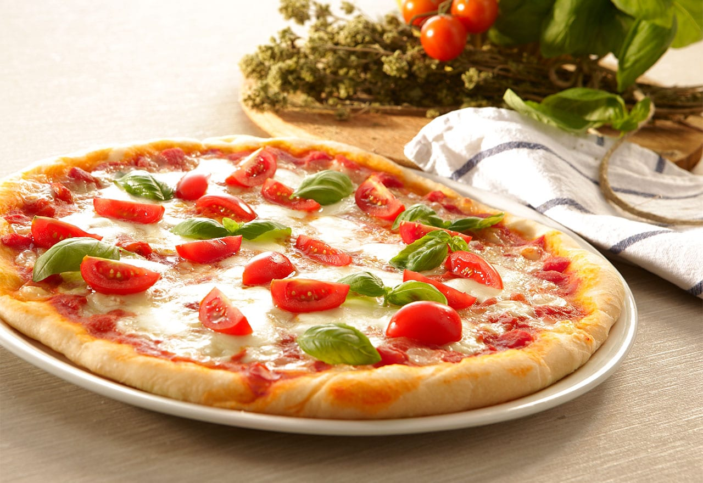  Wk6 Naan pizza cheese and tomato  Wk7 Mince pies
  Computing  We will be using our computer sessions for computer based maths and English sessions. While in these sessions we will still be developing the children’s knowledge of how to use different functions of the computer. | Expressive Arts  Cultural connections-  We will be looking at the whole RHS family and Celebrating and experiencing the many creative/artistic and cultural rituals, events and customs from across our Super Diverse Community. | Orange Class  Shine a light and celebrate  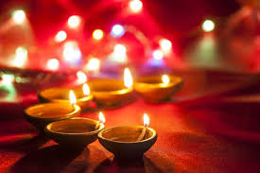  Autumn 2 Overview | Speech & Language  As always we will be focusing on the pupils communication throughout the school day.We will be having speaking and  listening groups which will  focus on the children extending  their listening skills and being  able to take turns and ask each  other simple questions and  listen to their answers. | PE  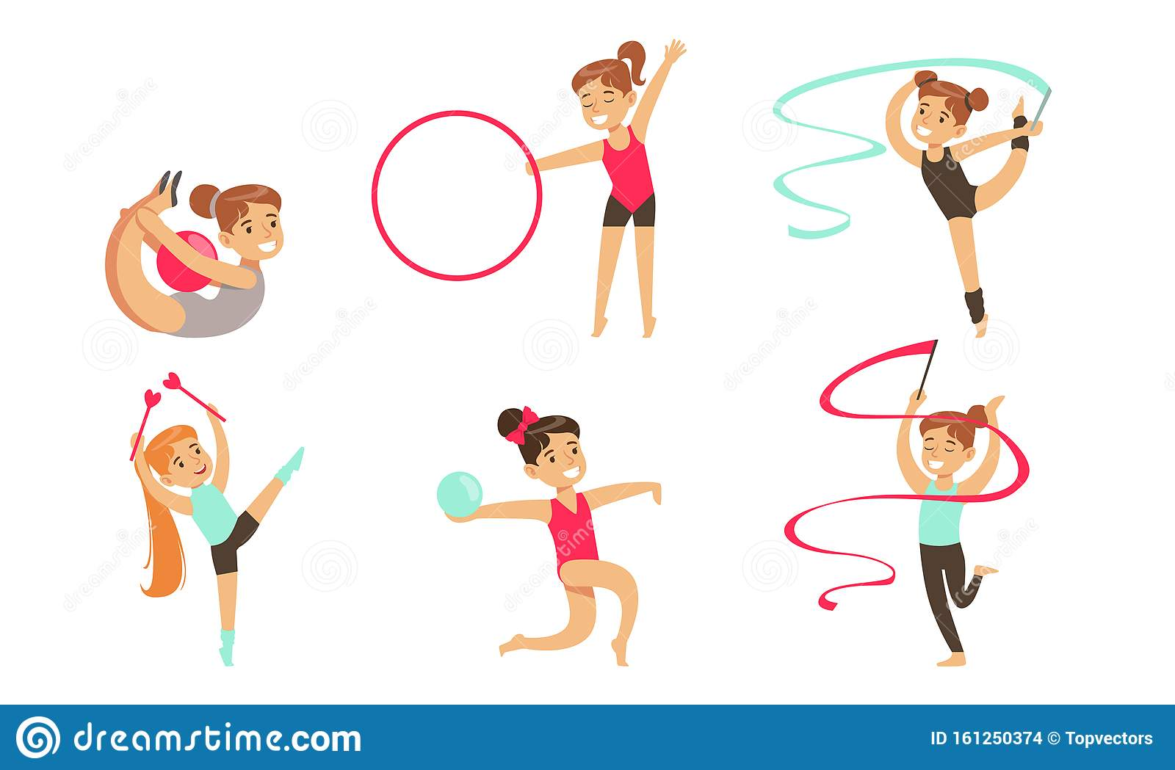  Our area of study in PE this half term will be rhythmic gymnastics. The children will learn the skills to move with equipment such as a hoop, ball and ribbon.
Home work  - Share the story of Little Red Riding Hood  - Go on a Autumn walk and collect objects of interest to create an Autumn collage.  - Create a crumpet/pitta pizza of your own , choosing your own toppings.  - Explore light and dark. | Science  Our science work will link in with our topic learning about physical properties with a focus on light.  Try exploring light sources around the home by turning off all the lights and watching them glow. | Trips  At the moment this half term we  have not planned any trips, due to the covid 19 situation.  We do a power walk around the  local area several times a week. | Important dates  15th November - Children in Need  Any other dates will be emailed to you either by myself via Orange class, or they will appear on RHS website or the school may email. | PSHE  Each class teaches bespoke PSHE in a fun and practical way. Following themes over the week or half term that include emotions, hygiene, personal safety, road safety, independence life skills.

