Topic  Our topic this half term is: “Shine a Light and Celebrate”.  The topic curriculum is split into weekly themes:  Week 1 – Bonfire Night  Week 2 - Diwali  Week 3 – Light sources (using torches)  Week 4 - Shadows  Week 5 – Light and Dark Art  Week 6 - Christmas  Week 7 - Christmas  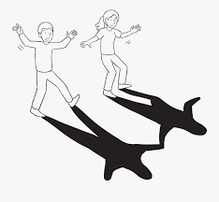 | Maths  Maths sessions will be focused on the three main areas of the maths curriculum. Number, Measure, using and applying statistics. Sessions will include activities from these areas.  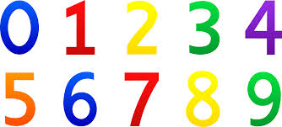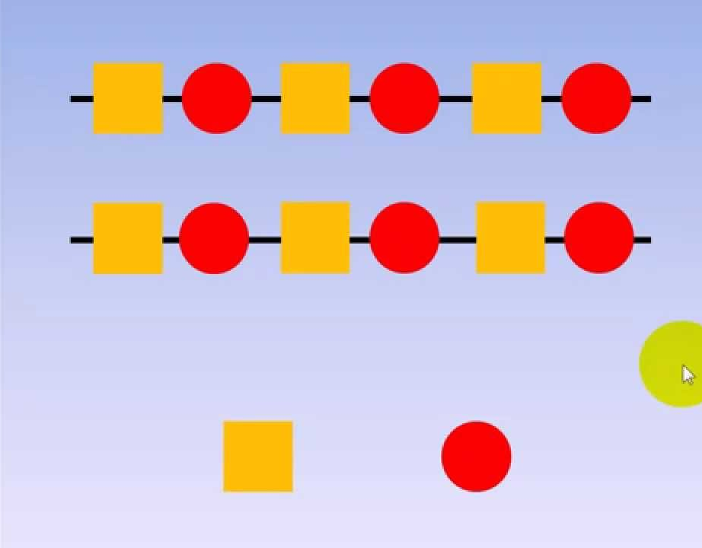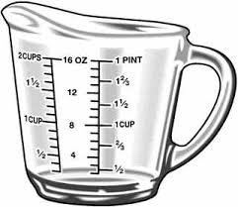 | English  This term we are focusing on two stories. Goldilocks and the three Bears for the first five weeks before moving onto Dear Santa story. The pupils will be encouraged to participate in reading the story and joining in with actions and sounds. We will complete art based activities, mark making and writing, reading and communication as well as following the sensory story!  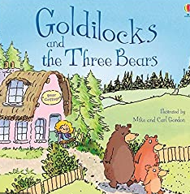.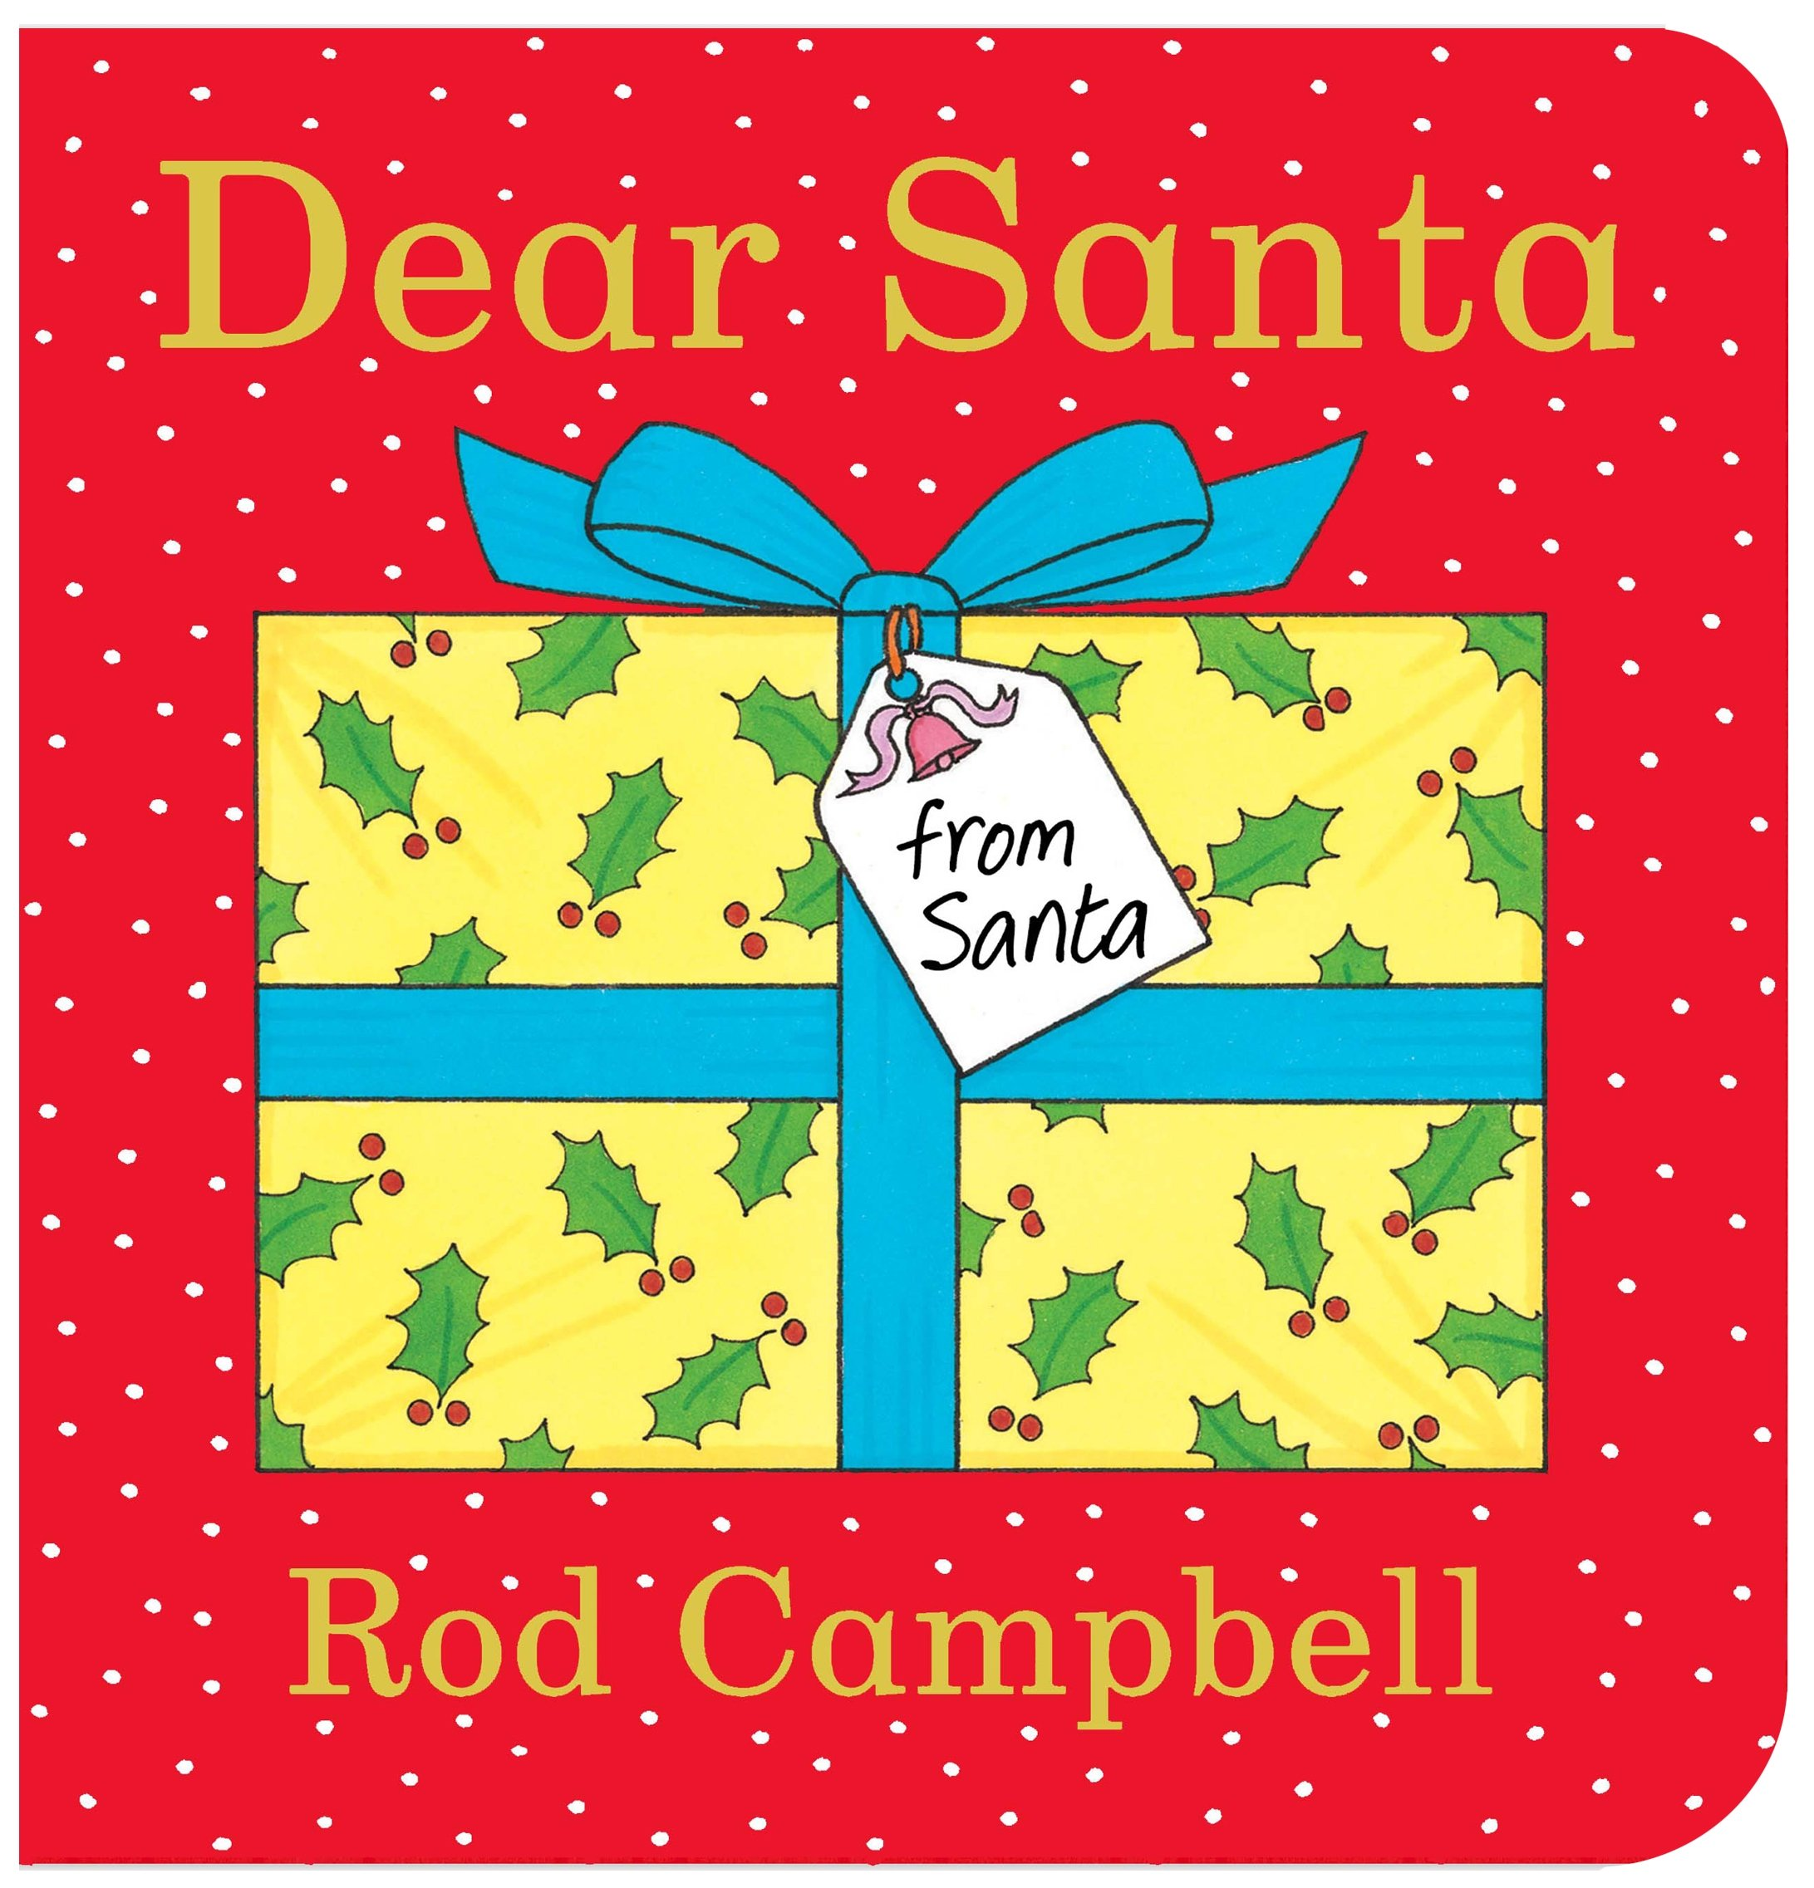  There are Youtube versions of the stories for you to watch at home. | Phonics / Reading  The pupils will have 2x weekly phonic sessions where we will focus on environmental and letter sounds. As well as focusing on mark making and writing with a variety of writing tools.  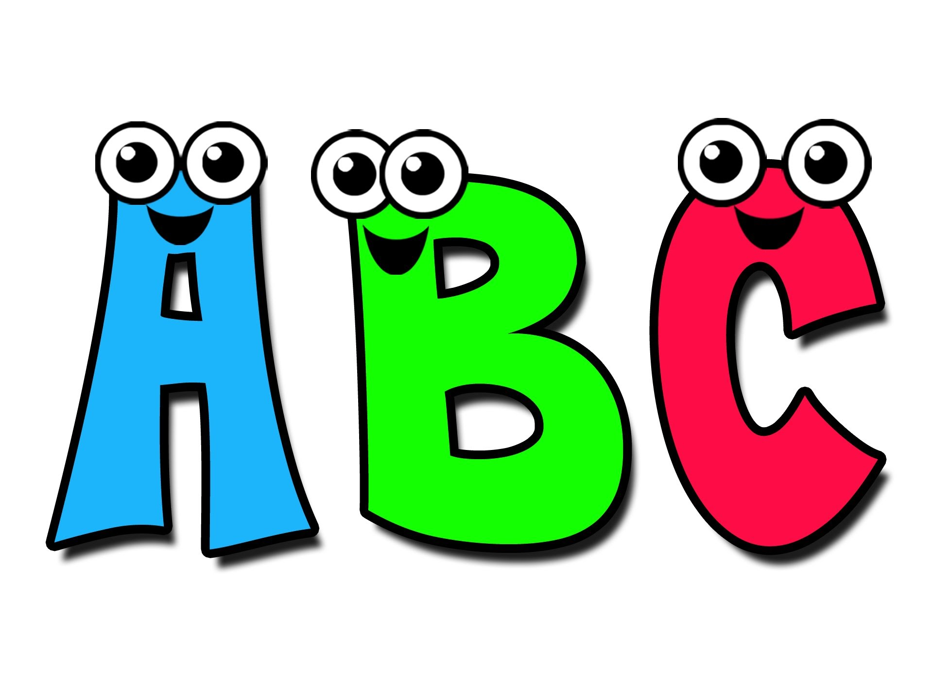 | Cookery  The cookery focus this half term is ‘making pizzas’. The skills taught are: chopping, spreading, grating and following instructions. The pupils are encouraged to taste different foods \and explore the ingredients used in cookery lessons.  During the last two weeks we will bake our Christmas favourites!  Each week we will make a different pizza:  Week 1: Cheese and Tomato  Week 2: Cheese and Mushroom  Week 3: Cheese and turkey ham  Week 4: Cheese and peppers  Week 5: White chocolate and banana  Week 6: Reindeer biscuits  Week 7: Mince pies  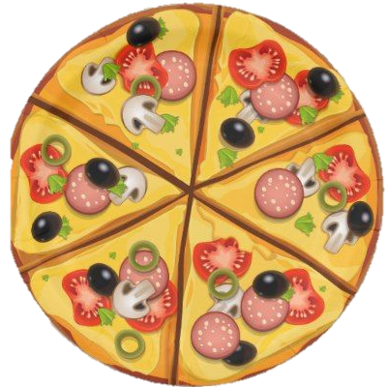
Speaking and listening groups
The pupils will have 3x weekly sessions where we focus on developing the children language and communication skills. We focus the sessions on recognising and understanding symbols/words, attending to sessions and developing an understanding of nouns/verbs/adjectives
Computing  Our skills focus in computing this half term is storytelling. We will be using a variety of different scenes from the story ‘Goldilocks and the Three Bears’ and characters to create our own versions of the story.   | Expressive Arts  Every week, the pupils participate in an expressive arts lesson with Coral. This half term the focus of the sessions will be ‘cultural dances’ linked to children’s backgrounds’. The first cultural event we will be focusing on is Diwali. During this session the pupils will be moving their bodies to music and following instructions. | Shine a Light and Celebrate   | Interventions  The pupils will take part in daily interventions including identiplay, PECs, intensive interaction, MacPac and shoe box tasks. These interventions are to help develop the pupils play skills, communication and attention in small group, focused sessions. | PE  The pupils have 2 PE sessions.  During PE sessions we will continue to work on pupils’ independence skills while getting ready for the lessons.  Pupils will take part indifferent activities that will contribute to developing gross motor and fine motor skills.
 |  | At home  If you want to continue your pupils' learning at home you could focus on activities on our topic ‘Shine a Light and Celebrate”. Activities could include making a den or experiencing using torches to navigate around rooms in the dark within your home. |  | Trips  Unfortunately due to the current situation we are unable to go on trips at the moment. However we will be going for power walks in the local environment to learn about road safety, keeping safe when out in public and to explore the world around us.

