Phonics and Reading Level 2
YEAR A
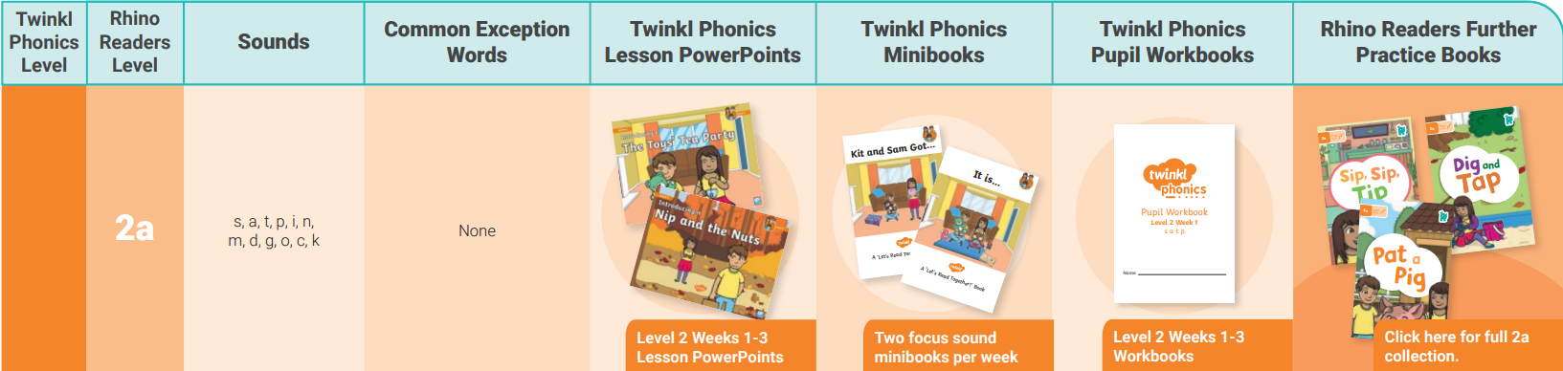

Weeks 1 - 6 (Aut 1)

Week | Day 1 | Day 2 | Day 3
1 | s | s | s
2 | a | a | a
Recap 3 = | S a | S a | S a
4 | t | t | t
5 | p | p | p
6 | S a t p | S a t p | S a t p

Weeks 7-12 (Aut 2)

Week | Lesson 1 | Lesson 2 | Lesson 3
7 | S a | T p | S a t p
8 | i | i | i
9 | S i | A t | P i
10 | n | n | n
11 | A n | S n | T p
12 | m | m | m

Weeks 13-18 (Spr 1)

Week | Lesson 1 | Lesson 2 | Lesson 3
13 | S a m | P i t | N m p
14 | d | d | d
15 | D m n a | M n i p | S a i t
16 | g | g | g
17 | G d m n i | S a t p | G d s a p
18 | o | o | o

Weeks 19 - 20 (Spr 2)

Week | Lesson 1 | Lesson 2 | Lesson 3
19 | O g d m n | I p t a s | S a t p i n m d g o
20 | c | c | c
21 | k | k | k
22 | K c o g d | M n l p t a | S c k d m a i
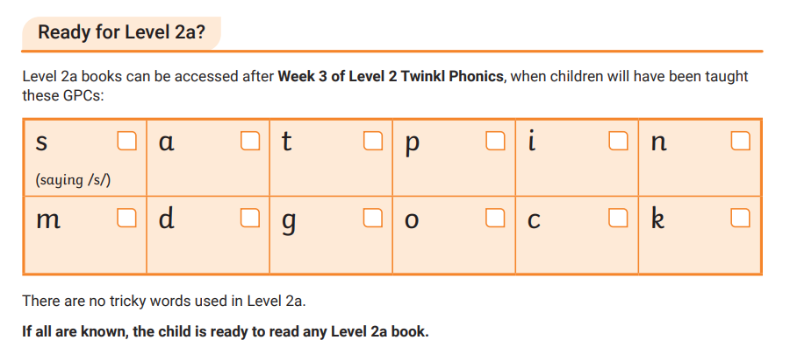
Weeks 23-24 (spr 2)

23 | Dig and Tap (2a book) | Dig and Tap (2a book) | Dig and Tap (2a book)
24 | Pat a pig (2a book) | Pat a pig (2a book) | Pat a pig (2a book)

Weeks 25- 27 (Sum 1)

Week | Lesson 1 | Lesson 2 | Lesson 3
25 | S c k d m a | M n l p t a | K c o g d
26 | Sip sip tip (2a book) | Sip sip tip (2a book) | Sip sip tip (2a book)
27 | K c o g d | S c k d m a | M n l p t a

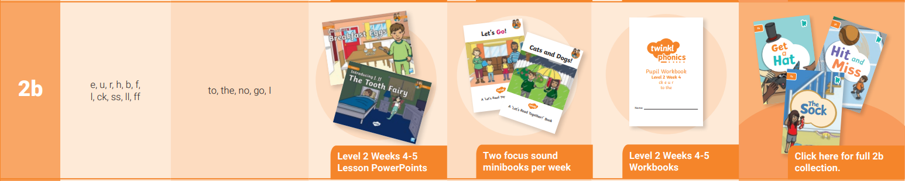

Weeks 28- 30 (Sum 1)

Week | Lesson 1 | Lesson 2 | Lesson 3
28 | e | e | e
29 | u | u | u
30 | E u a i | E u s a t p i | E u n m c k l p a t

Weeks 31-34 (Sum 2)

Week | Lesson 1 | Lesson 2 | Lesson 3
31 | r | r | r
32 | h | h | h
33 | R h e u c k | R h e u a i s p | R h e u n m l p t
34 | All sounds | All sounds | All sounds

YEAR B

Weeks 1 - 6 (Aut 1)

Week | Lesson 1 | Lesson 2 | Lesson 3
1 | s | s | a
2 | a | t | t
3 | p | p | i
4 | i | n | n
5 | S a t p i n | S a t p i n | S a t p i n
6 | m | m | d
Weeks 7 - 12 (Aut 2)

Week | Lesson 1 | Lesson 2 | Lesson 3
7 | d | g | g
8 | o | o | c
9 | c | k | k
10 | d | M | M d g o c k
11 | M d g o c k | S a t p i n | S a t p i n
12 | S a t p i n m d g o c k | S a t p i n m d g o c k | S a t p i n m d g o c k

Weeks 13 - 18 (Aut 2)

Week | Lesson 1 | Lesson 2 | Lesson 3
13 | e | e | u
14 | u | r | r
15 | h | h | b
16 | b | f | f
17 | l | l | ck
18 | S a t p i n m d g o c k | E u r h b f l ck | A e i o u t p ck h b l f

Weeks 19- 24 (Spr 1)

Week | Lesson 1 | Lesson 2 | Lesson 3
19 | S a t p i n m d g o c k | E u r h b f l ck | A e i o u t p ck h b l f
20 | ck | ss | ss
21 | ll | ll | ff
22 | ff | Ck ss ll ff | E u r h b f l ck ss ll ff
23 | Tricky words: the | Tricky words: to | Tricky words: I
24 | Tricky words: no | Tricky words: go | Tricky words: the, to, I, no, go

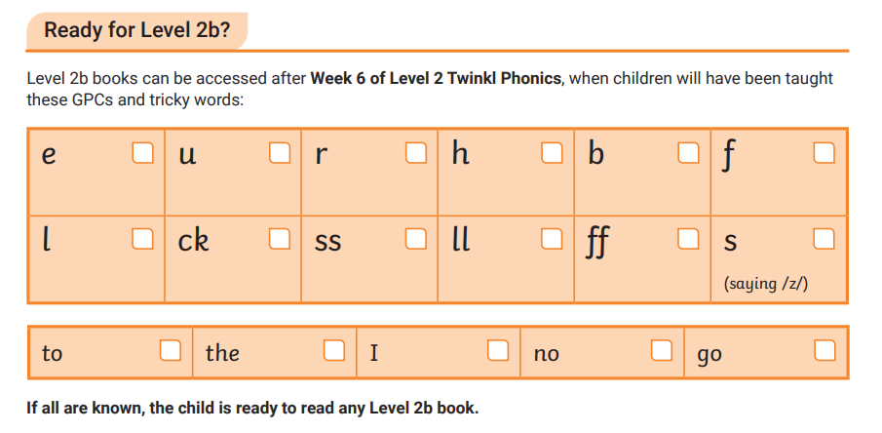
Weeks 25 - 30 (Spr 2)

Week | Lesson 1 | Lesson 2 | Lesson 3
25 | S a t p i n m d g o c k | E u r h b f l ck | Tricky words: the, to, I, no, go
26 | 2b book | 2b book | 2b book
27 | 2b book | 2b book | 2b book
28 | 2b book | 2b book | 2b book
29 | 2b book | 2b book | 2b book
30 | 2b book | 2b book | 2b book

Weeks 31-36 (Sum 1)

Week | Lesson 1 | Lesson 2 | Lesson 3
31 | S a t p i n m d g o c k | E u r h b f l ck | Tricky words: the, to, I, no, go
32 | 2b book | 2b book | 2b book
33 | 2b book | 2b book | 2b book
34 | 2b book | 2b book | 2b book
35 | 2b book | 2b book | 2b book
36 | 2b book | 2b book | 2b book

Weeks 37-42 (Sum 2)

Week | Lesson 1 | Lesson 2 | Lesson 3
37 | S a t p i n m d g o c k | E u r h b f l ck | Tricky words: the, to, I, no, go
38 | 2b book | 2b book | 2b book
39 | 2b book | 2b book | 2b book

YEAR C



