Half term overview- Yr 7
This is Year 7’s curriculum overview for the Autumn Term 1. This overview gives you a brief explanation of what the pupils will be doing in school.

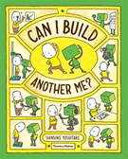  Topic  Our topic this half term is ‘All About Me’. It is focused on the children’s likes and dislikes, emotions, growing up and family.  We will also be linking in work on our RHS Value and this half term it is Pride. Taking pride in ourselves, our achievements and who we are.  We are using a visual and fun book called “Can I Build Another Me?” to support our work. | Maths  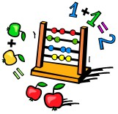  Each class will be covering the key areas of math – Number, Measure, Using & Applying & Stats.  We will be looking for opportunities to use functional math skills within the curriculum, dependent on COVID restrictions. For example, shopping in the local area and handling money. | English  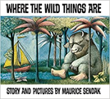  The Year 7 Book this half term is “Where the Wild Things Are”. We will use the book as the basis for communication, reading, writing and craft activities.
  Cookery  Cookery in Year 7 is based around building independence in the kitchen, using equipment safely and developing skills to make simple food items.  This half term our focus is using equipment safely:  Wk 2. Toaster - Toast, pancakes, crumpets, potato waffles  Wk 3. Kettle - Tea, cuppa-soup, hot chocolate, instant pasta  Wk 4. Microwave - Heating soup, heating instant meals,  WK 5. Microwave - Melting ingredients (chocolate for krispie cakes), microwave cakes.  Wk 6. Oven - Chips, pizza  Wk 7. Oven - Easy cookies and flapjacks |   Year 7  All About Me | Gardening and Life Skills  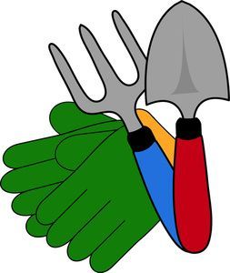  Aside from the life skills we learn in Cookery and ICT we will also be building our independence throughout the school day.  Students will have jobs that they need to complete e.g. washing up, drying up, tidying away etc  We as year seven are also going to oversee the garden. This will involve us helping other classes (covid restrictions permitting), making sure the garden is left tidy and managing the fruit and vegetables that are ready for harvest.  In time we hope to set up a fruit and vegetable stall to sell our produce to other classes and members of staff
Attention skills, Write Dance & Dough disco  Communication skills  Attention skills- teaches children to focus on an object, adult and their peers and to follow instructions.  Write Dance and dough disco are quick 5/10-minute activities which improve the children’s fine motor skills.  Children will also work in communication groups twice a week to build receptive and expressive communication and for some children - conversation skills.   | Phonics/ Reading  We will continue to teach phonics in our differentiated groups within class. Pupils will be learning sounds of the letters and how to blend sounds to read words.  Once a week the children will get a chance to read a book from the library. We will be assessing children and setting them up on a reading scheme if appropriate.   | Computing  In computing we will be focussing on life skills and how to use computers for ourselves.  We will spend this term learning functional skills from how to turn on a computer and use the desktop as well as build our typing skills.  E-safety will be a focus throughout the year.  

