Half term overview- Yr 7
This is Year 7’s curriculum overview for the Autumn Term 2. This overview gives you a brief explanation of what the pupils will be doing in school.

Topic  Our topic this half term is ‘Light!’  This gives us the opportunity to explore the science of light in our world, from shadows and light sources, to thinking about day and night, nocturnal animals and exploring our light room and different sensory experiences.  The topic of light also allows us to explore stories and events in other cultures to our own, learning about Diwali, Hannukah as well as starting to think about Christmas towards the end of term.  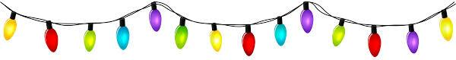 | Maths  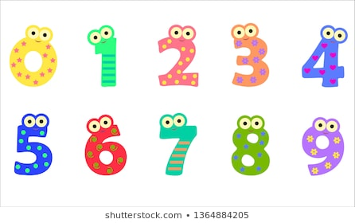  Each class will be covering the key areas of math – Number, Measure, Using & Applying & Stats.  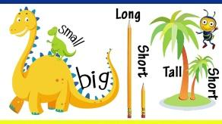  We will be looking for opportunities to use functional math skills within the curriculum, dependent on COVID restrictions. For example, shopping in the local area and handling money. | English, Phonics and Reading  We will continue to teach phonics and reading in differentiated groups and pupils will be learning sounds of the letters and how to blend sounds to read words.  .  In English we will be looking at traditional tales from Robin Hood to the Three Billy Goats Gruff!  We will be creating props, acting out elements of the story, developing our fine motor and writing skills and developing our communication, phonics and reading skills in lessons.  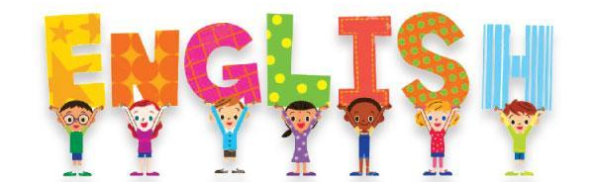
Cookery  Cookery in Year 7 is based around building independence in the kitchen, using equipment safely and developing skills to make simple food items.  This half term our focus is making snacks for ourselves safely and understanding portion sizes.  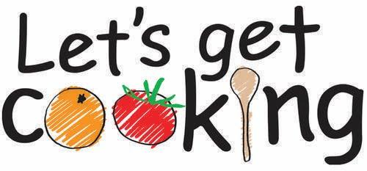 | Year 7  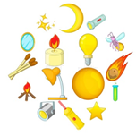  Light | Computing  In computing we will be focussing on life skills and how to use computers for ourselves.  We will spend this term learning functional skills from how to turn on a computer and use the desktop as well as build our typing skills.  E-safety will be a focus throughout the year.  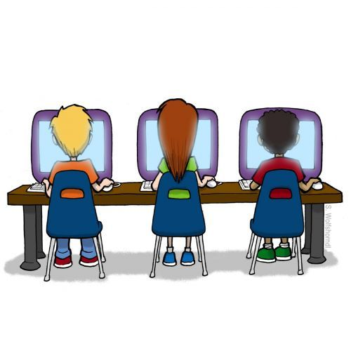
Attention skills, Write Dance & Dough disco  Communication skills  Attention skills- teaches children to focus on an object, adult and their peers and to follow instructions.  Write Dance and dough disco are quick 5/10-minute activities which improve the children’s fine motor skills.  Children will also work in communication groups twice a week to build receptive and expressive communication and for some children - conversation skills.  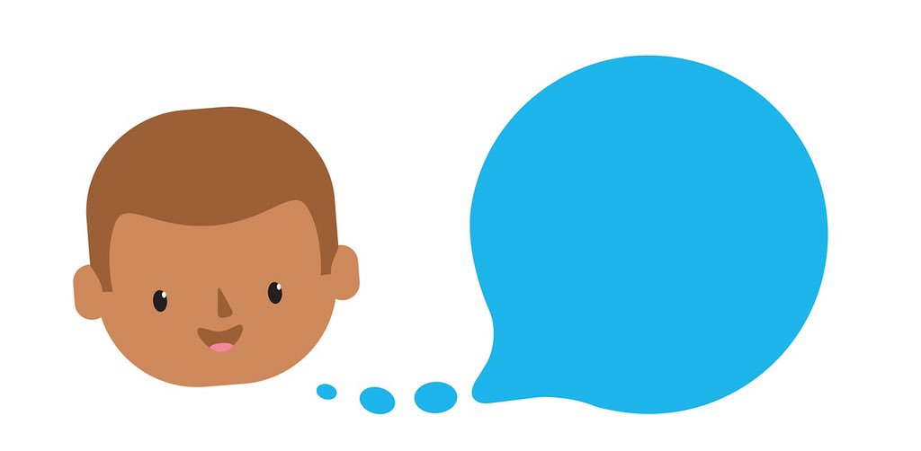 | PSHE and RSE  This half term we will be focussing more on RSE and considering ourselves and our bodies and the way we interact with others.  We will be talking about puberty and our bodies and using anatomical names to help us understand the changes we go through.  We will also be talking about privacy and personal space and learning how to build positive friendships and relationships as we become young adults rather than children.   | Life Skills and the Garden  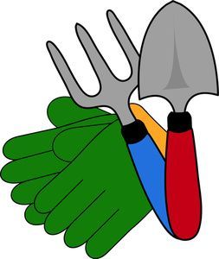  Aside from the life skills we learn in Cookery and ICT we will also be building our independence throughout the school day.  Students will have jobs that they need to complete e.g. washing up, drying up, tidying away etc  We as year seven are also going to oversee the garden. This will involve us helping other classes (covid restrictions permitting), making sure the garden is left tidy and managing the fruit and vegetables that are ready for harvest.  In time we hope to set up a fruit and vegetable stall to sell our produce to other classes and members of staff

