Topic  Our topic this half term is: ‘Let there be light’. The topic curriculum is split into weekly themes:  Week 1 - bonfire night  Week 2 - Diwali  Week 3 -shadows  Week 4 - light and dark  Week 5 - dens and light toys  Week 6 - day and night  Week 7 - Christmas  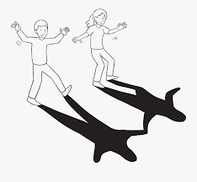 | Maths  Maths sessions will be focused on the three main areas of the maths curriculum.Number, Measure, using and applying statistics. Sessions will include activities from these areas.  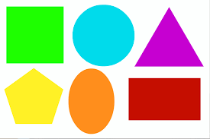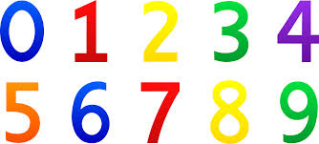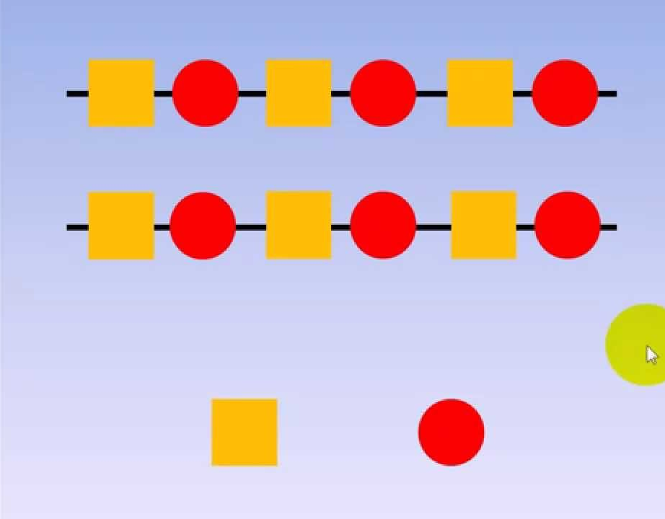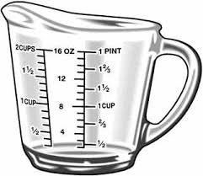 | English  This term we are focusing on two stories. The gingerbread man for the first six weeks before moving onto Dear Santa for the last week. The pupils will be encouraged to participate in reading the story and joining in with actions and sounds. We will complete art based activities, mark making and writing, reading and communication as well as following the sensory story  .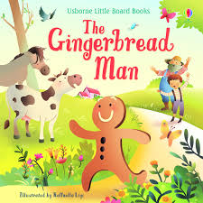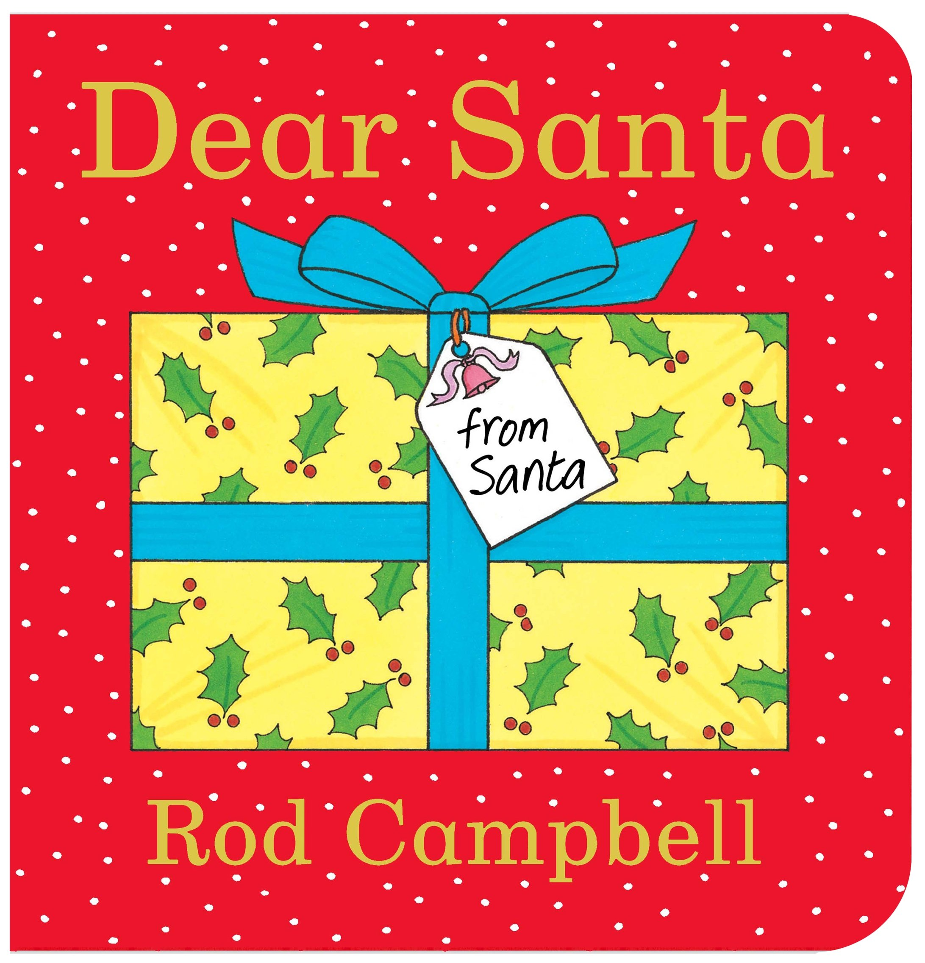  There are youtube versions of the stories for you to watch at home. | Phonics / Reading  The pupils will have 2x weekly phonic sessions where we will focus on environmental and letter sounds. As well as focusing on mark making and writing with a variety of writing tools.  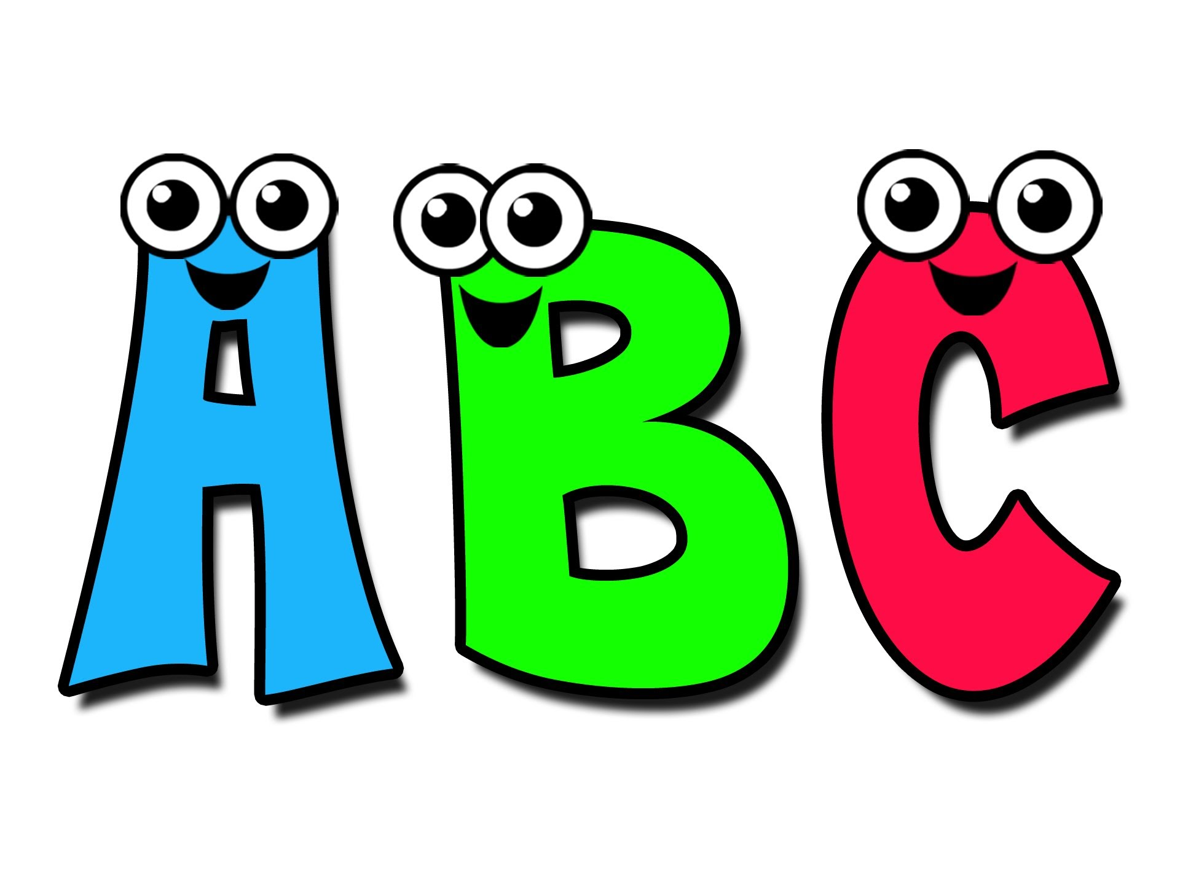 | Cookery  This term in cookery we are making shortcrust pastry. We will be focusing on skills including kneading, rubbing and using a rolling pin to roll out. Each week we will be using a different flavour to make tarts.  Week 1: strawberry jam  Week 2:lemon curd  Week 3:chocolate spread  Week 4: blackcurrant jam  Week 5: raspberry jam  Week 6: apricot jam  Week 7: mince pies  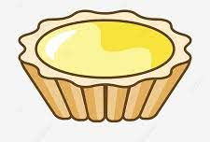
Speaking and listening groups
The pupils will have 3x weekly sessions where we focus on developing the children language and communication skills. We focus the sessions on recognising and understanding symbols/words, attending to sessions and developing an understanding of nouns.
Computing  Our skills focus in computing this half term is storytelling. We will be using a variety of different scenes from the story ‘the gingerbread man’ and characters to create our own versions of the story.   | Expressive Arts  Every week, the pupils participate in an expressive arts lesson with Coral. This half term the focus of the sessions will be ‘cultural dances’ linked to children’s backgrounds’. The first cultural event we will be focusing on is Diwali. During this session the pupils will be moving their bodies to music and following instructions. | Let there be light  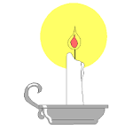 | Interventions  The pupils will take part in daily interventions including identiplay, PECs, intensive interaction, MacPac and shoe box tasks. These interventions are to help develop the pupils play skills, communication and attention in small group, focused sessions. |   PE  The pupils have 1x PE session a week with the PE teacher, Owen. This term pupils will be focusing on hockey. They will be learning to use a stick to guide the quoit and hit it into a net.
 |  | At home  If you want to continue your pupils' learning at home you could focus on activities on our topic ‘let there be light’. Activities could include making a den or experiencing using torches to navigate around rooms in the dark within your home. |  | Trips  Unfortunately due to the current situation we are unable to go on trips at the moment. However we will be going for power walks in the local environment to learn about road safety, keeping safe when out in public and to explore the world around us.

