Topic  Theme: our school theme this term is the natural world.  Year ⅔ Topic is called ‘Down on the farm’. Each week we will focus on a different area of farming.  Week 1 - crops  Week 2 - crops  Week 3 - farm vehicles  Week 4 - farm vehicles  Week 5 - farm animals  Week 6 - farm animals  Week 7 - habitats | Maths  Maths sessions will be focused on the three main areas of the maths curriculum.Number, Measure, using and applying statistics. Sessions will include activities from these areas.  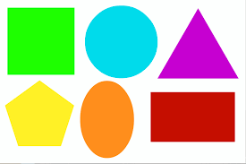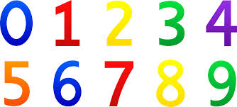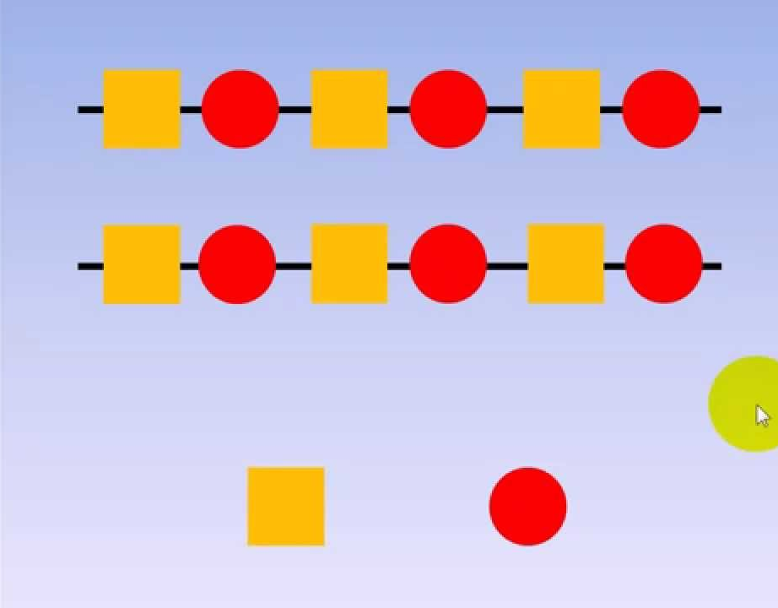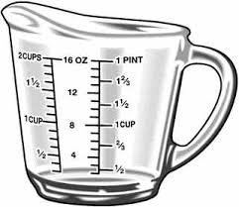 | English  This term we are focusing on two stories. Jasper’s beanstalk for the first four weeks before moving onto The Blue Balloon for the last 3 weeks. The pupils will be encouraged to participate in reading the story and joining in with actions and sounds. We will complete art based activities, mark making and writing, reading and communication as well as following the sensory story  .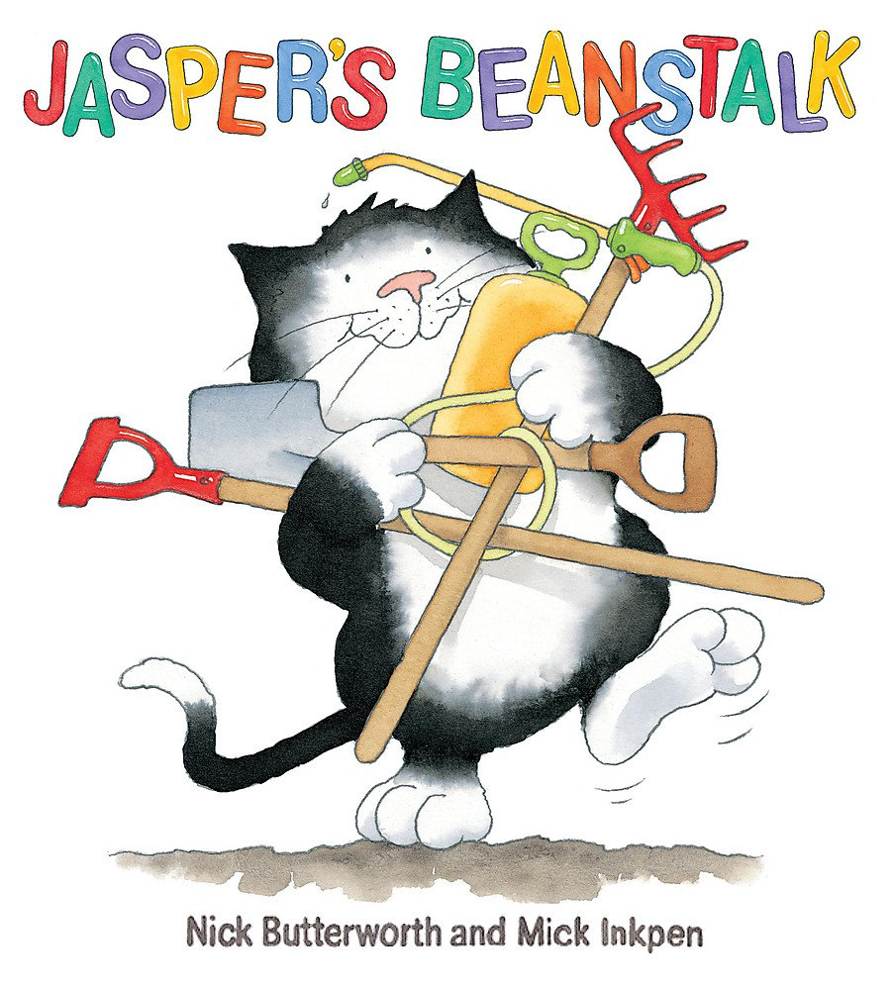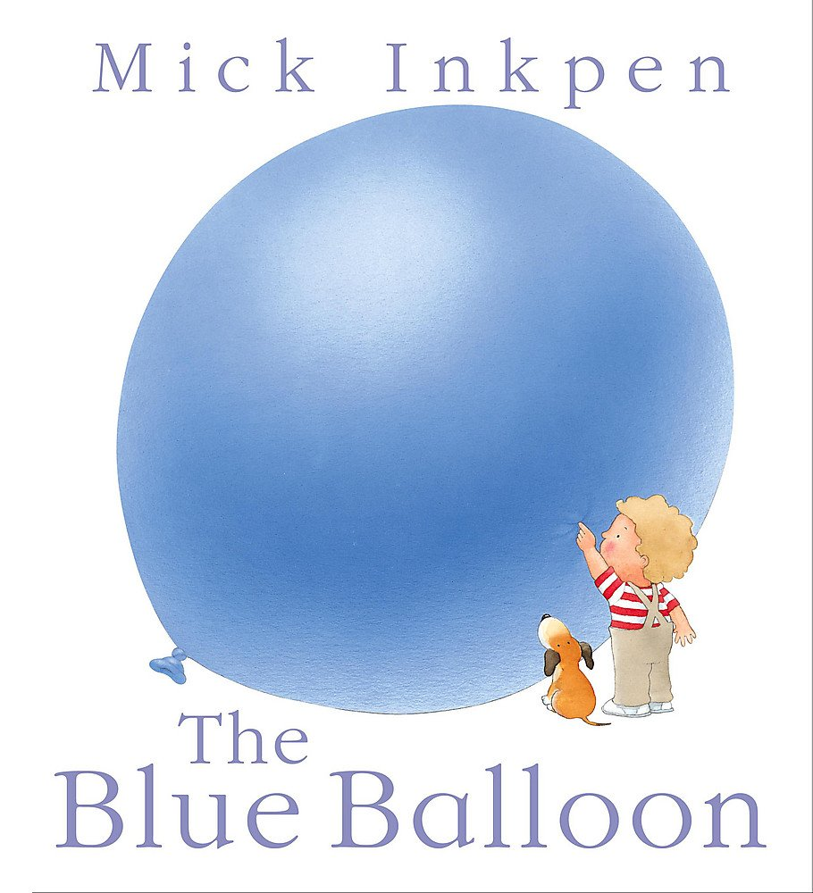  There are youtube versions of the stories for you to watch at home. | Phonics / Reading  The pupils will have 2x weekly phonic sessions where we will focus on environmental and letter sounds. As well as focusing on mark making and writing with a variety of writing tools.  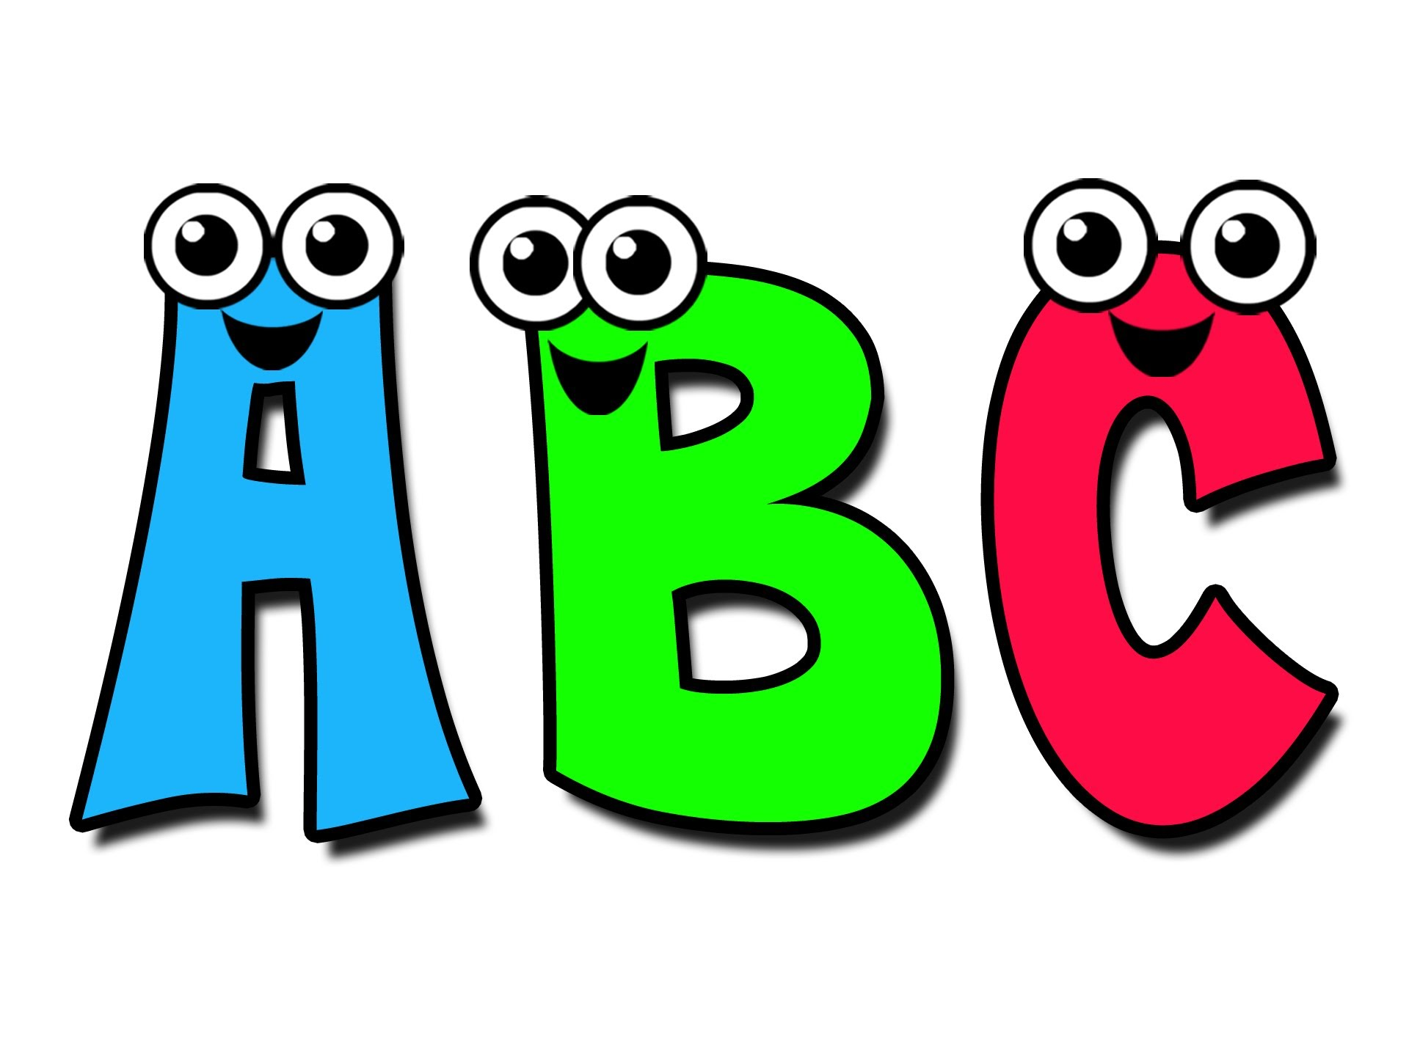 | Cookery  This term in our cookery sessions we are making Pitta bread pizzas.  Each week we will use different toppings to learn skills including cutting, spreading and grating.  1 margherita = cheese and tomato  2. Rainbow pizza =cheese, red pepper, sweetcorn  3. Hawaain pizza =quorn  (ham), pineapple  4. Green pizza = Cheese, Pesto, spinach, green pepper  5. Bbq chicken pizza = Cheese, Quorn chicken pieces, bbq sauce  6. Greek pizza = Feta, black olives, spring onion  7. Seafood pizza = Cheese, tuna, sweetcorn, oregano
Speaking and listening groups
The pupils will have 3x weekly sessions where we focus on developing the children language and communication skills. We focus the sessions on recognising and understanding symbols/words, attending to sessions and developing an understanding of nouns.
 | Expressive Arts  Every week, the pupils participate in an expressive arts lesson with Coral. The focus for this half term will be Lyrical/ Contemporary dance. The children will be exploring following a dance routine to the song ‘A whole new world’ using scarves. | Down on the farm  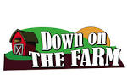 | Interventions  The pupils will take part in daily interventions including identiplay, PECs, intensive interaction, MacPac and shoe box tasks. These interventions are to help develop the pupils play skills, communication and attention in small group, focused sessions. | PE    This half term the focus will be ‘racket games’. The children will be exploring holding tennis rackets and balancing bean bags or balls on their rackets.
 |  | At home  If you want to continue your pupils' learning at home you could focus on activities on our topic ‘down on the farm’. Activities could include exploring farm animal sounds or visiting a farm or the country side to see farm animals. |  | Trips  Unfortunately due to the current situation we are unable to go on trips at the moment. However we will be going for power walks in the local environment to learn about road safety, keeping safe when out in public and to explore the world around us.

