Monday | Tuesday | Wednesday | Thursday | Friday | Saturday | Sunday
1  Today I feel... | 2  Shapes | 3  Pieces | 4  Hold | 5  Dark & Light | 6  Home | 7  Disappear
8  Self-care | 9  Weather | 10  Today I see... | 11  Connection | 12  Colourful | 13  I wish I was... | 14  Love
15  Family | 16  Today I hope... | 17  Textures | 18  Being human | 19  Contrast | 20  Dreams | 21  Growing
22  Challenging | 23  Stop | 24  Up & down | 25  Messy | 26  Today I will... | 27  Nature | 28  Tomorrow
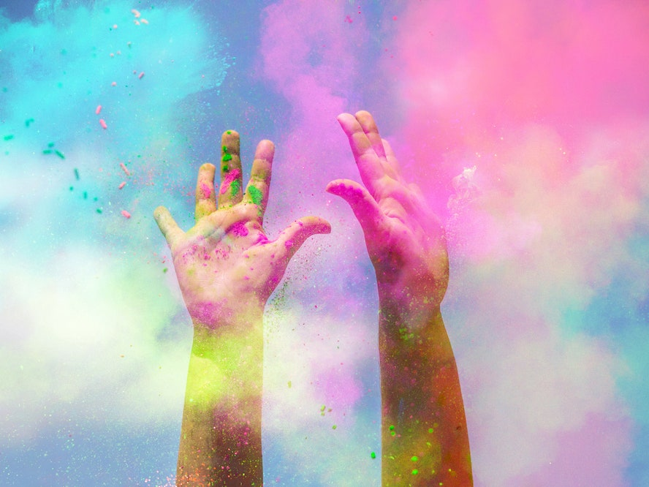
Lockdown Creative Calendar
Use each theme to make an image – take a photo, paint a picture, build a model... be as creative as you like and share your image with your teachers!
Feb
2021

