Topic  Our Thematic unit this half term is ‘Shine a light and celebrate’ which has RE, Science & History links. Each week we will be learning about a festival of lights.  Week 1- Guy Fawkes  Week 2- Shadows  Week 3- Diwali  Week 4- Torches  Week 5- Electricity  Week 6- Hanukkah  Week 7- Christmas  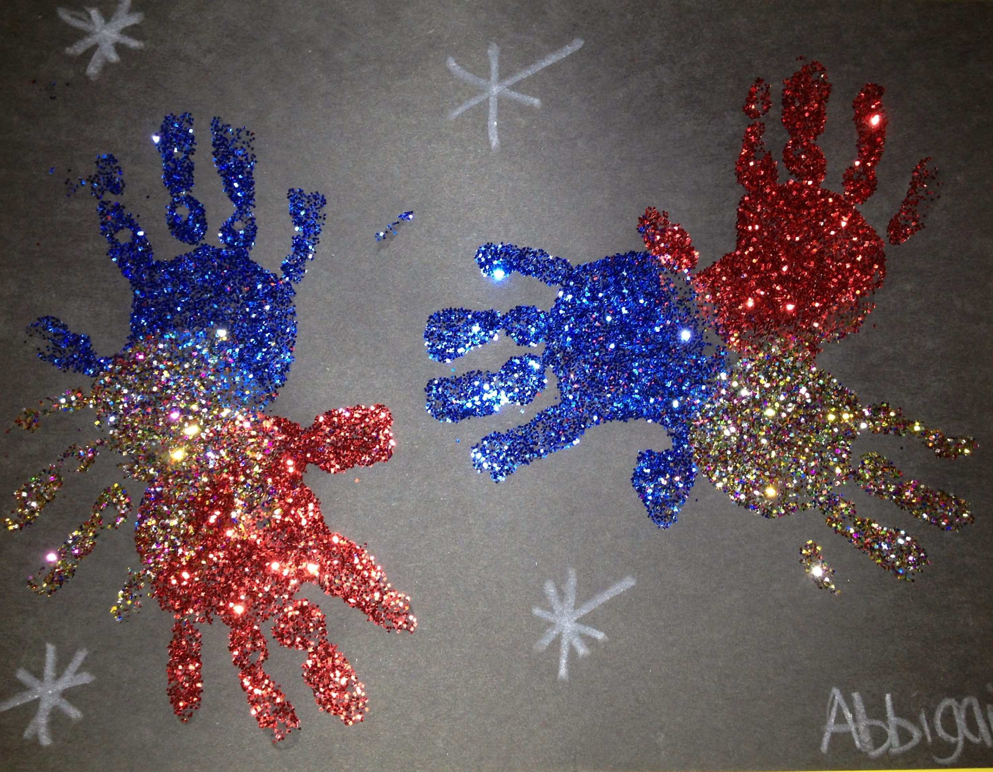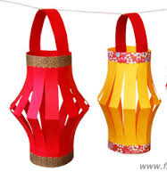 | Maths  Week 1- Number  Week 2- Measure  Week 3- Using and Applying  Week 4- Number  Week 5- Measure  Week 6- Using and Applying  Week 7- Number  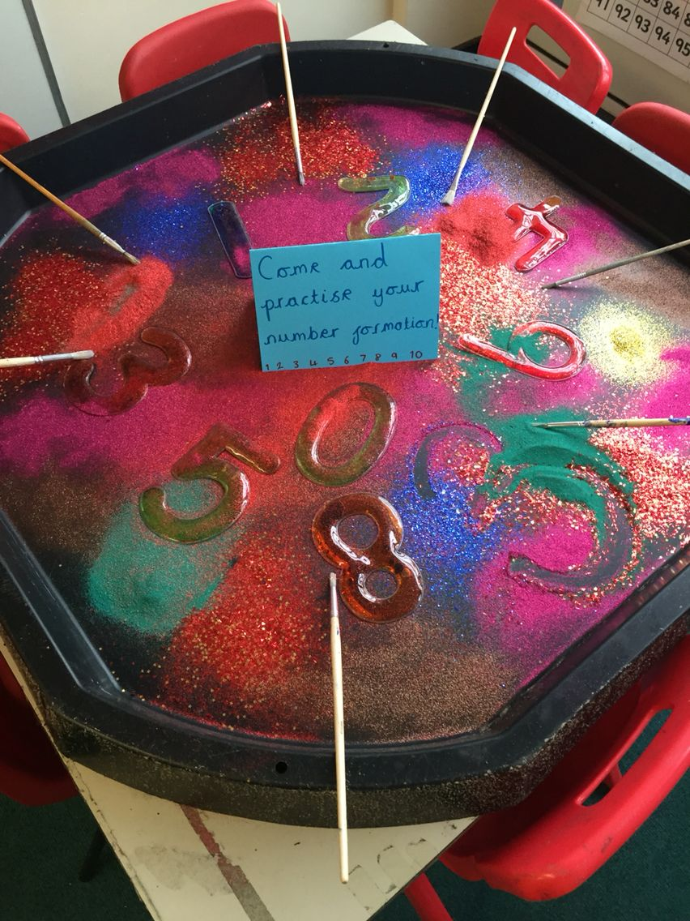 | English  This half term our school focus is Traditional Tales. We are reading ‘The Three Billy Goats Gruff’  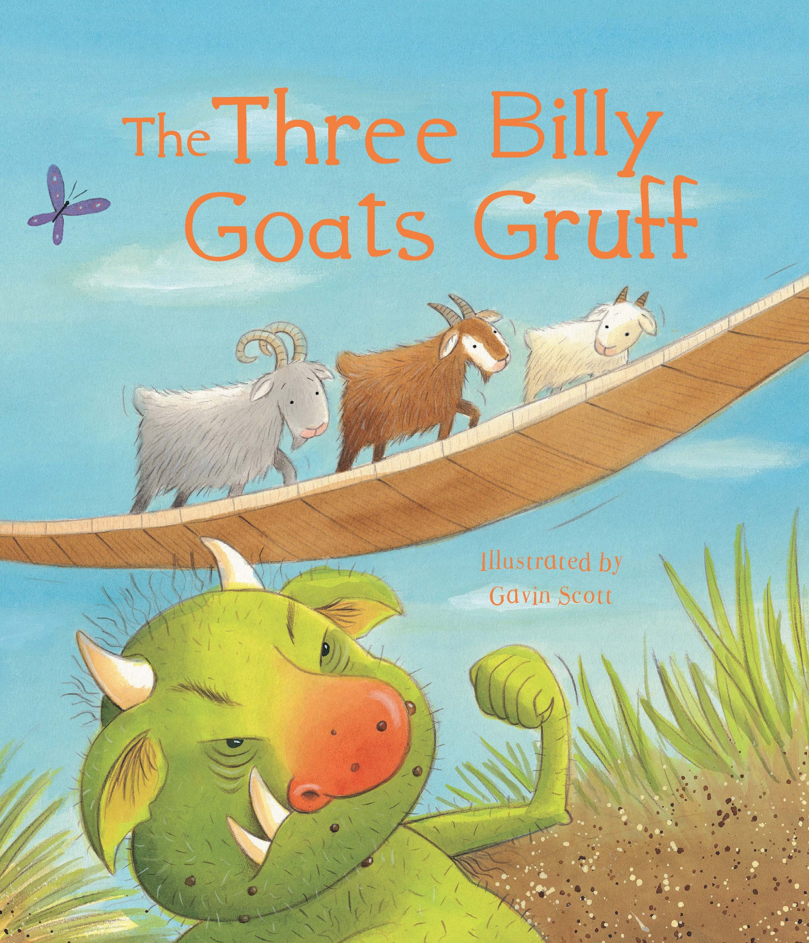  The Three Billy Goats Gruff click here for an animated video of our story.  We will be using role play and practising our storytelling, sequencing, writing and reading skills in activities linked to the story. | Phonics/ Reading  Some children are at the pre phonics stage learning to identify and discriminate between different sounds.  The majority of children are now learning the sounds of letters and how to blend sounds to read words. They are assessed every half term to see what the next steps are.  We will be working on the following sounds and words with the following sounds;  Week 1 - p  Week 2 - g  Week 3 - o  Week 4 - c  Week 5 - k  Week 6 - u  Week 7 - b | Cookery  Shoots cookery focus this half term is pizza with various toppings.  Wk1. Cheese and tomato crumpet pizza.  Wk2 Vegetable crumpet pizza  Wk3 Vegetable pitta pizza  Wk4 Vegetarian sausage pizza  Wk5 Tuna and sweetcorn pitta pizza  Wk6 Naan bread pizza cheese and tomato  Wk7 Mince pies  Alongside this we will be making some chocolate firework treats, decorating biscuits into spiders webs, traditional Barfi sweets and some Christmas treats too.
Computing  In Computing we will continue to extend our computer skills and we will use ICT to support our learning in Topic, English and Maths. | Expressive Arts  Cultural connections-  We will be looking at the whole RHS family and celebrating and experiencing the many creative/artistic and cultural rituals, events and customs from across our Super Diverse Community. | Peacock Class  Shine a light and celebrate  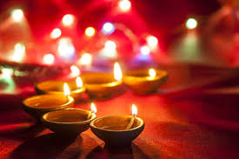  Autumn 2 Overview | Speech & Language  We will be using a visual resource called ‘Colourful Semantics’ as a strategy to help the children verbalise simple sentences. They will look at a picture and use symbols to say 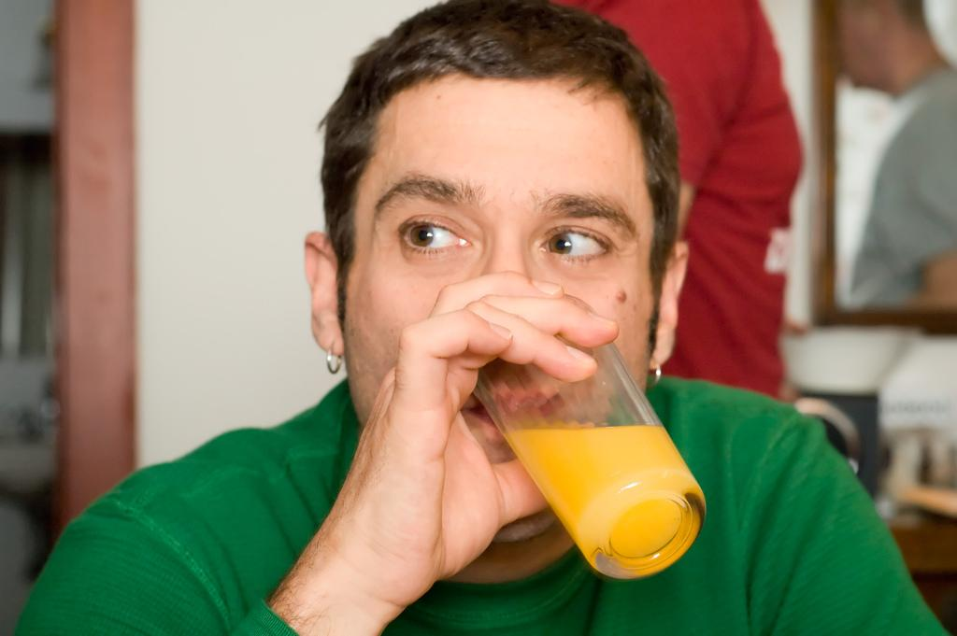The man is drinking juice. | PE  This half term in PE is led by Owen the pupils will be focussing on Quoit hockey. The skills the children will be learning are :-  - To hold the hockey stick appropriately  - Dribbling with the quoit  - Shooting the quoi  In addition each class the children will continue to do power walks , wake up, shake up songs and yoga.
Home work  - Share the story of the ‘Three Billy Goats Gruff’.  - Go on an Autumn walk and collect objects of interest to create an Autumn collage.  - Create a crumpet/pitta pizza of your own, choosing your own toppings.  - Explore light and dark e.g. glow sticks and sparklers outside. | Science  Our science work will link in with our topic learning about physical properties with a focus on light.  Try exploring light sources around the home by turning off all the lights and watching them glow. | Trips  Trips are now allowed to be planned into the curriculum. We will build a weekly walk of the local area into our weekly routine and I will contact you with information regarding any trips planned. | Important dates  15th November - Children in Need  Any other dates will be emailed to you either by myself via Peacock class, on the RHS website or parent mail. | PSHE  Each class teaches bespoke PSHE in a fun and practical way. Following themes over the week or half term that include emotions, hygiene, personal safety, road safety, independence life skills

