Peacock Class
Topic  Our Thematic unit this half term is ‘The Natural World which has a Science focus. We will be looking at lifecycles of different animals. In addition we will have 2 weeks focusing on Ramadan.Ramadan is the ninth month of the Islamic calendar, observed by Muslims worldwide as a month of fasting, prayer, reflection and community.  Week 1- Ramadan  Week 2- Butterfly  Week 3- Frog  Week 4- Chicken  Week 5- Ramadan  Week 6- Mini beasts  Week 7- Human life cycle | Maths  Week 1- Number  Week 2- Measure  Week 3- Using and Applying  Week 4- Number  Week 5- Measure  Week 6- Using and Applying  Week 7- Number  ’. 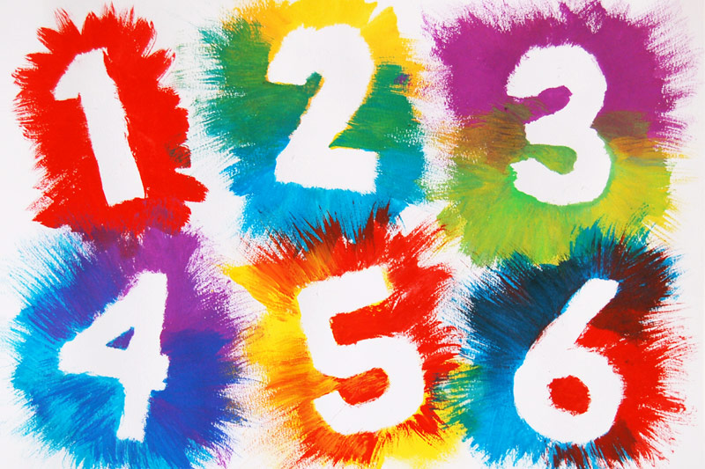 | English  This half term our school focus is Well known authors. Shoots at East have chosen the book ‘Barry the fish with fingers.  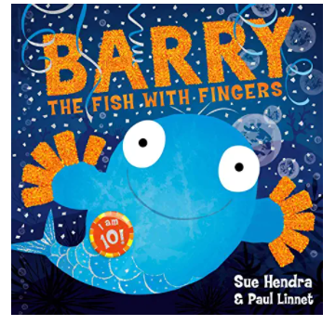  Have you EVER seen a fish with fingers?  No?  Well, neither had the fish at the bottom of the ocean ...  This crazy deep-sea caper is sure to be a hit with all kids. | Phonics/ Reading  We will continue to teach phonics. Some children are at the pre phonics stage learning to identify and discriminate between different sounds.  The majority of children are now learning the sounds of letters and how to blend sounds to read words. They are assessed every half term to see what the next steps are.  In reading the pupils will be reading 1:1 with an adult at least once a week. | Cookery  Shoots cookery focus this half term is cookies.  Wk1. Fork cookie  Wk2 Fork chocolate cookie  Wk3 Chocolate chip cookie  Wk4 Double chocolate chip cookie  Wk5 Raisin cookie  Wk6 Cranberry and white chocolate cookie  Wk7 Favourite cookie  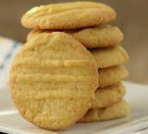  .
Computing  In computing we will continue to extend our computer skills and we will use the computer to support our learning in Topic, English and Maths. | Expressive Arts  This half term the children will be learning Lyrical/ Contemporary dance routines.   | Peacock Class  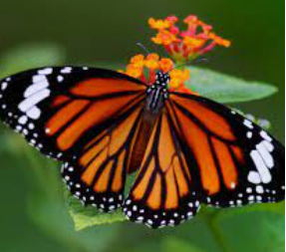  The Natural World  Summer 1 Overview | Speech & Language  We will be using a visual resource called ‘Colourful Semantics’ as a strategy to help the children verbalise simple sentences. They will look at a picture and use symbols to say 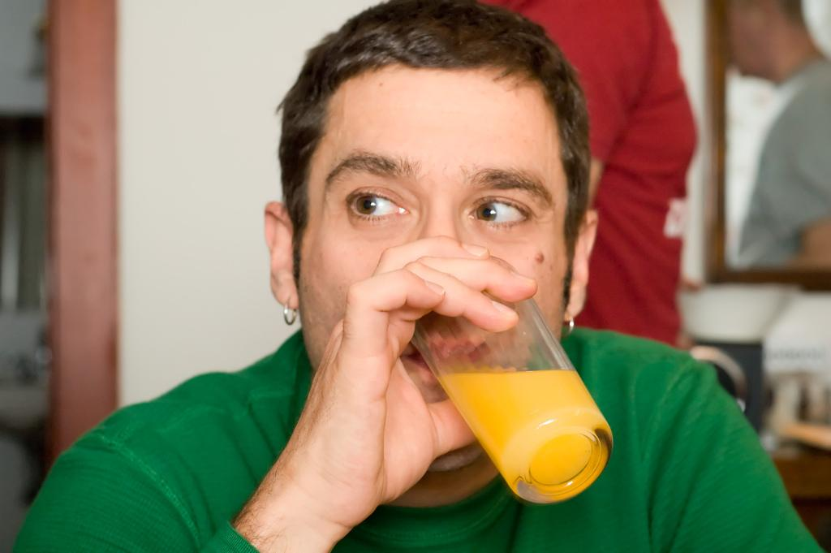The man is drinking juice. | PE  This half term in PE the pupils will be focussing on Racket tennis  In addition each class the children will continue to do power walks, wake up, shake up songs and yoga.
Home work  - Share the story of the Barry the fish with fingers  - Try making a fork cookie at home.  - Practise reading and writing simple CVC words/sentences.  - Play games and practise turn taking at home. | Science  Our science work will link in with our topic learning about the Natural World. Looking at life cycles from butterflies to humans. Additional bespoke Science lessons will be taught . | Trips  Individual class teachers will inform of any updates on trips via the class email address. | Important dates  Any other dates will be emailed to you either by myself via Peacock class, on the RHS website, parent mail or the school admin email. | PSHE  Each class teaches bespoke PSHE in a fun and practical way. following themes over the half term that include emotions, hygiene, personal safety, road safety, independence life skills.  Our values focus this half term is: Happiness.

