This is Gold Classes curriculum overview for the Autumn 2 term. This overview gives you a brief explanation of what the pupils will be doing in school. It also gives you suggestions of activities to support pupil’s learning at home. These are only suggestions, not compulsory activities.
Topic  Our topic this half term is ‘Shine the Light’ . Each week we will be learning about a festival of lights.  Week 1- Guy Fawkes & Bonfire Night  Week 2- Diwali  Week 3- Light and shadows  Week 4- Hanukkah  Week 5- Light and mirrors  Week 6- Electricity and batteries  Week 7- Christmas  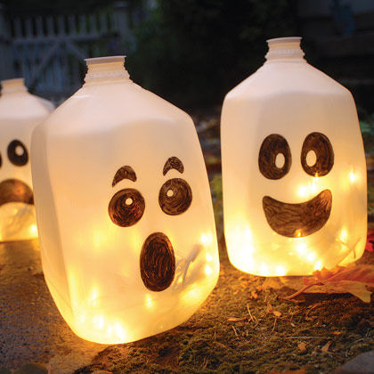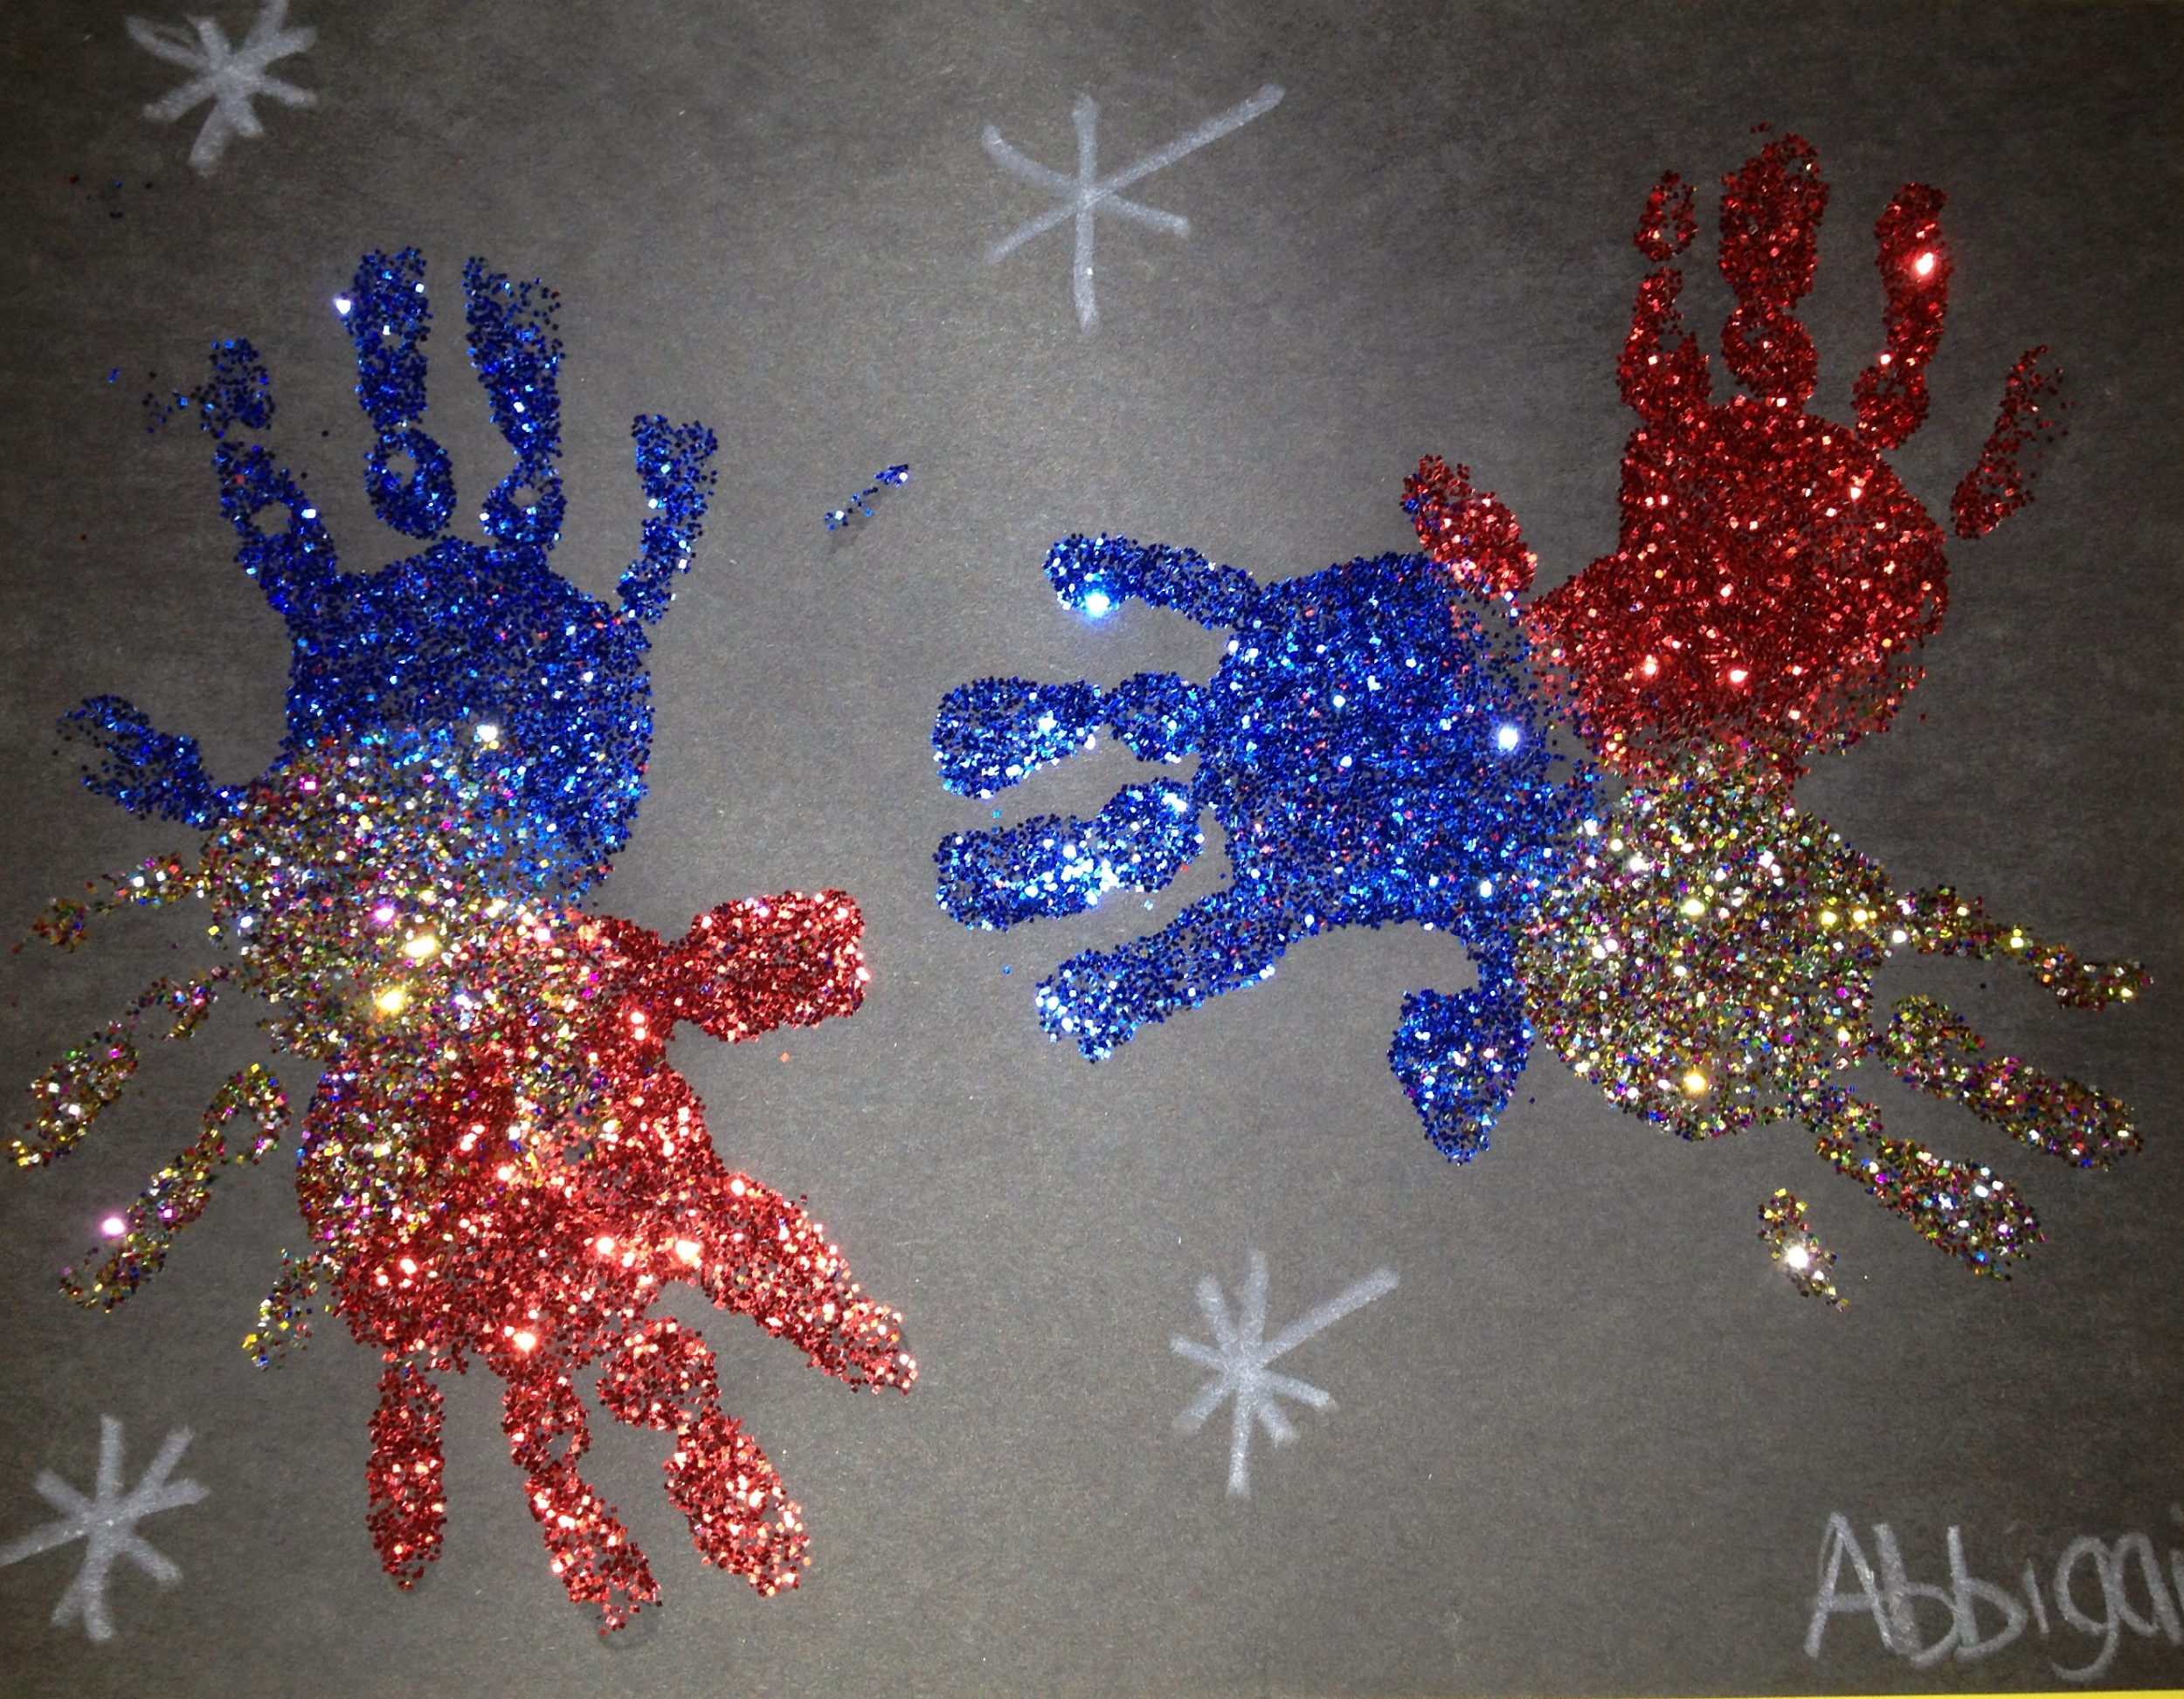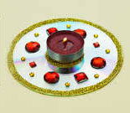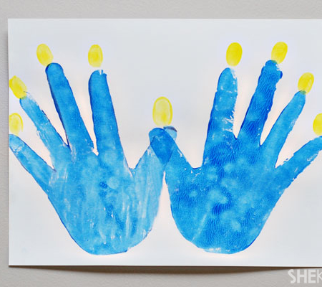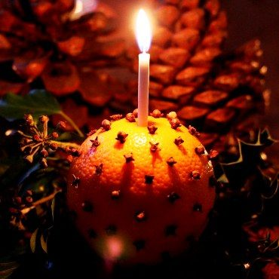 | Maths  Week 1- Number  Week 2- Geometry  Week 3- Measure  Week 4- Number  Week 5- Geometry  Week 6- Measure  Week 7- Number  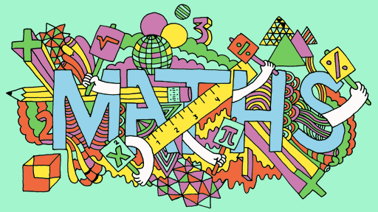 | English  This half term our school focus is Traditional Tales. Gold’s chosen tale is ‘Little Red Riding Hood’  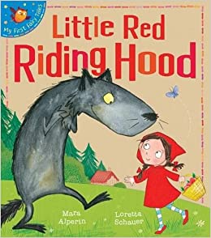 | Phonics/ Reading  We will continue to teach phonics in our differentiated groups within the year group. Pupils will be learning the sounds of letters and how to blend sounds to read words.  In reading the pupils will be reading 1:1 with an adult and sharing a book from the library. We will also be looking at non-fiction texts linked to our topic. | Cookery  We will be making pizzas and looking at the different toppings we can put on them  Alongside this we will be making some chocolate firework treats, decorating biscuits, traditional Barfi sweets and some Christmas treats too.  
Computing  We will continue to go the ICT room twice a week. Once will be to transfer some of the knowledge that we have been learning in maths this week. The other session will be to do some activities associated with the weekly topic. | Expressive Arts  The expressive arts topic is called ‘Reconnect through culture’  It is looking at creative/artistic and cultural rituals, events and customs. | Gold Class  Shine the Light and celebrate  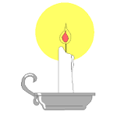  Autumn 2 Overview | Speech & Language  We will continue with our weekly focus on speaking and listening with fun tongue and mouth warm ups. We will be focusing on role play and taking on different characters from our story Little Red Riding Hood. Also learning to say new rhymes in front of our peers. | PE  This half term in PE the pupils will be focusing on quoit hockey.  We will continue to take part in some morning exercise- focusing on trampet work, yoga and keep fit exercises.  We will continue to do a weekly power walk around the woods.
Things to do at home...  -  Look at things around the home that use electricity and explore different light uses around the home.  Have fun using a torch when it is dark. | Science  Our science work will link in with our topic learning about physical properties with a focus on light.  Each week we will be taking a different aspect of light and learning about it. We will also look at electricity and build simple circuits and look at being safe with electricity. | Trips  We are hoping to go on a trip nearer to Christmas and will let you know the details if we are able to. | Important dates  We have booked the bus for Tuesday 8th December. | PSHE  We will be exploring our value of ‘Co-operation’. We will also be learning about people who help us in the community. We will continue to work on individual PLP learning targets each week.

