This is Gold Classes curriculum overview for the Summer1 term. This overview gives you a brief explanation of what the pupils will be doing in school.
Topic  Our topic is called The Natural World  Week 1 and 5 – Ramadan  Week 2 and 6 – Plants  Week 3 and 7– Animals  Week 4 – Humans  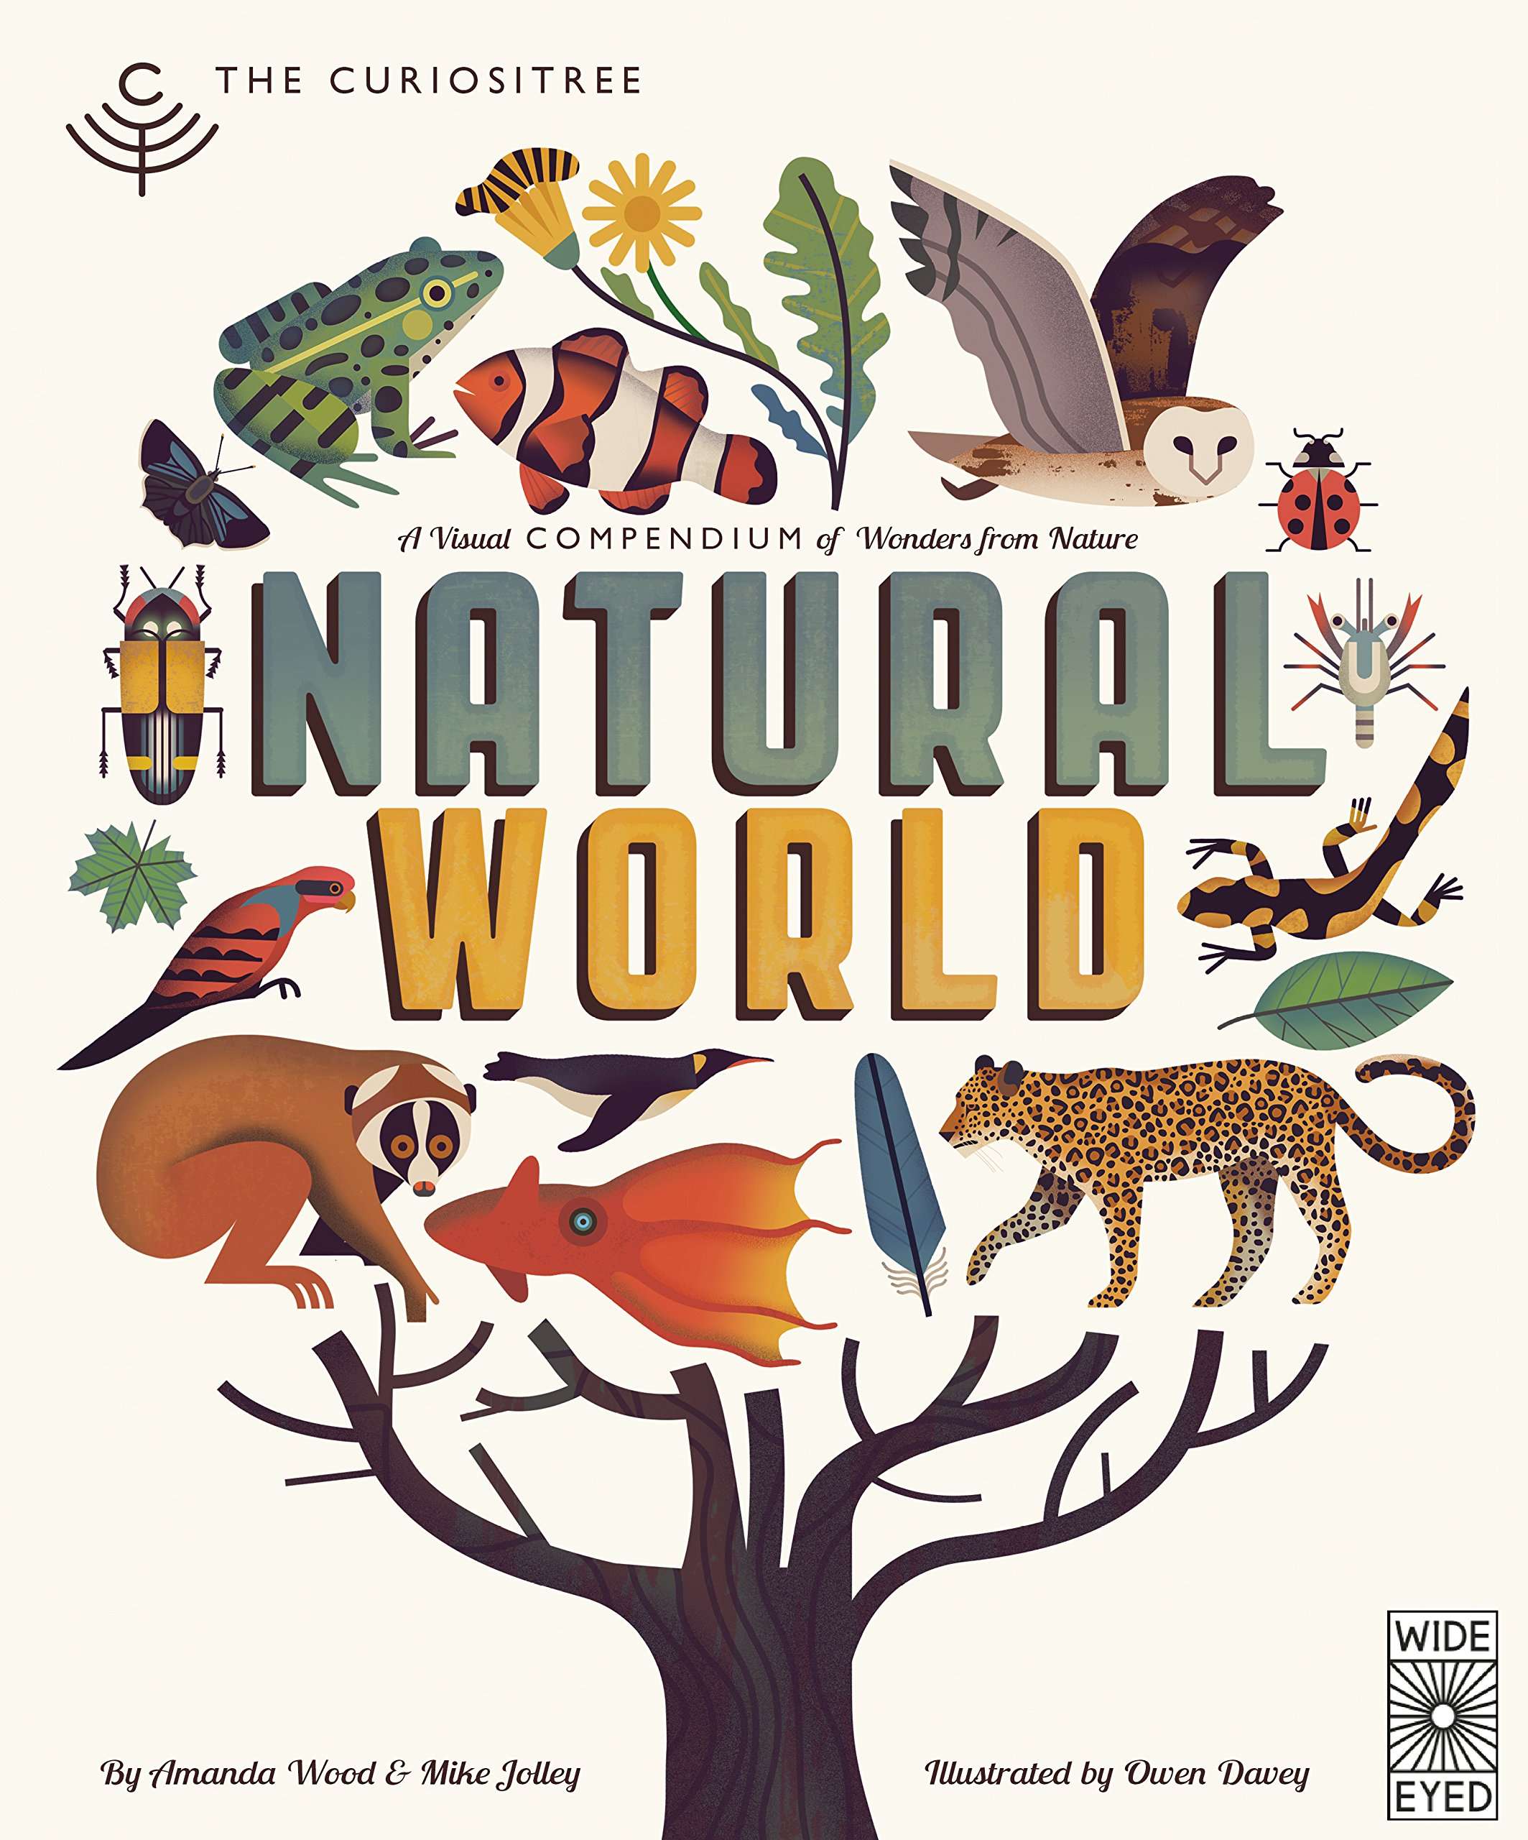 | Maths  Week 1 – Using and Applying  Week 2 - Number  Week 3 - Measurement  Week 4 – Using and Applying  Week 5 – Number  Week 6 - Measurement  Week 7 – recap  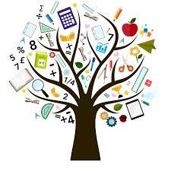 | English  Our story is called The snail and the Whale by Julia Donaldson and is about a snail travelling the world  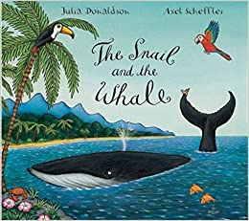 | Phonics/ Reading  We will continue to teach phonics. Pupils will be learning the sounds of letters and how to blend sounds to read words.  In reading the pupils will be reading 1:1 with an adult and sharing a book from a library.  We will visit the library to change our books once a week. We will also be looking at non-fiction texts linked to our topic and about some books about snails and whales. | Cookery  Shoots cookery focus this half term is mug cakes. Each week we will be making a different cake in a mug  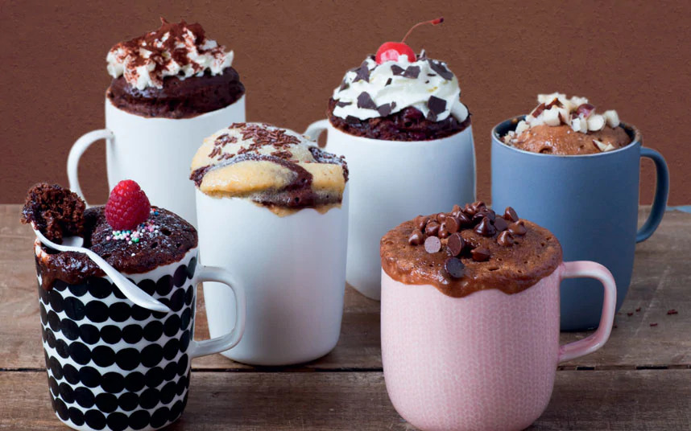
Computing  We will continue to have two sessions a week which will focus on maths skills and computer skills. We will be learning how to use the letters and tools on the keyboard this term.   | PSHE/RSE  This half term we will be looking at the topic of safety.  Week 1 – keeping myself safe  Week 2- safety in the home  Week 3 – safety in the home  Week 4 – safety outside  Week 5 – stranger danger  Week 6 – road safety  Week 7 – road safety  In RSE we will be exploring the terms for parts of our body and looking at how we develop as we grow older. We will also explore personal hygiene. | Gold class  The Natural World  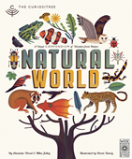  Summer 1 Overview | Speech & Language  This term we will continue our weekly group speaking and listening sessions. This half term we will be looking at making different types of voice and using intonation when speaking in different ways. Also recalling information that we have been told. | PE  This term we will be going outside to do PE with John we will be using the trampoline and developing our skills on it. We will also be using this time to go on the zip wire.  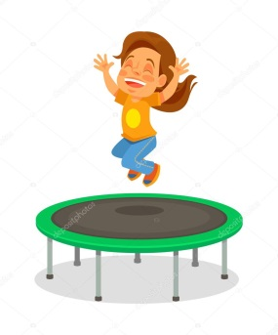
Homework  Talk about and explore the natural world, go on walks to look at different plants and try doing some growing of seeds at home. | Expressive Arts  The focus for our expressive arts lessons this half term will be:  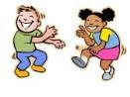  Dance | Trips | Important dates | PLP’s  Each week we will be focusing on our individual targets and have two sessions working specifically on our targets.

