This is Gold Classes curriculum overview for the Summer 2 term. This overview gives you a brief explanation of what the pupils will be doing in school.
Topic  Our topic is all about Water  Week 1 – water and plants  Week 2 – mixing with water  Week 3 – water habitats  Week 4 – water conservation  Week 5 – uses of water  Week 6 – water fun   | Maths  Week 1 – Length  Week 2 - Length  Week 3 – Position and Direction  Week 4 – Position and Direction  Week 5 – Money  Week 6 - Money  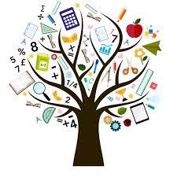 | English  Our story is called Owl Babies and is by Martin Waddell.  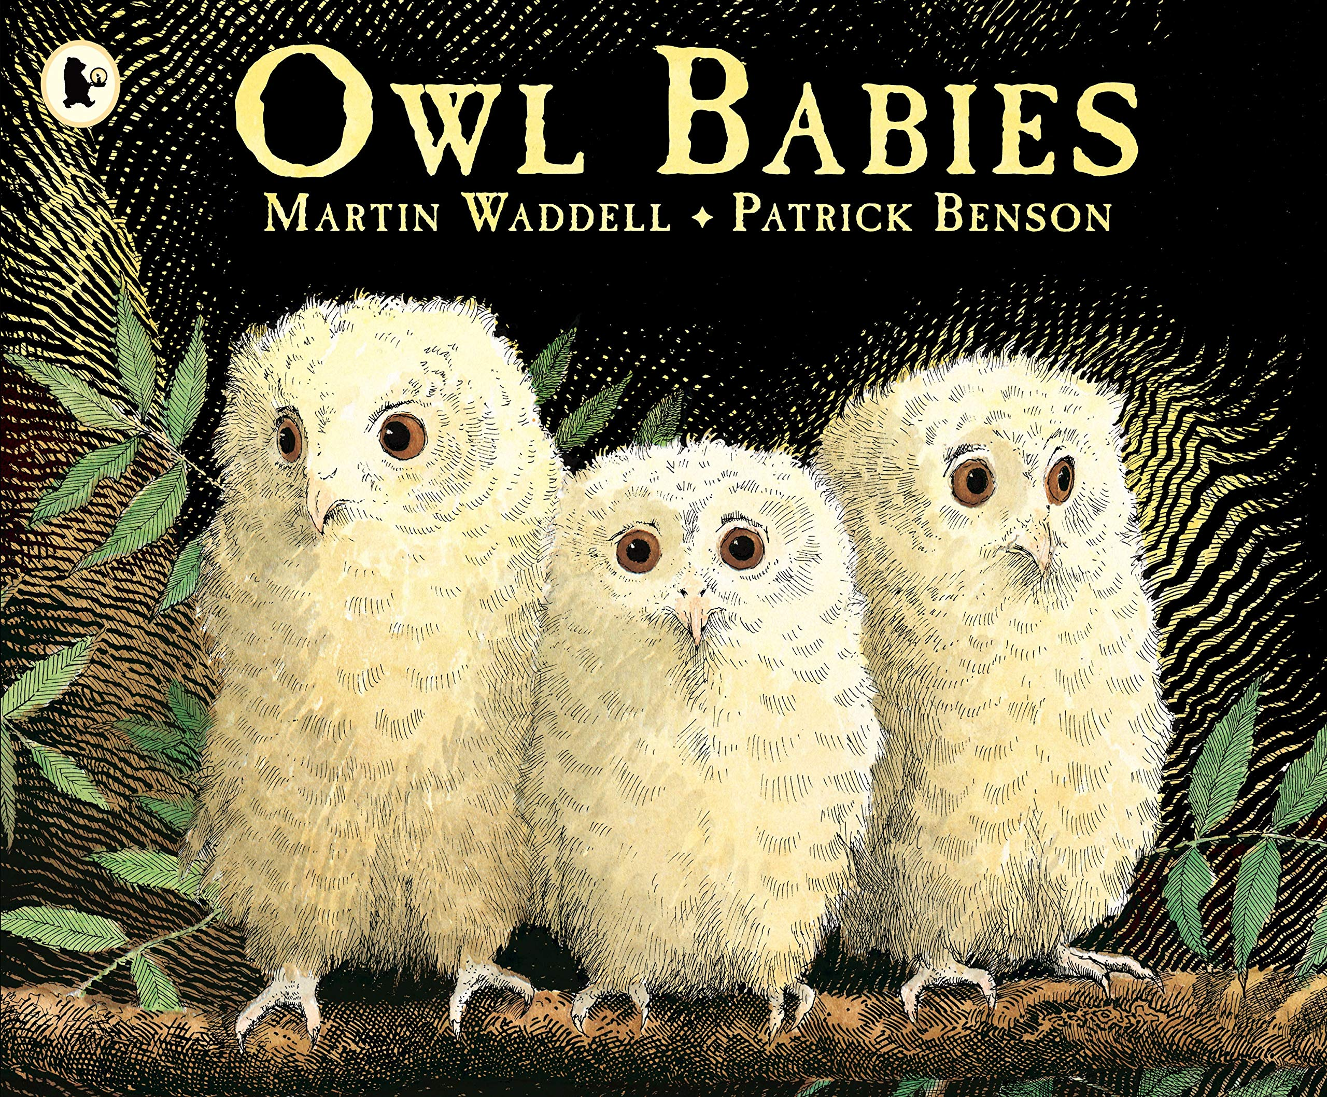 | Phonics/ Reading  We will continue to teach phonics. Pupils will be learning the sounds of letters and how to blend sounds to read words.  In reading the pupils will be reading 1:1 with an adult and sharing a book from a library.  We will visit the library to change our books once a week. We will also be looking at non-fiction texts linked to our topic and about some books about owls. | Cookery  Shoots cookery focus this half term is picnic food. Each week we will be making a different item to take on a picnic.  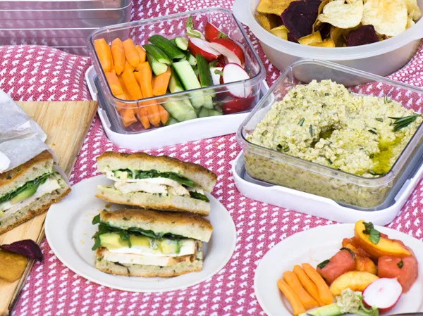
Computing  We will continue to have two sessions a week which will focus on English skills and computer skills. We will be learning how to do simple word processing   | PSHE/RSE  This half term we will be looking at the topic of transition and goals and our ambitions.  Week 1 – When I joined RHS  Week 2 - Transition  Week 3 – What can I do now?  Week 4 – Transition  Week 5 – My ambitions  Week 6 – Transition  In RSE we will continue exploring the terms for parts of our body and looking at how we develop as we grow older. We will also explore personal hygiene and keeping ourselves safe | Gold class  Water  Summer 2 Overview | Speech & Language  This term we will continue our weekly group speaking and listening sessions. This half term we will be looking at role play and using puppet to make different voices. Also recalling information that we have been told and using the phone to practice making appointments and ordering takeaways.  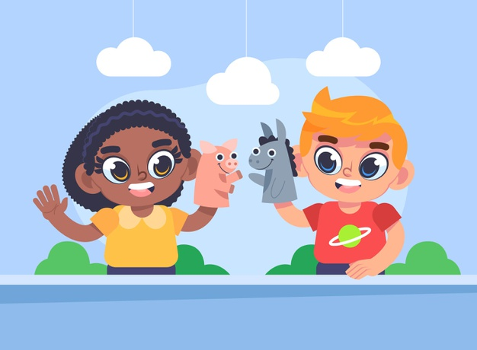 | PE  This term we will be going outside to do PE with John we will practice running races and doing obstacle races for sports day.  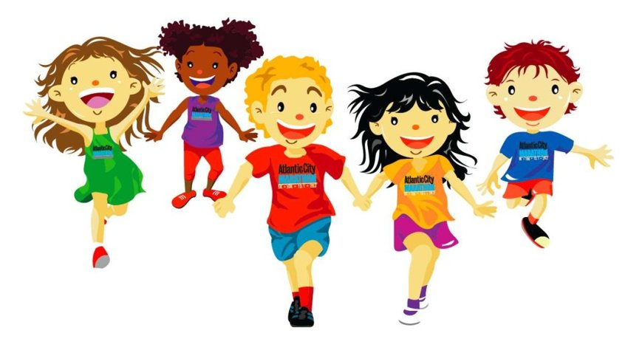
Homework  Talk about and explore different uses of water, go on walks to look at rivers and try doing some watering of the garden or watering some houseplants to make sure they grow. | Expressive Arts  The focus for our expressive arts lessons this half term will be:  Singing  | Events  Child safety week  Father’s Day  Healthy Eating week | Important dates | PLP’s  Each week we will be focusing on our individual targets and have two sessions working specifically on our targets.

