Bilateral integration:
Using two hands together with one hand leading
And
Object manipulation:
The ability to skilfully manipulate tools
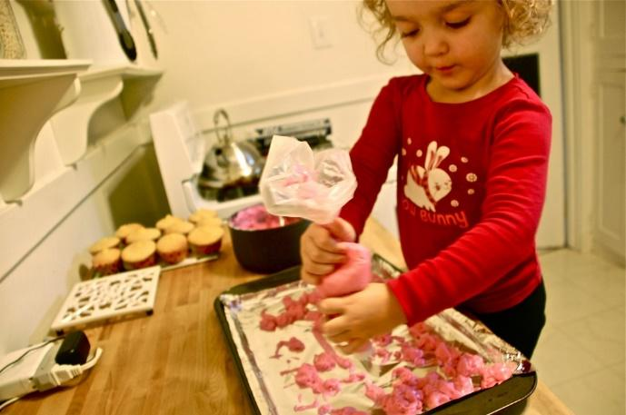
Using an icing bag not only involves using two hands but also helps develop upper body and fine motor muscles.

For the stronger children move on to an icing syringe. It’s fun and messy to fill but challenging to use, make sure you have a large nozzle to begin with so that there is not too much pressure, but you could reduce the size of the nozzle as the children grow in strength.
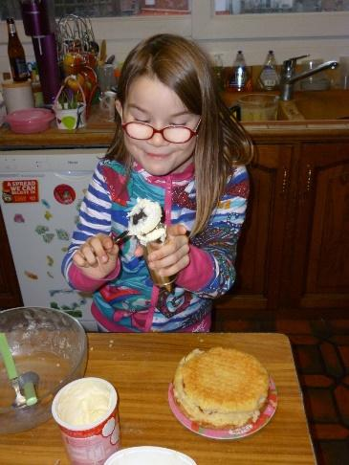
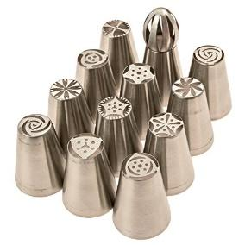
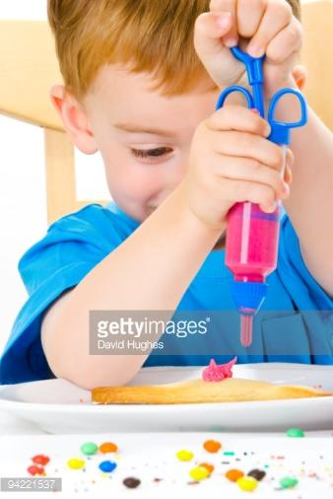

Nuts and Bolts
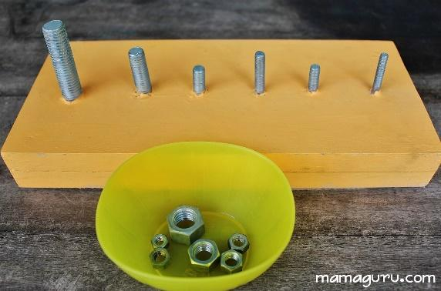
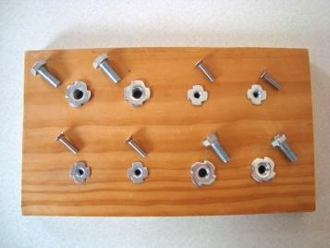
Begin with a one handed task of screwing the bolts onto fixed nuts (I’m sure Andrew could easily make some of these). This enables the children to get used to turning the bolts in a clockwise direction – righty tighty! Then unscrewing – lefty loosey!

Then you can progress on to using both hands, one to keep the bolt or nut still, the other to turn.
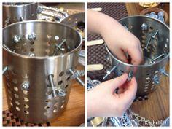
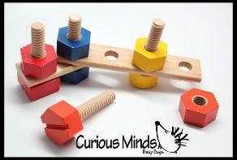
Next, or
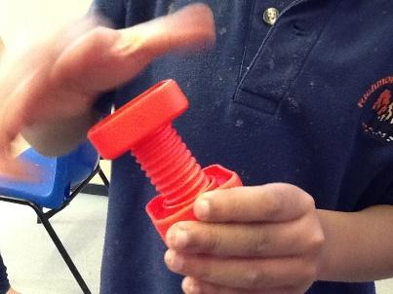

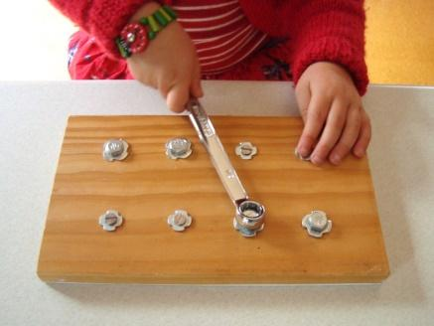
Then, start using tools.
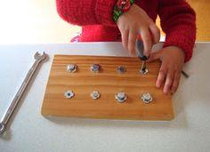

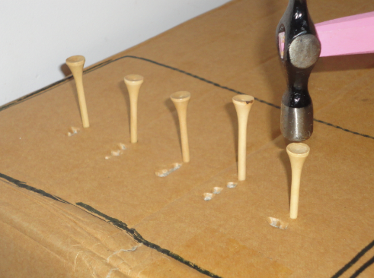

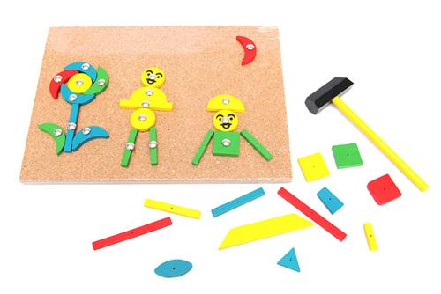
No these aren’t nuts and bolts but still good use of tools. Children sets (Tap, Tap) can be purchased specifically for this activity.

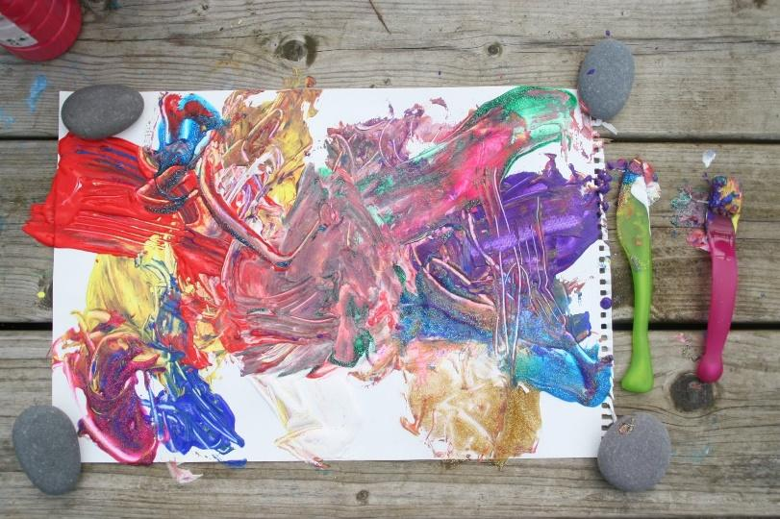
Knives and Forks
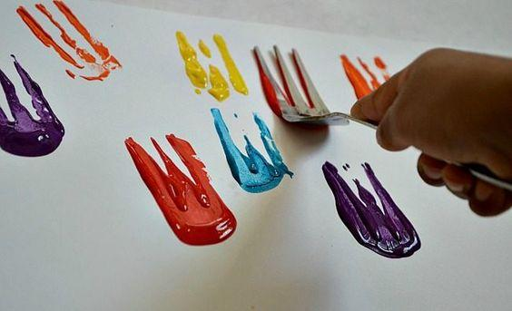

Paint

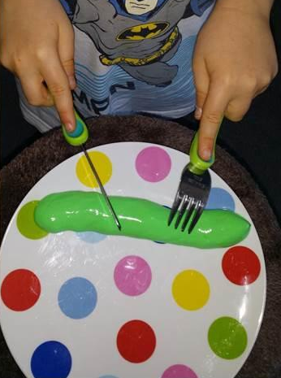
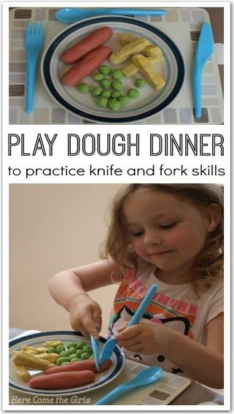
or play dough

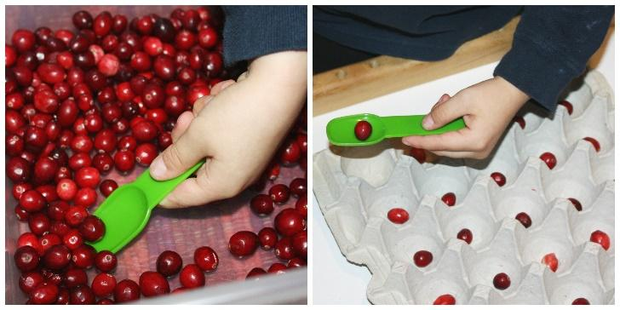
Spoons and scoops…
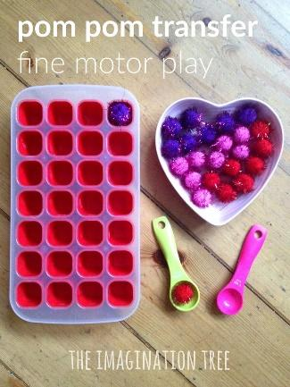
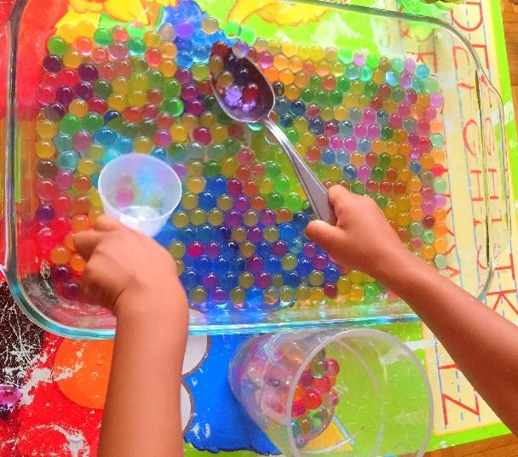
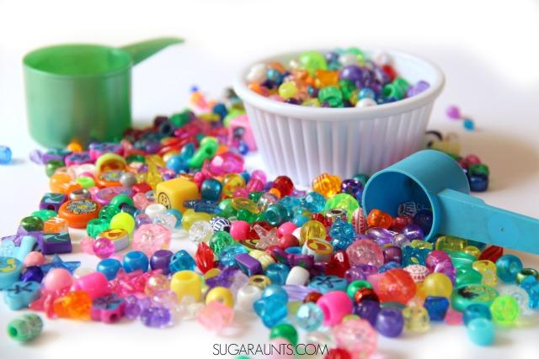

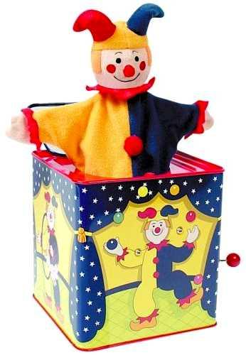
Jack in the box, one hand keeps the box still while the other one winds the handle.

Opening containers, whether big or small
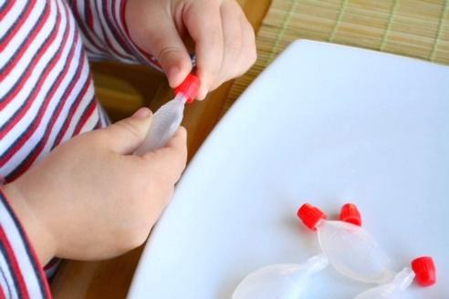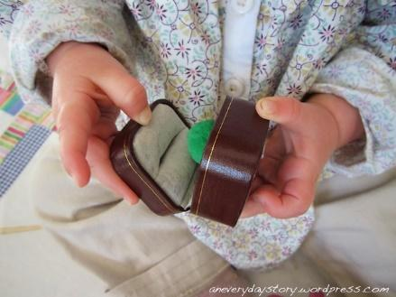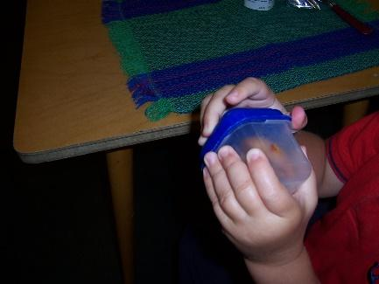
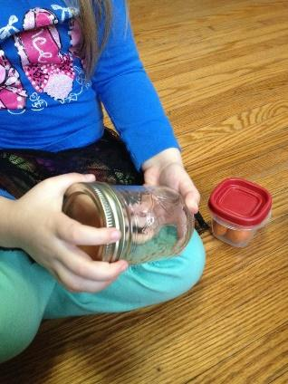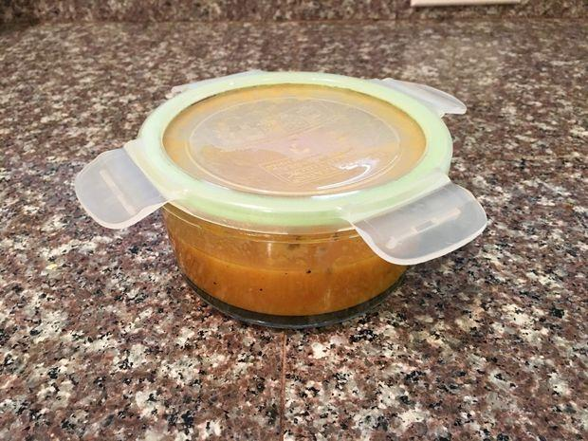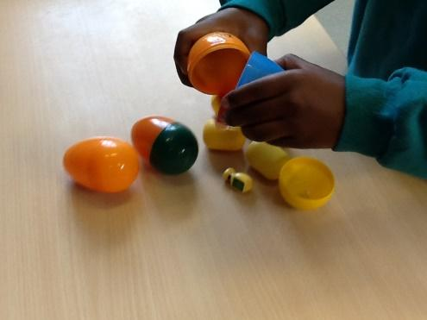

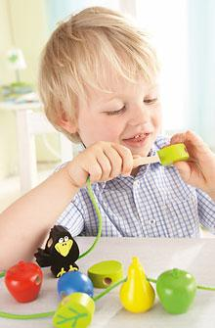
Threading beads and lacing cards.
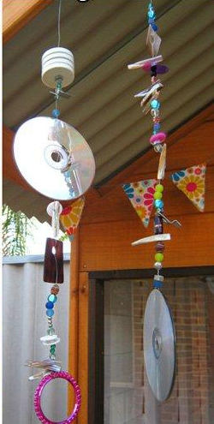
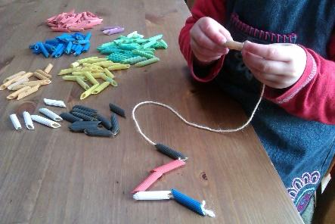
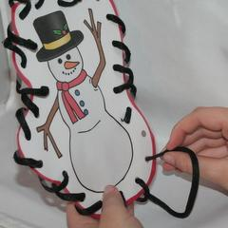

Or even threading mobiles to decorate your outside area.

Folding paper
Great for using two hands but also useful for practising crossing the midline.
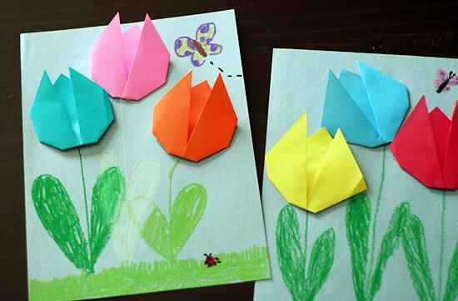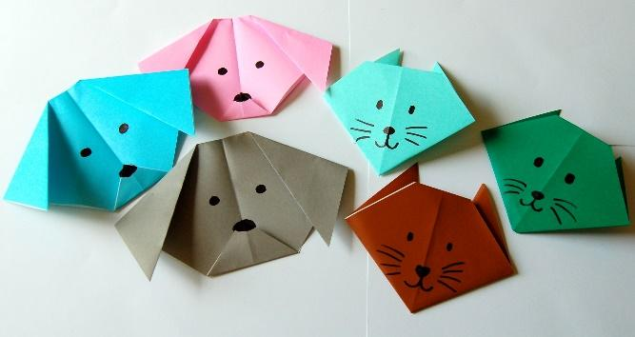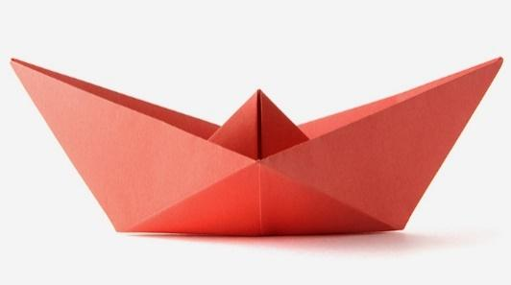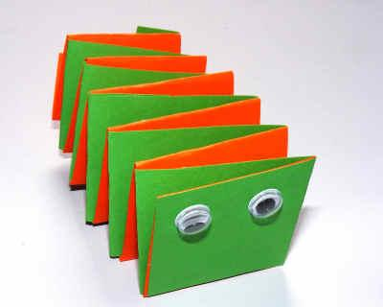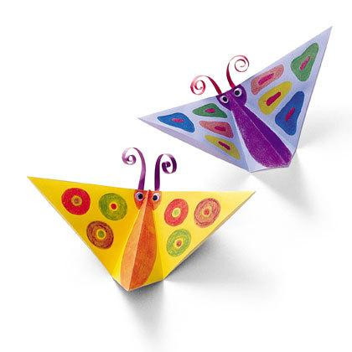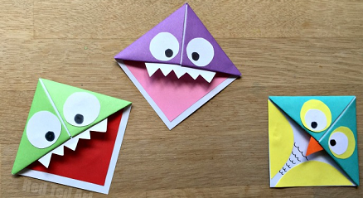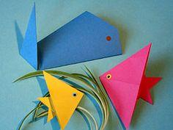
There are loads more simple ideas for kids on line.

And don’t forget tearing and scrunching paper – it’s a skill!
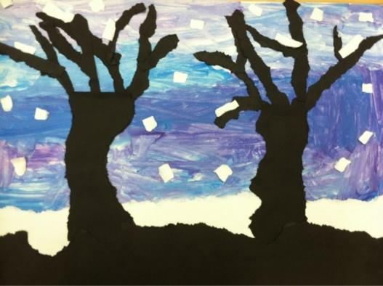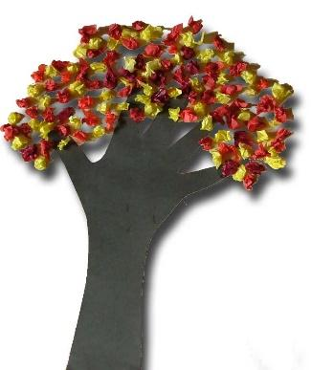
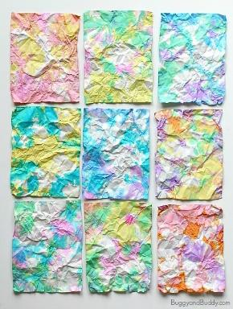
And you can make some fabulous pictures with it too!
You can even make art by crumpling paper, see http://buggyandbuddy.com/crumpled-paper-art-for-kids-inspired-by-ish/
for instructions.

