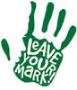
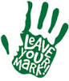
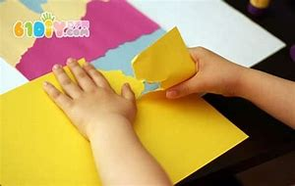
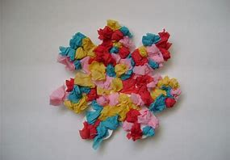
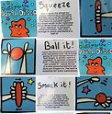
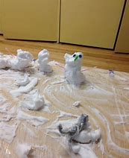
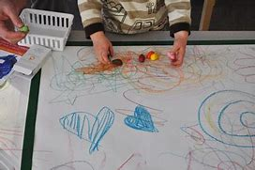
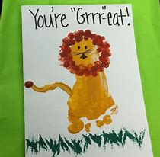
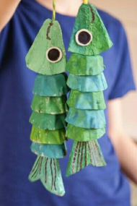
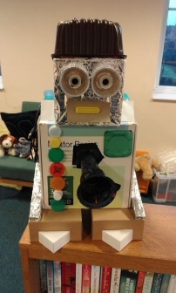
Creative ideas
Rip and tear paper.
Play with play dough. Can you squeeze, ball it and smack it?
Use shaving foam to make snowmen.
Make marks using as many different tools as possible.
Use pencils, crayons, felt tips and pens
Draw a picture of your favourite toy.
Make a card for someone in your family.
Paper art
Moldable materials
Make holes in egg boxes and thread string through to make an animal.
Use recyclable items from home to make a person or a robot.
Scrunch paper into balls and make a picture.
Recyclable art
Collage

