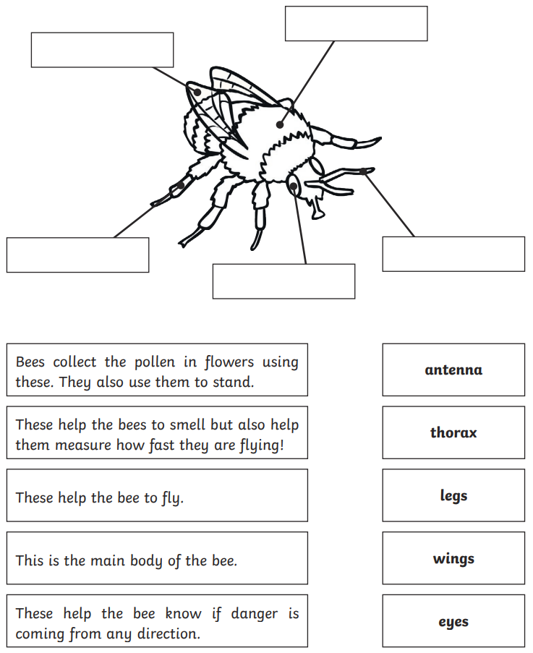
Can you label the Bee`s body parts?
leg
Can you draw a line to match the body part to its job?

